Simulation Project - Final Report

Intersection of Leipziger Str. and Am Fuchsberg / Erich-Weinert Str.

Team D - Team Tetrahedron

**Name: Student ID:**

Lauro Fialho Müller 213317

Chandan Radhakrishna 229746

Raghava Vinaykanth Mushunuri 230176

Kavya Vajja 229749

Arnab Das 229581

Anjan Chatterjee 230211

Submission date: 07.07.2020

# Table of contents

Introduction 8

1. Milestone overview 9

1.1 Team introduction 9

1.2 Project planning 12

1.2.1 Milestone breakdown and work packets 13

1.2.2 Project management tools 15

1.3 Conceptual model 16

1.3.1 Individual and composite model building blocks 16

1.3.2 Conceptual model of Leipziger Str. 20

1.3.3 Conceptual model of Am Fuchsberg - Erich-Weinert Str. 22

1.3.4 Assumptions of the conceptual model 24

1.3.5 Experiments and quantities measured 25

1.4 Data analysis 26

1.4.1 Input data and statistical analysis 27

1.4.2 Considerations regarding the limitations of statistical analysis 28

1.4.3 Analysis of traffic phases 32

1.4.4 Analysis of pedestrian interarrival times 33

1.4.5 Analysis of turning probabilities 35

1.5 Simulation program 36

1.5.1 Program concept and structure 36

1.5.2 Modularization or other special issues 38

1.5.3 Differences to the conceptual model 39

1.5.4 Steps taken to verify the program 39

1.5.5 Difficulties encountered 40

1.6 Validation and quality control 40

1.6.1 Face validation 41

1.6.2 Sensitivity analysis 43

1.7 Experiments 46

1.7.1 Variables of interest 47

1.7.2 Statement of accuracy 48

1.7.3 Claims regarding the current system 48

2. Model assumptions and decisions 52

3. Experiment description, justification, and results 52

3.1 Experiment 1: Open one road at a time 53

3.1.1 Experiment results 54

3.2 Experiment 2: Open non overlapping traffic signals of opposite roads 57

3.2.1 Experiment results 57

3.2.2 Statistical significance 60

3.3 Experiment 3: Allow cars on the blocked tram line on Leipziger Str. north 61

3.3.1 Experiment results 62

3.3.2 Statistical significance 64

3.4 Experiment 4: Car bridge between Am Fuchsberg and Erich-Weinert Str. 65

3.4.1 Experiment results 66

3.4.2 Statistical significance 69

3.5 Experiment 5: Free right lane from Leipziger Str. south into Erich-Weinert Str. 70

3.5.1 Experiment results 70

4. Recommendations 71

4.1 Statistical analysis 72

5. Limitations and trade-offs 74

6. Cost overview 76

6.1 Statement of profit / loss 78

7. The team 79

7.1 Specific difficulties faced during the project execution 79

7.2 Experiences and events of interest 80

7.3 Team evaluation 80

7.4 What could be done differently 81

7.5 Most important lessons learned from the project 81

7.6 Comments on the project as a university course 82

8. Conclusion 82

Statement of profit / loss 84

# List of figures

Figure 01: Crossed representation of single lanes with multiple possible directions 18

Figure 02: Movement restrictions for left turns 19

Figure 03: Pedestrian movement 20

Figure 04: Conceptual model of Leipziger Str. 21

Figure 05: Tram and car sharing the same lane 22

Figure 06: Conceptual model of Am Fuchsberg - Erich-Weinert Str. 23

Figure 07: Histogram and theoretical distribution (blue line) for Am Fuchsberg 29

Figure 08: Q-Q plot for Am Fuchsberg 30

Figure 09: Histogram and theoretical distribution (blue line) for Erich-Weinert Str. 31

Figure 10: Q-Q plot for Erich-Weinert Str. 32

Figure 11: Main control structures in the simulation program 37

Figure 12: Results of car generation experiments 43

Figure 13: Change in throughput with varying input mean for Erich-Weinert Str. 44

Figure 14: Relative change in throughput 45

Figure 15: CI for the cumulative throughput of the current system 49

Figure 16: CI for the average time in model of the current system 50

Figure 17: CI for the total stop count of the current system 51

Figure 18: CI for the total stop count with the changes from experiment 1 54

Figure 19: CI for roadwise throughput with the changes from experiment 1 55

Figure 20: CI for cumulative throughput with the changes from experiment 1 56

Figure 21: CI for the total stop count with the changes from experiment 2 58

Figure 22: CI for roadwise throughput with the changes from experiment 2 59

Figure 23: CI for cumulative throughput with the changes from experiment 2 59

Figure 24: Difference CI for roadwise through and stop count for experiment 2 61

Figure 25: CI for roadwise throughput with the changes from experiment 3 62

Figure 26: CI for cumulative throughput with the changes from experiment 3 63

Figure 27: CI for stop count and time in model with changes from experiment 3 63

Figure 28: Difference CI for roadwise throughput and stop count for experiment 3 65

Figure 29: CI for roadwise throughput with the changes from experiment 4 67

Figure 30: CI for stop count and time in model with changes from experiment 4 67

Figure 31: CI for cumulative throughput with the changes from experiment 4 68

Figure 32: CI for stop count and time in model with changes from experiment 4 69

Figure 33: CI for roadwise throughput with the changes from experiment 5 70

Figure 34: Difference CI for roadwise throughput with cumulative changes 73

Figure 35: CI for stop count with cumulative changes 74

Figure 36: Project cost overview 77

# List of tables

Table 01: Role distribution among Team Tetrahedron 09

Table 02: Input data required for the project execution 10

Table 03: Member performance evaluation criteria 12

Table 04: Milestone 3 task breakdown 13

Table 05: Milestone 4 task breakdown 14

Table 06: Milestone 5 task breakdown 14

Table 07: Milestone 6 task breakdown 14

Table 08: Milestone 7 task breakdown 15

Table 09: Milestone 8 task breakdown 15

Table 10: Conceptual model building blocks 17

Table 11: Overview of input and output variables 26

Table 12: Summary of vehicle analysis results 28

Table 13: Summary of traffic light phase analysis results 33

Table 14: Summary of pedestrian analysis results 34

Table 15: Summary of turning probability analysis results 35

Table 16: Variables of interested and respective experiment goals 48

Table 17: Overview of measurements for variables of interest in original model 51

Table 18: Numerical results of experiment 1 56

Table 19: Traffic phases and directions for experiment 2 57

Table 20: Numerical results of experiment 2 60

Table 21: Numerical results of experiment 3 64

Table 22: Numerical results of experiment 4 68

Table 23: Summary of recommendations to the City of Magdeburg 72

Table 24: Cost overview per milestone and team member 78

# Introduction

Computer simulations of real-world scenarios provide a cost-effective and flexible venue not only for understanding the system’s mechanics to a deeper extent but also for implementing and testing modifications to the system without the need of real changes to it[1]. This is not equivalent to saying that computational modelling is an effortless endeavor; on the contrary, it requires not only commitment from the entire simulation team but also precise conceptualization, measurements, analytics, software programming, and quality control. It is on the lines of the aforementioned steps and with the supreme goal of quality that Team Tetrahedron has conducted the Simulation Project for the traffic intersection between Leipziger Str., Am Fuchsberg, and Erich-Weinert Str. in the Summer Semester of 2020 at the Otto-von-Guericke University of Magdeburg.

This report details the work developed during the eight milestones that encompassed the execution of the project. In the first section, the team details the work done in each individual milestone of the project. We also provide all the relevant charts, calculations, analyses, and conclusions from each of the milestones. In the second section, we detail the assumptions of the model, as well as the decisions made during the different milestones and the justification for each of the decisions. The third section highlights the findings of our most promising experiments, together with the relevant statistical calculations that prove the efficiency of our modifications. Building on these experiments, the fourth section details our recommendations to the City of Magdeburg, together with the statistics of the combined model which incorporates all the suggested changes simultaneously. The fifth section discusses the limitations and the trade-offs of both the simulation program and the team’s recommendations. The sixth section provides a detailed overview of the project’s costs, and it discusses several strategies used by the team to stay on track regarding project progress cost. The seventh and eighth sections discuss project management related aspects, such as the team’s perception of the project as well as the lessons we have learned along the way. Finally, the ninth section summarizes the content of the report and highlights its most important aspects.

# **1.** Milestone overvi**ew**

## 1.1 Team introduction

The team introduction milestone had four main deliverables which allowed us to familiarize ourselves not only with the team but also with the traffic intersection: team organization, project analysis, conceptualization of project goals, and definition of evaluation metrics.

The first deliverable, the team organization, has allowed us to distribute roles for each of its members, so that the work could be evenly split throughout the team and the members could benefit from more realistic management responsibilities. The roles were divided as follows:

| **Role** | **Team member** |
| --- | --- |
| Team leader | Lauro Fialho Müller |
| Conceptual model designer | Chandan Radhakrishna |
| Input data analyst | Raghava Vinaykanth Mushunuri |
| Chief software architect | Kavya Vajja |
| Experiment designer | Arnab Das |
| Validation and quality control | Anjan Chatterjee |

**Table 01:** Role distribution among Team Tetrahedron

In addition to establishing the team roles, we have defined project management elements such as a collaborative team environment, effective progress tracking tools, efficient communication channels, and a convincing visual identity for the project.

The second deliverable, the project analysis, has given us the change to better understand the node by visiting it multiple times and identifying the major characteristics of the traffic and pedestrian flows, as well as the main challenges presented by the node. We have identified the following as particularly relevant node characteristics:

1. Seemingly heavier traffic on the south part of Leipziger Str.
2. Pedestrians are allowed to cross on all four sides of the intersection.
3. Erich-Weinert-Str. presents an exclusive lane for right turns into Leipziger Str.
4. Leipziger Str. also has a tram line, which poses unique restrictions on traffic phases and traffic flow.
5. Cars from all roads and directions are allowed to turn both right and left, as well as proceed forward. This characteristic, as it will be seen in section 1.7, leads to a considerably high count of vehicles stopping within the main intersection, an indicator that the intersection is rather accident-prone.

In addition to identifying the peculiar characteristics of the node, the team has also identified the necessary input data for the simulation program, so that we would be able to correctly represent the interactions happening within the node. Table 02 presents a summary of the input data that we have considered relevant for the project execution.

| **Data category** | **Data dimensions** |
| --- | --- |
| Vehicle data | Interarrival times, direction, alternation between cars and trams. |
| Traffic light data | Duration, traffic phase variation, impact of pedestrians pressing the button. |
| Public transportation data | Timetable of trams and buses, delays. |
| Pedestrian data | Interarrival times. |
| Safety data | Accident-related statistics such as frequency and magnitude. |

**Table 02:** Input data required for the project execution

When considering this data, we have identified a major challenge related to the impossibility of directly simulating accidents due to their random nature. Instead of collecting direct data on accidents, we would have to design indirect measures of traffic safety. An example of measure that we have used in our experiments is the total number of car stops happening within the main intersection boundaries during the time window of the simulation execution. The reasoning is straightforward: the lower the number of cars stopping within the main intersection, the lower the probability of accidents happening between cars and between cars and pedestrians.

An additional deliverable of the project analysis has been the conceptualization of several experiments that could be implemented in the simulation program. As the list has gone through changes during the project execution, we have opted to include only the final list of experiments in section 1.7.

The third deliverable, the conceptualization of project goals, allowed the team to have clear targets for the project. Since no project can be executed if the team does not work harmoniously, we have set as our primary team goal to “establish a cooperative environment where each team member contributes with meaningful insights and learns from the others.” Only then we would be able to achieve the project goals of completing each milestone within budget and schedule and of delivering a high-quality simulation program that offers valuable insight on how to improve safety and reduce congestion.

The fourth deliverable, the definition of evaluation metrics for both the team members and the quality of the simulation program, enabled us to have objective measures of performance and dedication of each team member towards the project.

On the member evaluation side, the team has agreed on three main areas: group participation, deadlines and timeliness, and quality of tasks delivered. Table 03 provides a detailed overview of the different dimensions of each area. We have also adopted an objective measurement scale with four possible choices and a detailed rubric that maps member performance to each choice in order to remove as much subjectivity from the process as possible.

| **Evaluation area** | **Evaluation dimensions** |
| --- | --- |
| Group participation | Attendance in meetings  Interaction during the meetings  Interaction outside of the meetings  Team work |
| Ownership, deadlines and timeliness | Submission of work  Team meeting  Ownership of tasks |
| Quality of tasks | Quality of work delivered  Amount of necessary reviews  Proactiveness  Project related documentation & artifacts |

**Table 03:** Member performance evaluation criteria

## 

On the simulation program evaluation side, we have focused on the statistical significance of the simulation measurements, stability of the model, modularity and scalability aspects, quality of the conceptual model, and quality of the experiments performed.

## 1.2 Project planning

The scope of the project planning milestone was to draw a well-defined plan for the project execution by identifying the major tasks of each milestone, dividing them into work packets, and assigning each of these work packets to one or more team members. In addition to the task breakdown, secondary goals of this milestone included agreeing on tools for communication, progress tracking, and cost tracking.

### 1.2.1 Milestone breakdown and work packets

The milestone breakdown was executed for each of the following five milestones of the project (in this report, sections 1.3 until 1.7 in addition to the final milestone of finalizing this very document). Due to having defined more than one hundred work packets, representing all of them in this report would be unnecessarily lengthy. Instead, Tables 04 through 09 present an overview of the top-level work packets for each of the milestones, together with the member responsible for the respective work packet. Additionally, for the sake of brevity we intentionally omit repetitive work packets such as assembling the milestones’ documentations and presentations.

| **Milestone 3 - Conceptual model - Estimated cost: € 6180.00** | | |
| --- | --- | --- |
| **ID** | **Description** | **Responsible team member** |
| 3.1 | Conceptualize the Petri Net | Chandan Radhakrishna |
| 3.2 | Draw Petri net diagram electronically | Lauro Fialho Müller |
| 3.3 | Review the Petri Net | All members |
| 3.4 | Precisely define the experiments that will be performed in terms of changes in the Petri net. | Arnab Das |

**Table 04:** Milestone 3 task breakdown

In addition to the work packet distribution, we have also performed a detailed cost estimation for each milestone. This was done based on the detailed overview of the work packets and on the milestone duration. The team has also agreed to leave a buffer of € 3000.00 to be used in the case of any unforeseen events. The estimated costs are shown next to the title of each milestone table. Together with the cumulative estimated costs of € 9105.00 for both first and second milestones, the total estimated sum is € 57000.00.

| **Milestone 4 - Data analysis - Estimated cost: € 10300.00** | | |
| --- | --- | --- |
| **ID** | **Description** | **Responsible team member** |
| 4.1 | Analyze the data provided by the City of Magdeburg | Raghava Vinaykanth Mushunuri |
| 4.2 | Analyze the data provided by the previous year’s team | Raghava Vinaykanth Mushunuri |
| 4.4 | Collect necessary data at the node | Everyone |
| 4.5 | Analyze data collected at the node | Kavya Vajja |

**Table 05:** Milestone 4 task breakdown

| **Milestone 5 - Simulation program - Estimated cost: € 10300.00** | | |
| --- | --- | --- |
| **ID** | **Description** | **Responsible team member** |
| 5.1 | Collect information on AnyLogic’s road traffic library | All members |
| 5.2 | Build the program based on the conceptual model | Kavya Vajja |
| 5.3 | Run the model and analyse its behavior | Anjan Chatterjee |
| 5.4 | Verify the model against the conceptual design and implement necessary changes | Chandan Radhakrishna |

**Table 06:** Milestone 5 task breakdown

| **Milestone 6 - Validation and quality control - Estimated cost: € 9270.00** | | |
| --- | --- | --- |
| **ID** | **Description** | **Responsible team member** |
| 6.1 | Review the implementation of roads, traffic lights, vehicle generation, traffic flow, program code, and input distribution correctness. | Anjan Chatterjee |
| 6.5 | Update the model where it is not performing according to the expected in terms of "normal behavior" | Kavya Vajja |
| 6.6 | Output analysis: calculate mean, standard deviation, CI, and sensitivity analysis for the defined output variables | Lauro Fialho Müller |

**Table 07:** Milestone 6 task breakdown

| **Milestone 7 - Experiments - Estimated cost: € 8240.00** | | |
| --- | --- | --- |
| **ID** | **Description** | **Responsible team member** |
| 7.1 | Create dedicated models for each experiment: describe and justify the experiment | Arnab Das |
| 7.2…  7.6 | Conduct experiments and perform output analysis. | All members |
| 7.7 | Draw conclusion from the experiment result - whether it helped or not to achieve its goal. | Arnab Das |
| 7.8 | Create the statement of accuracy for interesting system variables. | Anjan Chatterjee |
| 7.9 | Identify final recommendations to the customer. | All members |

**Table 08:** Milestone 7 task breakdown

| **Milestone 8 - Final report - Estimated cost: € 3605.00** | | |
| --- | --- | --- |
| **ID** | **Description** | **Responsible team member** |
| 8.1 | Create and format the final report document. | Lauro Fialho Müller |
| 8.2 | Read and review the final report. | All members |

**Table 09:** Milestone 8 task breakdown

### 1.2.2 Project management tools

In addition to dedicating enough time to conceive the work packets for all the upcoming milestones, the team has also agreed on several tools that would facilitate both the project communication and the overall project tracking. The adopted structure for the planning involves:

1. **GitHub issues** to track the progress of individual milestones, as well as to track whether the milestone will be completed and delivered on time.
2. **Google sheets** to track the costs and individual expenditures during the execution of the project. All our team members have followed a similar structure, and we have used the information throughout the project execution to update our progress and cost trackers.
3. **Slack** for project communication. We have created several channels for each milestone, so that we could keep communication separate and direct to address the issues of each milestone.

Finally, due to the large amount of tasks involved in ensuring the excellence of the project execution, we have agreed on three weekly calls to follow up on each member’s progress and discuss issues relevant to the present and future milestones.

## 1.3 Conceptual model

The main deliverable of the conceptual model milestone was a detailed Stochastic Petri Net representing the underlying interaction and sequence mechanics of the model to be implemented during the simulation program milestone (details of the simulation program are discussed in section 1.5). In order to facilitate comprehension, the conceptual model was split into two main submodels. Before describing the detailed behavior of the conceptual model, section 1.3.1 focuses on describing the individual and composite building blocks of the models, so that the understanding of the following detailed descriptions is supported. Subsection 1.3.2 discusses the modelled behavior in Leipziger Str., and section 1.3.3 discusses the modelled behavior in Am Fuchsberg and Erich-Weinert Str.

### **1.3.1 Individual and composite model building blocks**

We believe it is crucial to provide an overview of the main building blocks of the conceptual model and their meaning, since they are essential for understanding the mechanics of the Petri Net. We start by describing the individual building blocks. Table 10 provides a detailed explanation of each of them, as well as a numeric reference for later use in the remainder of this section.

| **ID** | **Visual representation** | **Semantic meaning** |
| --- | --- | --- |
| **#1** |  | The **blue rectangle** with an outgoing arrow represents the sources of elements in the conceptual model. These can be either vehicles or pedestrians, with the specific type being inferred from the position of the source in the model. |
| **#2** |  | The **orange rectangle** with an incoming arrow represents the sinks for elements in the conceptual model. Elements (vehicles and pedestrians) exit the system when entering the sink. |
| **#3** |  | The **bordered circles** represent the places that can be occupied by elements in the model. They are connected through transitions, which can be either immediate (**#4**) or timed (**#5**). |
| **#4** |  | The **shaded rectangles** with labels with either *pX* or *[condition]* represent immediate transitions in the system. *pX* represent probabilities, and they invariably add to one for parallel shaded rectangles. *[condition]* represents a specific condition that must be fulfilled so that the transition is enabled. |
| **#5** |  | The **transparent rectangles** represent timed transitions in the system. The timings normally represent the duration of an element’s movement (for example, a vehicle does not immediately transition between places; instead it requires time due to acceleration and deceleration). |
| **#6** |  | The **back arrows with a rounded end** represent transition blockers. In other words, if an element is present in the bordered circle with an outgoing blocker, the transition which it points at is blocked until that place becomes empty. |

**Table 10:** Conceptual model building blocks

While having an understanding of the fundamental elements discussed above provides a good basis for comprehending the model, further discussion of the main aggregate components of the interaction is recommended for a deeper understanding of the model mechanics. These are crossed representations of single lanes and transition restrictions on left turns due to concurrent traffic on the opposite direction. These are also linked to numeric IDs, so that they can be later referenced in a concise manner.

**Crossed representation of single lanes with multiple possible directions (ID #7)**

The first construct we would like to clarify is used several times throughout both submodels and represents cars occupying the same lane but having different target directions. The adjacent figure shows two places at top, each one representing a different target direction. The shaded rectangles represent the probabilities of a car turning in each direction. As shown at the bottom, the cars come from a single place, which represents the concept of a single lane. The crossed design shows that the next place on the lane can be occupied by a single car which is going in either direction, but not simultaneously by more than one car. Having a car present on the top left circle blocks both transitions, as well as having a car present on the top right circle. This leads to the desired “mutually exclusive” behavior of the construct.

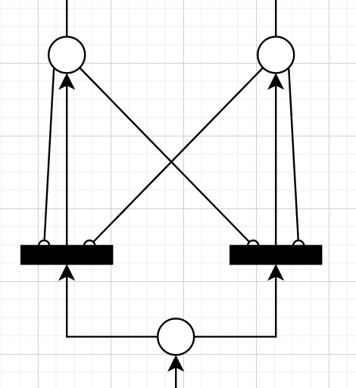

**Figure 01:** Crossed representation of single lanes with multiple possible directions

**Movement restrictions for left turns due to opposite traffic and pedestrians (ID #8)**

Figure 02 provides a closer overview of the traffic movement restrictions due to pedestrians and opposite flow traffic.

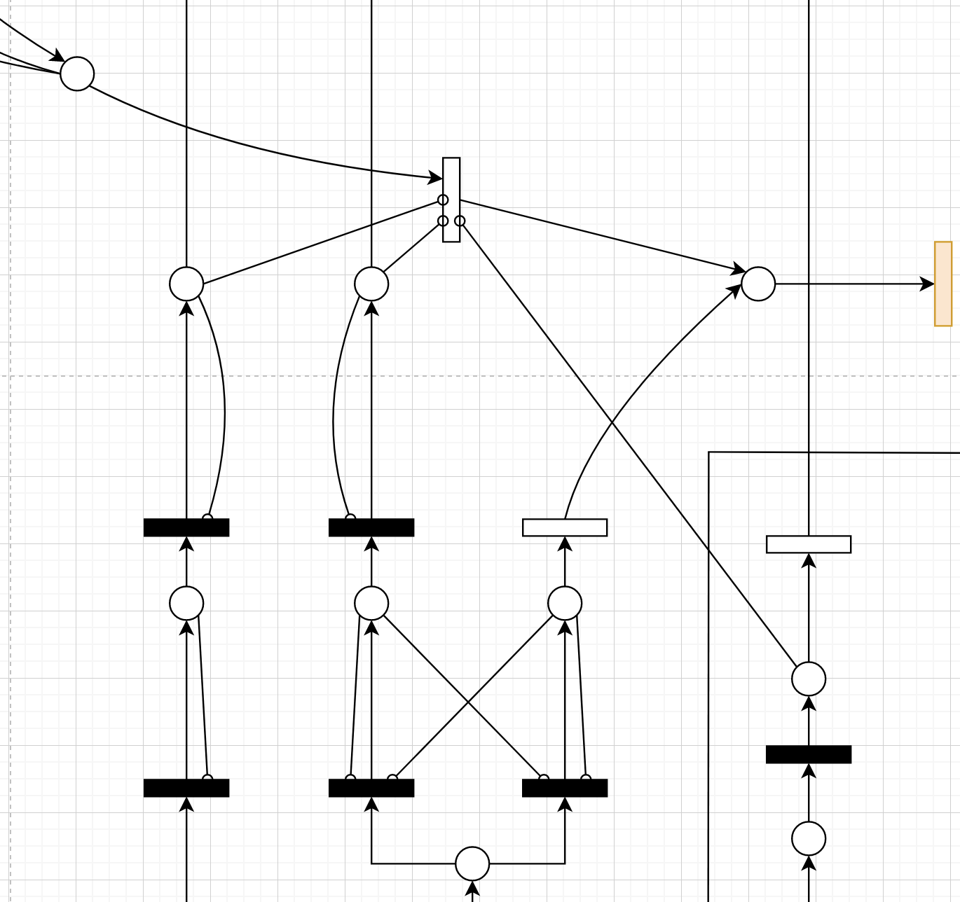

**Figure 02:** Movement restrictions for left turns

The bottom right circle represents cars on the left turn flow. As it can be seen, the timed transition is blocked by three other places: pedestrians crossing the street at the intersection which will be entered by the car turning left, and vehicles moving forward on both the left and the right opposite lanes. The construct also shows how construct **#7** is integrated in the system. Only when the three places blocking the timed transition are empty, the vehicle on the left turn direction is allowed to continue. We have observed that this may pose serious delays and a high number of cars waiting to turn left within the intersection boundaries, which has motivated several of the experiments detailed in section 1.7.

### **1.3.2 Conceptu**al model of L**eipziger Str.**

With the main individual and composite elements of the conceptual model clarified, we now move to examining the conceptual model of the interactions taking place in Leipziger Str. Figure 03 provides the overall picture of the conceptual submodel, together with alphanumeric indicators to guide the discussion of its most important parts.

**LS#1** represents pedestrian behavior. Pedestrians arrive from the sink and wait at the first place until the immediate transition becomes enabled. This transition represents the pedestrian traffic light. Once it becomes enabled, the pedestrians move to the next place, which represents “crossing”. The next transition is a timed transition, which represents the time that pedestrians take to cross the street. The cardinality of the transition reflects one of our model assumptions: all pedestrians cross the street simultaneously. While place **C** is occupied, the left turns from the opposite road are blocked. The pedestrian behavior is repeated across all the pedestrian intersections.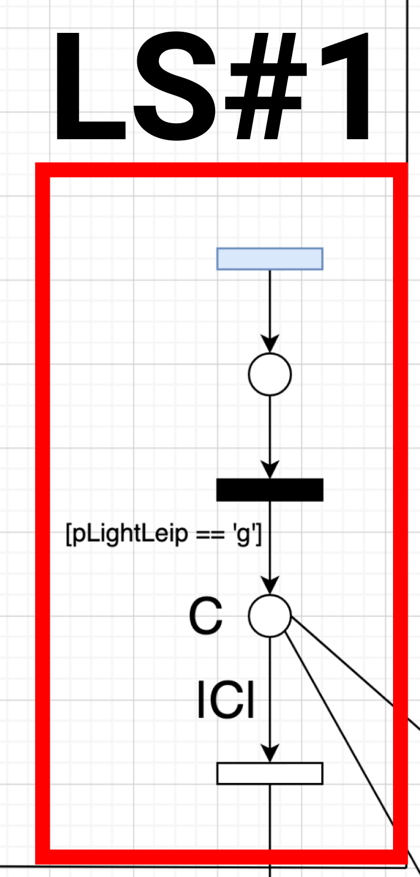

**Figure 03:** Pedestrian movement

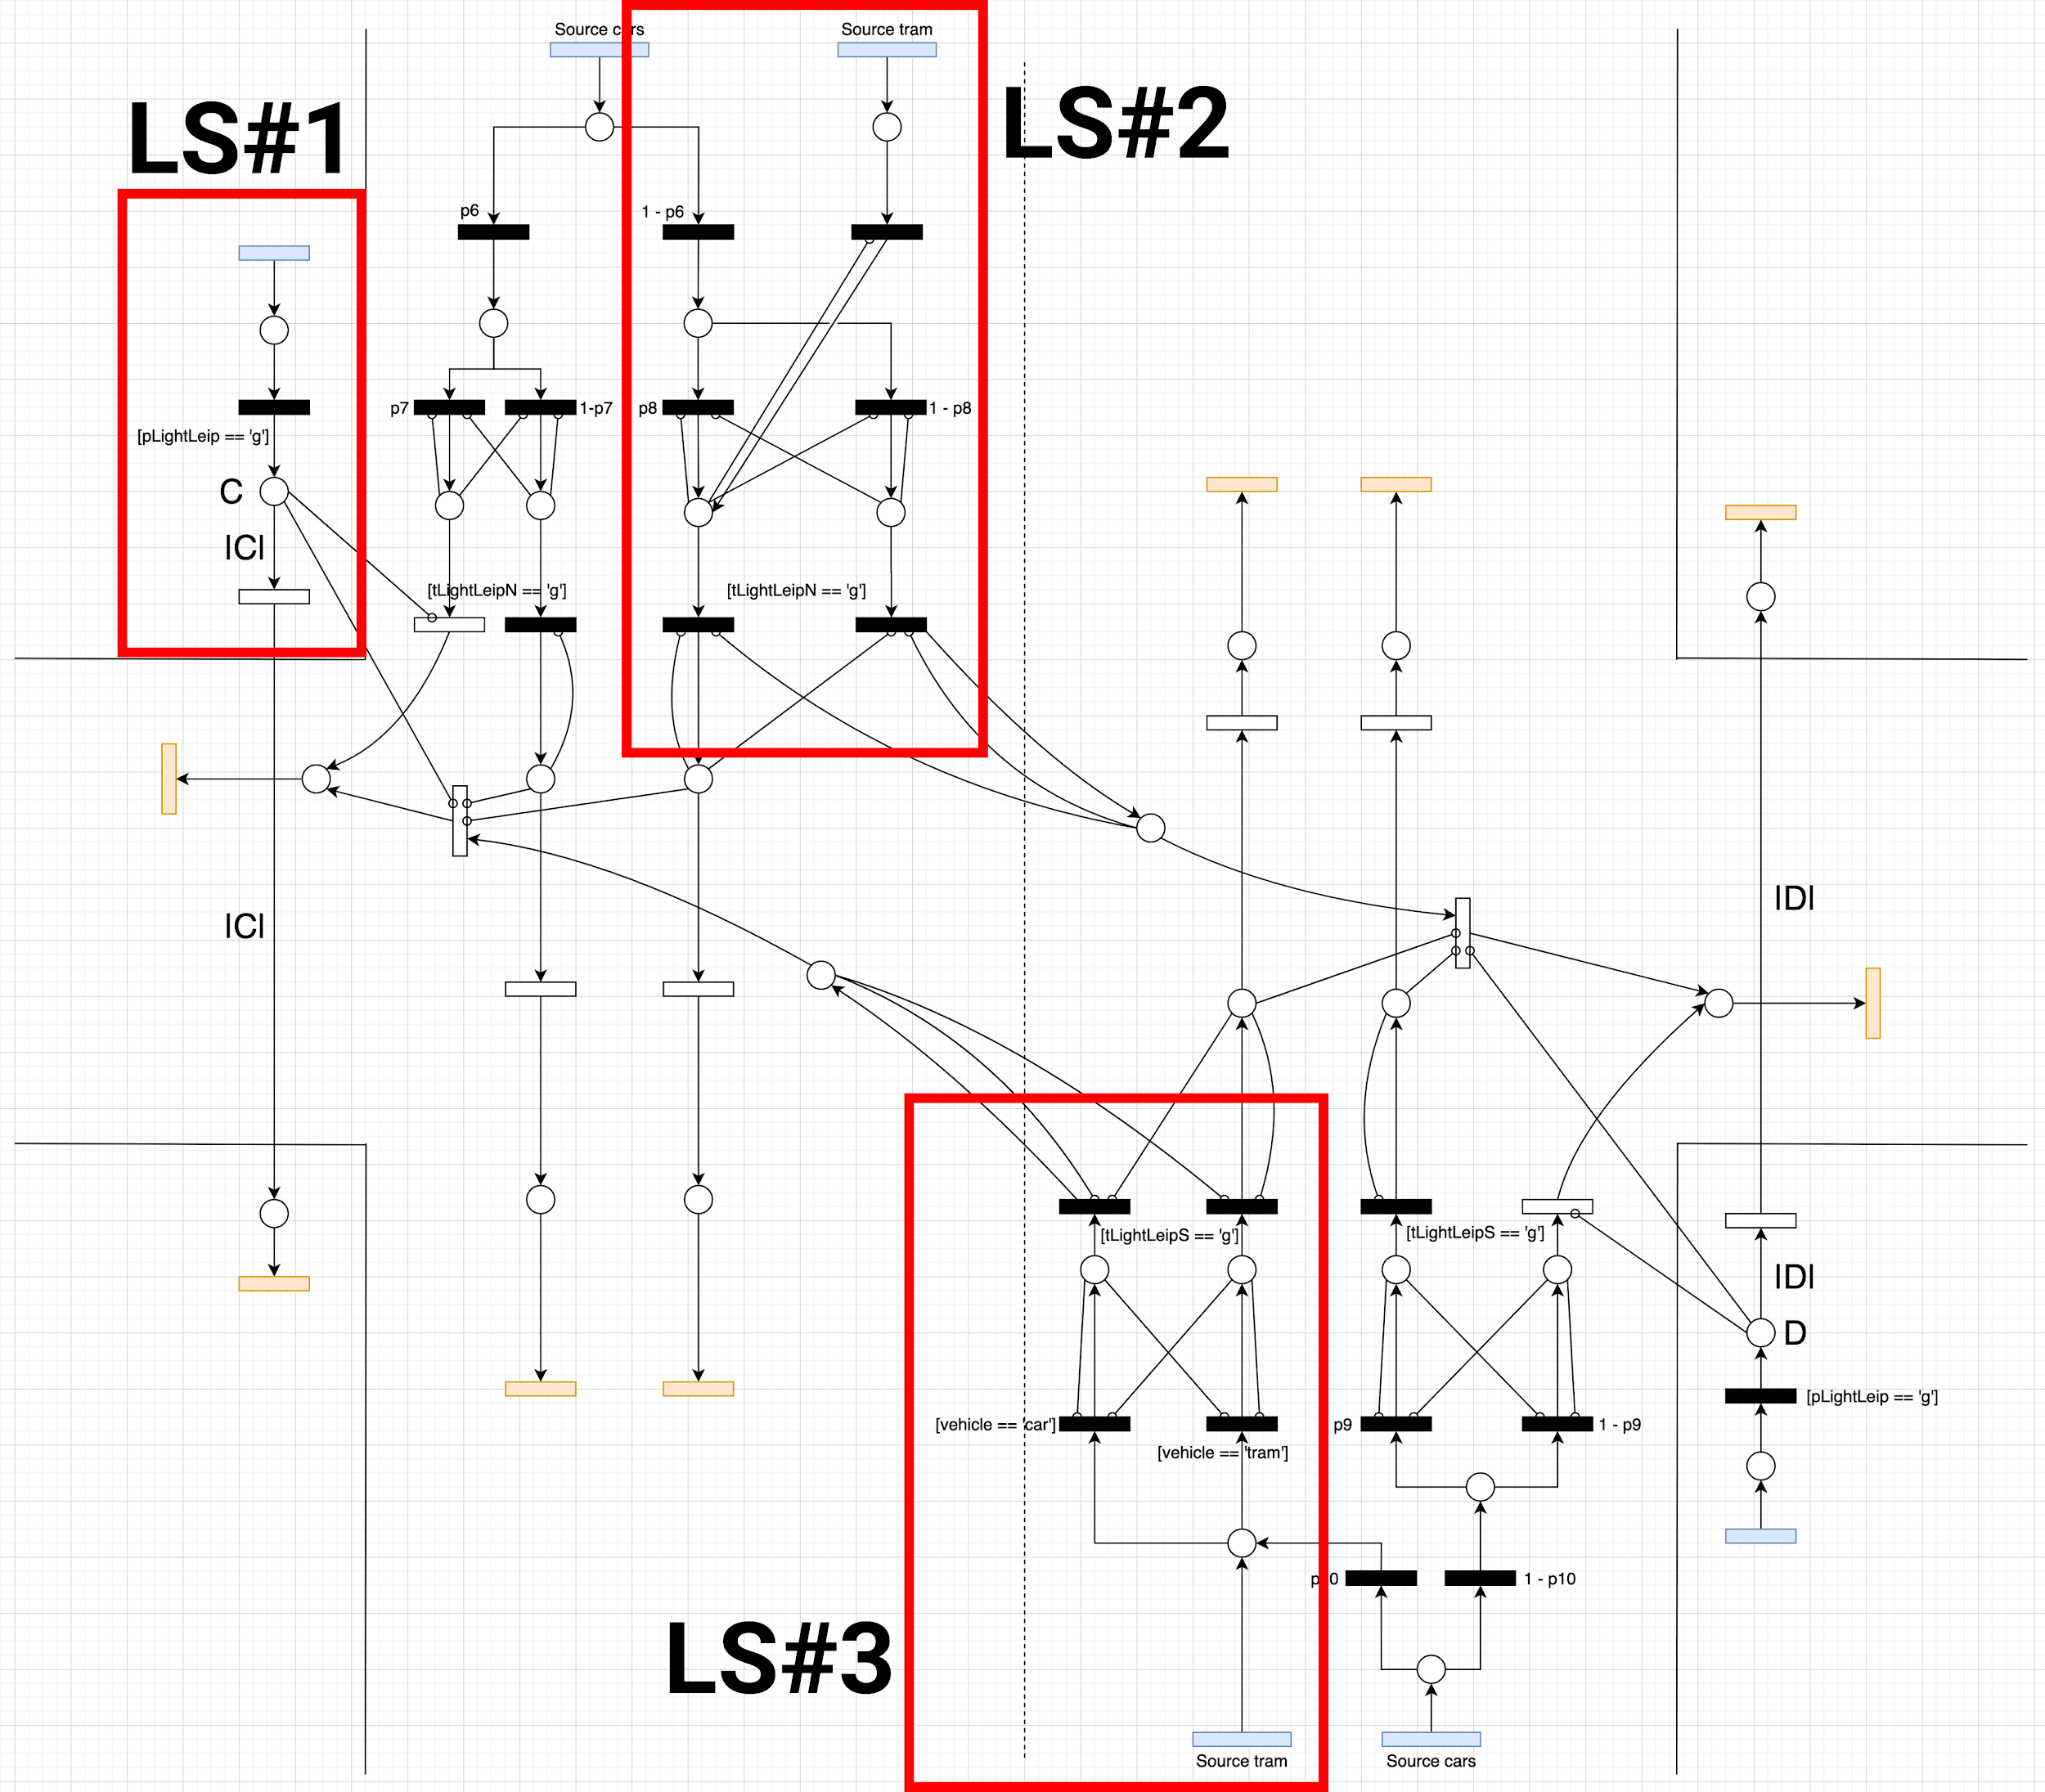

**Figure 04:** Conceptual model of Leipziger Str

In **LS#2**, we have represented the interaction between trams and cars while occupying the same lane. As it can be seen, both vehicles cannot simultaneously occupy the same lane. A limitation of this simplified representation, however, is that we do not show that trams are given preference over cars. This, however, has been implemented in the simulation program detailed in section 1.5.

Finally, **LS#3** represents the interaction between cars and trams at the south part of the Leipziger Str. A more detailed explanation here is necessary, since as we have observed, cars are not allowed to navigate on the forward tram lane in Leipziger Str. north. Therefore, we have devised a mechanism to differentiate vehicles by their type, so that we can deterministically establish that cars on the left forward lane of Leipziger Str. south invariably turn left, while trams on that same lane invariably move forward. This was necessary to represent the intersection dynamics realistically and allow for a better comparison of the model output variables in other experiments.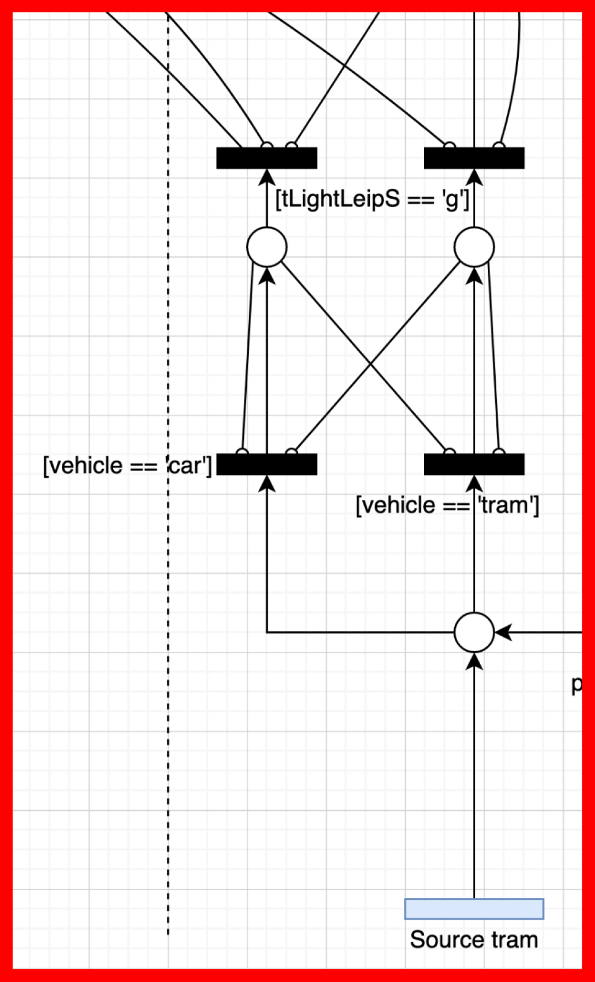

**Figure 05:** Tram and car sharing the same lane

### 1.3.3 Conceptual model of Am Fuchsberg - Erich-Weinert Str.

Finally, Figure 06 (better visualized on the horizontal direction) represents the interactions taking place at Am Fuchsberg - Erich-Weinert Str. There are no new complex constructs in this intersection, since it has a similar behavior as Leipziger Str. The **EW#1** construct represents the traffic split into the different directions in Erich-Weinert Str., and **AF#1** represents the same concept for Am Fuchsberg. As it can be seen, we have also used construct **#7** (crossed representation of a single lane) in Am Fuchsberg, since the right forward lane is used for cars both going straight and turning right. The pedestrian constructs explained in section 1.3.2 are also used here, and we have included a basic interaction for representing the side road present before the sink in Erich-Weinert Str.

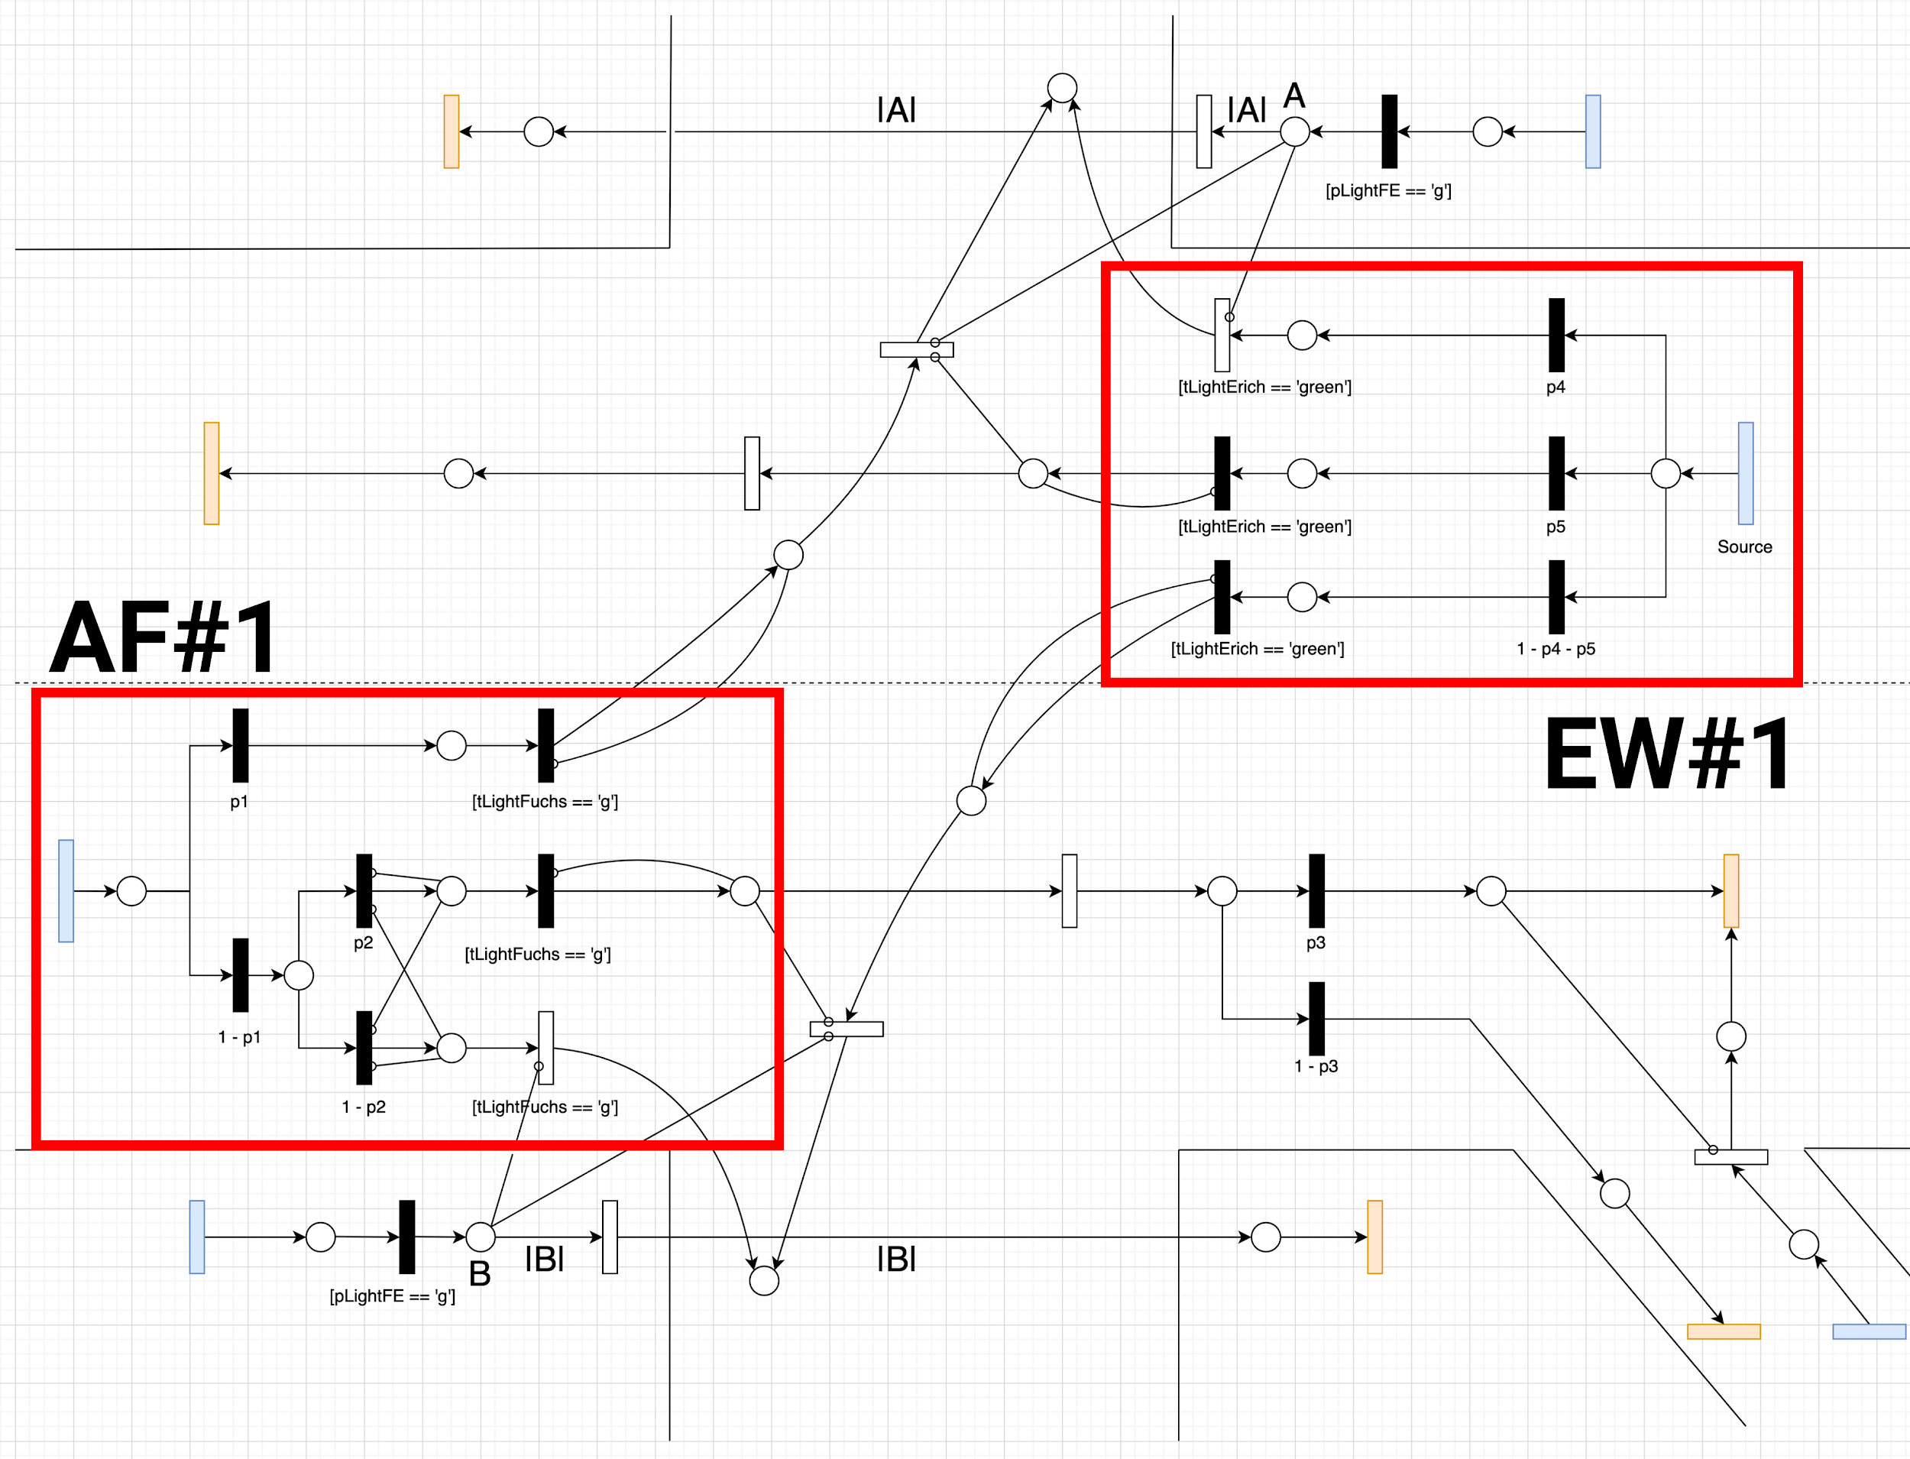

**Figure 06:** Conceptual model of Am Fuchsberg - Erich-Weinert Str.

### 1.3.4 Assumptions of the conceptual model

While the models provided above embed a high degree of complexity to represent the intersection as realistically as possible, the team has made several assumptions during the model conception. These are necessary so that we abstract details that we believe are not crucial for the understanding and later modelling of the intersection behavior.

Firstly, we have assumed that all motor vehicles are of the same type, except for trams, which are treated differently. More specifically, we have assigned a “car” label for vehicles which are not trams, and a “tram” label to trams. This allows us to fine tune the direction and behavior of these two classes of motor vehicles.

Secondly, we have assumed that all pedestrians and cyclists behave in the same way. This means that we assume they share the same pedestrian lanes, and move in the same direction at the same speed. This allows us to abstract their behavior and drastically simplify implementation without losing generalizability power.

Thirdly, we have built in the model the assumption that pedestrians move in only one direction. This does not hurt the model generalizability, since cars are not allowed to move as long as there is a pedestrian crossing (the direction from which the pedestrian is coming does not play an important role in this mechanics). We have then modelled individual sources for each road, so that we have pedestrians crossing in every part of the intersection.

Fourthly, we assume that there are no major changes in the behavior of cars and pedestrians between different years. This is a crucial assumption of our model, since we have worked with data from the previous year, as well as with Magdeburg data from different years. Additionally, due to the pandemic situation which took place in 2020, we have decided that any new data collection in this period would not be representative of the normal behavior of the node. Therefore, we have limited the scope of our data to the data from previous years. A more detailed discussion of the limitations of this approach is provided in section 1.4.

Fifthly, we assume that trams are given higher precedence when there is a conflict between a tram and a car in a specific lane. While this is not directly represented in the conceptual models discussed above, this behavior has been incorporated in our simulation program.

### 1.3.5 Experiments and quantities measured

A third major aspect of this milestone was revisiting the experiments defined during the first milestone now that the team had collected more information about the node dynamics and the possibility towards more realistic experiments.

We have defined six experiments to be run later during the execution of the project. The scope of the first experiment was to vary traffic light duration to seek for the optimal combination of traffic phases in terms of throughput. The second experiment focused on opening traffic lights for each direction in different phases to check whether different phases provide safety improvements. In the third experiment we proposed the construction of a free lane for cars to turn right from Leipziger Str. south into Erich-Weinert Str., in order to relieve the traffic in the south part of Leipziger Str. The fourth experiment focused on allowing car traffic on the blocked tram line in Leipziger Str., which also had the goal of relieving traffic on the south part of the street and in the north sink. The fifth experiment aimed at overloading the system to verify the behavior of the traffic and ensure that the system is behaving correctly despite being overloaded. Finally, in the sixth experiment we targeted the construction of a bridge for cars going straight in the Erich-Weinert Str. / Am Fuchsberg directions so that cars do not enter the intersection directly and relieve the load on the intersection.

Finally, we have precisely defined which input and output variables we should observe during the execution of the models. Table 11 provides a detailed overview of both groups.

| **Category** | **Detailed measurements** |
| --- | --- |
| **Input measurement variables** | 1. Interarrival times of cars; 2. Number of cars going in each direction; 3. Traffic light duration; 4. Tram timings, tram and cars alternation; 5. Interarrival times of pedestrians and cyclists; 6. Time to cross the street |
| **Output / simulation result measurement variables** | 1. Average cars between source and sink 2. Queue Lengths for each lane 3. Average time the car takes to travel from source and sink 4. Amount of cars passing through a transition |

**Table 11:** Overview of input and output variables

## 1.4 Data analysis

This section discusses the specifics of the data analysis milestone. First we discuss the input data used and the output values calculated. We then move to highlighting the difficulties encountered during the data analysis phase, as well as the limitations of the analysis and why they do not pose major limitations to the validity of the simulation model. Finally, we highlight the findings of additional analyses related to traffic phases, pedestrian interarrival times, and turning probabilities.

It is important to highlight that this milestone has proved to be one of the most challenging aspects of the project execution due to the fact that we worked with data measured by other teams. A direct consequence of this was the limited insight we had into the specific procedures for data collection. We have opted to proceed with the assumption that the collected data was reliable and representative of the node behavior, and have carried the statistical analysis to the best of our technical skills.

### 1.4.1 Input data and statistical analysis

As input data for the analysis of vehicle behavior, we have used interarrival times for estimating the theoretical distribution density functions. This applies to all vehicles except trams, for which we have used the available timetables and have introduced some degree of uncertainty through a truncated normal distribution for delays. Finally, we have used the data from the City of Magdeburg to estimate the pedestrian interarrival times.

Before discussing the analysis results, it is crucial to precisely define the steps we have taken during the analysis. We have opted for a considerably robust data analysis focused on numeric analysis rather than visual guessing of distributions. In other words, we have used statistical programming libraries to test for a variety of candidate distributions and find the one that provides the best for the input data. The process steps are as follows:

1. Plot the data histogram to form a visual intuition of which theoretical distributions may be suitable to the data.
2. Create a script to iterate over all the suitable theoretical distributions:
   1. Fit the distribution candidates based on the raw data;
   2. Generate theoretical values based on the distribution’s Probability Density Function (PDF) and Cumulative Density Function (CDF), as well as the data quantiles;
   3. Compare the mean squared errors for each candidate;
   4. Select the candidate that provides the lowest mean square value.
3. Fit the selected distribution once again to the raw data.
4. Perform a goodness-of-fit test through the Chi-Square test and Q-Q plots.

The table below presents a summary of the theoretical distribution parameters that we have established through the above analysis.

| **Vehicle type** | **Source** | **Distribution shape** | **Parameters (in terms of the underlying normal distribution)** |
| --- | --- | --- | --- |
| **Car** | **Am Fuchsberg** | Lognormal | Mean: 1.267 seconds  Standard deviation: 0.593 seconds |
| **Car** | **Erich-Weinert Str.** | Lognormal | Mean: 1.161 seconds  Standard deviation: 0.533 seconds |
| **Car** | **Leipziger Str. north** | Lognormal | Mean: 1.511 seconds  Standard deviation: 1.112 seconds |
| **Car** | **Leipziger Str. south** | Lognormal | Mean: 1.18 seconds  Standard deviation: 1.25 seconds |
| **Tram** | **Leipziger Str. north and south** | Truncated normal | Mean: 10 minutes  Standard deviation: 2 minutes  Min value: 8 minutes  Max value: 10 minutes |

**Table 12:** Summary of vehicle analysis results

### 1.4.2 Considerations regarding the limitations of statistical analysis

While statistical analysis allows us to estimate theoretical distributions with well-defined parameters and known behavior, it rarely provides a perfect match between real data and theoretical estimations. This is not an unexpected result, since real-world phenomena are directed by many unknown events and rarely follow a well-behaved theoretical distribution for the events of interest (in our case, the interarrival times of vehicles).

Below we provide a visual inspection of our analysis results for Am Fuchsberg and Erich-Weinert Str. We aim at discussing a few common elements and limitations of fitting a theoretical distribution to real-world data. These elements have also been present in the distributions of Leipziger Str. north and south sections.

One major aspect that deserves attention is the strong concentration of low interarrival times for all the streets. This skewes the distribution towards lower values, leading to an underestimation of higher interarrival times.

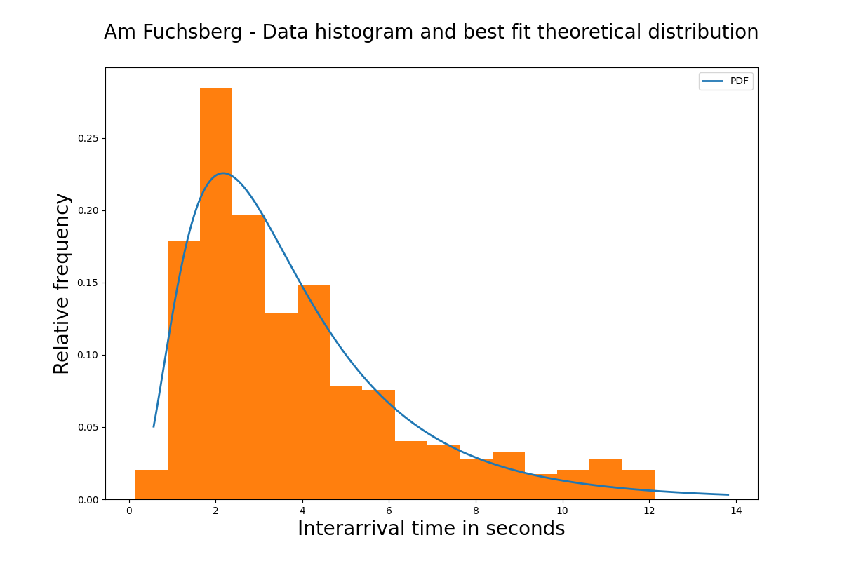

**Figure 07:** Histogram and theoretical distribution (blue line) for Am Fuchsberg

This can clearly be seen in Figures 07 and 09. As it can be seen, the blue line representing the best-fit theoretical distributions decrease at a higher rate than the orange bars representing the collected data. This can also be seen in Figures 08 and 10. Q-Q plots aim at comparing the quantiles of real-world data and theoretical distributions. An ideal Q-Q plot has all the points lying on a 45-degree line passing through the origin of the coordinate system. Our charts show that the best-fit theoretical distribution succeeds in providing realistic values for lower interarrival times, but underestimates the probability of producing higher interarrival times.

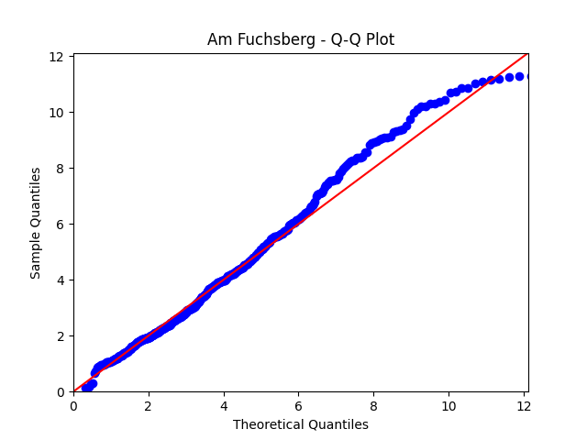

**Figure 08:** Q-Q plot for Am Fuchsberg

As already mentioned, this behavior is observed in all sources, thus skewing our system towards a more vehicle-intensive representation. The team has extensively discussed alternative courses of action to address the problem. Here the limitations of working with third-party-collected data have become evident. It was not possible to evaluate the quality of the data provided to us from the previous project teams and whether it contained deviations from reality, so we have opted to proceed with the theoretical distributions that we have estimated based on the provided information. In the worst case scenario, our model would have a higher vehicle count than in reality, however this does not pose a threat to the overall effectiveness of the recommendations proposed by the team. This happens because we have consistently used the same theoretical distributions throughout the execution of the experiments, which allowed us to use a relative approach to establishing experiment validity and statistical significance.

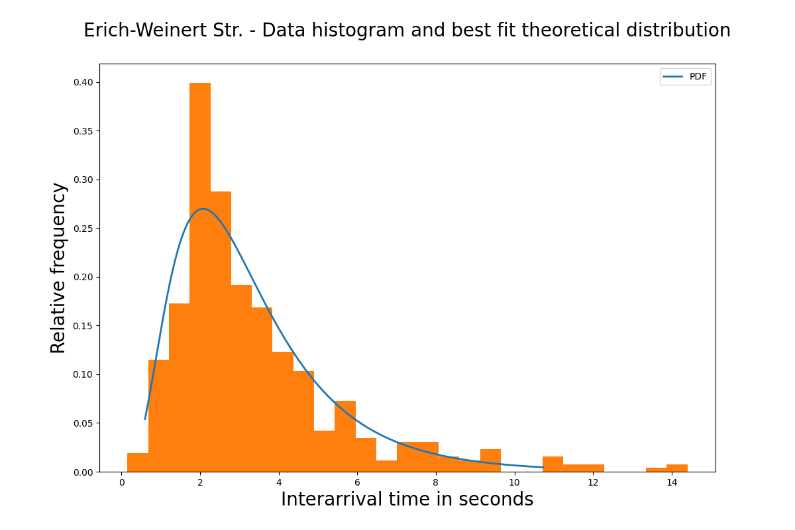

**Figure 09:** Histogram and theoretical distribution (blue line) for Erich-Weinert Str.

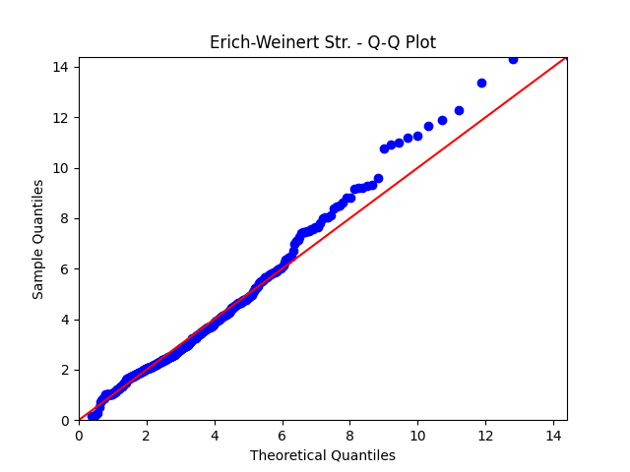

**Figure 10:** Q-Q plot for Erich-Weinert Str.

### 1.4.3 Analysis of traffic phases

The traffic phase estimation has required careful observation of the traffic signals in order to abstract the many possible phase variations into a more consistent, less complex system that still resembles reality to a high extent. Using the data provided by the City of Magdeburg, as well as in-person observation and recording, the team has agreed to proceed with the system as described in Table 13 (below).

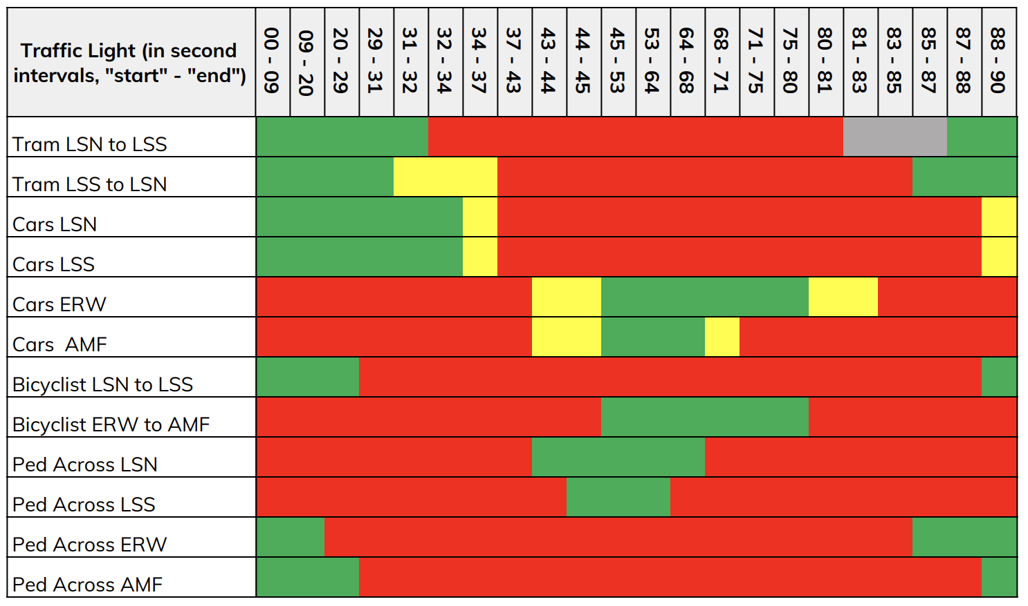

**Table 13:** Summary of traffic light phase analysis results

As it can be seen, there are several components considered here, with not all the traffic phases of vehicles moving in the same direction being fully synchronized. The full cycle was built by considering the data from the City of Magdeburg, as well as actual observations done in the node during the same time periods of the data we were working with throughout the project. The cycle has a duration of 90 seconds, and since the duration of the traffic phases was not exactly the same for opposite roads, we have used individual traffic lights for each road, pedestrian, and tram navigating the system.

### 1.4.4 Analysis of pedestrian interarrival times

Pedestrian interarrival times were also a challenge for the theoretical distributions. In fact, the data provided from the previous project team had no information whatsoever regarding the pedestrian interarrival times. In addition to this, we were not able to collect reliable data to estimate pedestrian distributions due to the fact that pedestrian traffic was considerably reduced by the social distancing and isolation rules put in place to combat the COVID-19 pandemic.

We have extensively discussed how to proceed here, and, before highlight our decisions, it is important to highlight the role of the team’s assumptions that (1) pedestrians move roughly simultaneously, and (2) all pedestrians move with the same speed (we have taken the lower speed of walking pedestrians rather than the higher speed of cyclists). These two assumptions led us to conclude that it is safe to assume a uniform interarrival distribution of pedestrians. There is little change in the model behavior if there are five or twenty pedestrians waiting to cross the street, since all of them will start crossing once the pedestrian traffic light opens. Additionally, our assumption of uniform interarrival times also allows for pedestrians to enter the intersection while the pedestrian traffic light is open, simulating real-life scenarios in which cars in movement must stop for new pedestrians to cross.

Considering all these aspects, we have worked with data provided by the City of Magdeburg and have calculated the maximum and minimum cumulative counts of pedestrians within the hour considered for the analysis (between 16h and 17h). Table 14 summarizes our estimations.

| **Pedestrian origin** | **Pedestrian target** | **Lower interval bound (in seconds)** | **Upper interval bound (in seconds)** |
| --- | --- | --- | --- |
| Leipziger Str. south | Leipziger Str. north | 9.92 | 26.28 |
| Leipziger Str. north | Leipziger Str. south | 12.41 | 27.91 |
| Am Fuchsberg | Erich-Weinert Str. | 9.16 | 19.36 |
| Erich-Weinert Str. | Am Fuchsberg | 9.32 | 33.96 |

**Table 14:** Summary of pedestrian analysis results

### 1.4.5 Analysis of turning probabilities

Based on the aggregate data provided by the City of Magdeburg, we have estimated a constant turning probability for cars throughout the time period considered for our simulation. Table 15 summarizes our estimations.

| **Vehicle origin** | **Vehicle target** | **Probability** |
| --- | --- | --- |
| Leipziger Str. south | Left: Am Fuchsberg | 0.49 |
| Right: Erich-Weinert Str. | 0.15 |
| Straight: Leipziger Str. north | 0.36 |
| Leipziger Str. north | Left: Erich-Weinert Str. | 0.16 |
| Right: Am Fuchsberg | 0.21 |
| Straight: Leipziger Str. south | 0.63 |
| Am Fuchsberg | Left: Leipziger Str. north | 0.23 |
| Right: Leipziger Str. south | 0.05 |
| Straight: Erich-Weinert Str. | 0.72 |
| Erich-Weinert Str. | Left: Leipziger Str. south | 0.27 |
| Right: Leipziger Str. north | 0.04 |
| Straight: Am Fuchsberg | 0.69 |

**Table 15:** Summary of turning probability analysis results

In conclusion, as to compensate for the many challenges and uncertainties faced during the data analysis phase, we have put extra effort into ensuring that the exact same data is used for all the validation simulations and model experiments. As already mentioned, this allows us to compare the results from a relative perspective, and to extrapolate the results obtained by the team to the real world scenario.

## 1.5 Simulation program

The scope of the fifth milestone was to devise a robust, realistic, and scalable simulation program for further use in performing the experiments and providing meaningful recommendations to the City of Magdeburg. This section will explore the overall simulation program and its structure, its modularization features, the main differences between the program and the conceptual model, the steps towards the program verification, and the difficulties encountered while implementing the simulation program.

### 1.5.1 Program concept and structure

We have used AnyLogic[2] and its Road Traffic Library artifacts as the simulation software to model the intersection. The simulation program was designed with two main objectives in mind:

1. **Correctly represent traffic flow restrictions regarding lanes and turnings**. For example, cars on the left lane in the south of Leipziger str. should invariably turn left due to the prohibition of cars on the opposite tram lane.
2. **Avoid collisions between cars and between cars and pedestrians**. While AnyLogic provides some functionality around collision detection, we have soon learned that it was not enough to avoid all collisions. We had to implement additional constructs in order to address these issues.

The program is built around a single Road Network Descriptor, which is used to dictate the common behaviors of the agents within the models. One major difference to traditional models is the usage of individual roads to represent the lanes rather than the usage of single roads with multiple lanes. This was necessary due to the fact that the underlying AnyLogic traffic library does not allow to fine tune the car movement between lanes, only between roads. As discussed in section 1.3, restricting the movement of cars due to the presence of tram lanes was crucial for implementing a realistic model. Therefore, the team decided to increase the complexity of the simulation program by using individual roads and further tailoring the behavior of the system to represent the interactions observed in real life.

As already stated, one of our assumptions is that all vehicles are of the same type, except for trams. Therefore, we have used one single vehicle type to represent cars and trucks, and another type to represent trams. Additionally, a third type of agent was used to represent pedestrians. Both the vehicles and trams inherit from a base agent which holds parameters that allow us to define specific behaviors based on the current agent’s state. This has allowed us to, for example, measure car stops only when cars are within the main intersection, thus allowing us to have a reliable proxy to measure safety in the system. In addition to using agents to represent cars, trams, and pedestrians, we have added several control structures to address some of the challenges encountered while modeling the interaction between vehicles and between vehicles and pedestrians. Figure 11 shows an overview of the main constructs used.

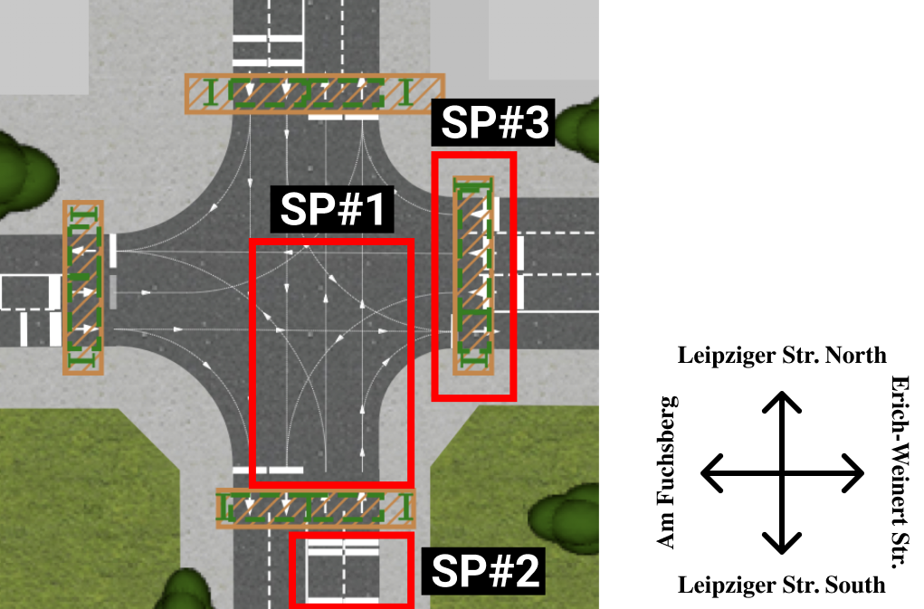

**Figure 11:** Main control structures in the simulation program

**SP#1** shows how we have assigned specific directions within the main intersections to each of the individual roads. As it can be seen, agents populating the left forward lane of Leipziger Str. south can only move forward or turn left. An additional restriction is that only trams are allowed to move forward, while cars must inevitably turn left. We have implemented decision mechanisms in our system to segregate cars from trams based on parameter values and enforce the correct assignment of directions for each of the agents.

**SP#2** shows how we have used stop lines to prevent cars from exerting unwanted behaviors such as colliding with pedestrians or not stopping on time before reaching the intersection.

**SP#3** demonstrates constructs employed to model pedestrian behavior. They serve multiple purposes. The first and most important purpose is to identify that pedestrians are crossing the street and consequently to stop the cars from simultaneously entering the road and colliding with pedestrians. The second purpose of the construct is to limit pedestrian behavior within its range. This prevents pedestrians from spreading across the system and interfering with subsystems.

### 1.5.2 Modularization or other special issues

On the modularization topic, we have adopted several techniques to ensure that the simulation program is not only easily maintainable but also scalable and easily modifiable. The two latter characteristics are highly desirable since they drastically facilitate the implementation of multiple experiments.

Two main characteristics define the modularization of our system. Firstly, we have used parameters and variables for every numerical information in the system, thus avoiding hard-coding information. We have then referenced such variables within the necessary contexts, and have been able to successfully adjust them to perform several relevant experiments. Secondly, we have used a hierarchical agent structure, with an abstract agent representing all vehicles and two subclasses representing trams and non-tram vehicles. As a consequence, we were able to quickly add and customize vehicle-specific parameters that were later used to refine agent behavior.

### 1.5.3 Differences to the conceptual model

Due to AnyLogic’s underlying mechanics of collision detection, acceleration, and deceleration of vehicles, it was possible to abstract several constructs from our conceptual model.

First and foremost, there was no need to implement the crossed single lane construct (section 1.3, **#7**), since AnyLogic automatically handles cars populating the same lanes. We were also able to abstract all the timed transitions, which are now automatically handled through the configuration of acceleration and deceleration rates. On the same lines, the intermediary places used to represent cars within the main intersection and block vehicles turning left from the opposite direction (for more details, see the construct **#8** in section 1.3) are not needed anymore. AnyLogic’s underlying collision detection functionality automatically prevents cars from turning left if the opposite traffic is flowing.

### 1.5.4 Steps taken to verify the program

Verification involves ensuring that the model behaves according to the specified design requirements[3]. In order to test the behavior of the model, we have used several techniques that are related to verifying both the absence of programming bugs and the correctness of the model behavior (for example, absence of vehicle collisions, correctness of vehicle direction, among other indicators).

Firstly, we have run the model multiple times with varying parameters to ensure that no exception was thrown during its execution. This was strongly verified due to the fact that each validation run entailed one hundred replications, resulting in several thousand executions of the underlying simulation program.

Secondly, we have performed a detailed visual verification of collisions between vehicles and between vehicles and pedestrians, ensuring that such events were not present in our system. While visual verification has helped us to refine the vehicle behavior parameters, influencing AnyLogic’s underlying collision detection library has proven itself a considerable challenge. In order to address that, we have used the constructs explained in section 1.5.1.

Finally, we have performed a careful analysis and testing of the Java code of our program and ensured that it was not only syntactically correct but also semantically precise. We have revised and confirmed that all the calculations and logical statements were performing their expected tasks and providing the expected numerical results.

### 1.5.5 Difficulties encountered

We have already mentioned particularly challenging aspects of the model such as collision detection and pedestrian modelling. One important difficulty, however, was not yet mentioned and refers to the validation of the model. Due to the lack of output data, as well as the atypical traffic situation due to the COVID-19 pandemic, model validation is not fully possible. We have considered mainly face validation and ensuring that the model works as expected: cars on a given lane are able to stop on time, initial speed is within reasonable limits, cars do not drive over pedestrians, cars respect the lane restrictions regarding directions, among other conditions.

## 1.6 Validation and quality control

The scope of the validation and quality control related to analyzing the output of the model for several quality-related criteria. Validation itself seeks to analyze whether the model correctly reflects the behavior of the real-world system. Due to the unique circumstances in the social interaction realm due to the COVID-19 pandemics (for more details, see section 5), it was not possible to directly validate the system. The team identified two alternative ways of validating the system: using output data from the previous team and using output data from the city of Magdeburg. None of these options, however, proved to be implementable. The problem related to the first approach is straightforward: there was no output data available in the datasets provided by the previous year’s team. The issue with the second approach is slightly more complex. If we had decided to move forward and compare our system’s output against the data provided by the City of Magdeburg, we could leap to false conclusions. This is because the data was collected in different years and during different times of the day. Therefore, any validation conclusions put forward here would be misleading.

Despite these challenges, the team has identified two major opportunities for validation. The first one, discussed in section 1.6.1, describes the process of face validation. The second, discussed in section 1.6.2, presents a sensitivity analysis on the parameters of the system.

Before moving forward, however, it is important to describe in detail the validation experiment setup, as to demonstrate its statistical validity. We have adopted a number of 100 replications for every system configuration, which provides us enough samples to draw statistically robust conclusions about the system. Additionally, we have adopted a confidence interval of 99% in order to ensure the high reliability of our conclusions.

### 1.6.1 Face validation

Face validation involves questioning whether the system built matches the specific configuration of the node under consideration, whether there are no clear mistakes on the program structure, whether the input variables are within reasonable values, and whether the system behaves in a predictable manner when run multiple with the same input parameters.

While these tests are mostly subjective or implemented through apparently self-validating experiments, they serve as a first sanity check for model correctness.

One experiment that we have performed was to verify that the number of cars generated on the main system matches the number of cars generated on a vanilla system without complex structures such as traffic lights. This is important to ensure that no advanced structure in our system is affecting the number of cars being generated at the sources. In order to test for that, we have performed a difference CI experiment between the full model and a simpler one with only one road connecting each source to its respective sink (in other words, without complex elements such as traffic lights, pedestrians or intersections).

Before we discuss the results, it is important to highlight that we soon became aware that the expected amounts of generated cars for the Am Fuchsberg and Erich-Weinert Str. sources were unrealistically high. Although the data analysis was performed to the best of our ability and we were able to find the best fit distributions to the data provided to us, the final expected number of cars generated simply appeared to be too high. This was confirmed when compared with the data from the City of Magdeburg. We have decided, nonetheless, to proceed with the high estimates, and the reasoning goes in the direction that a more crowded system tends to pose more challenges than a less crowded system. Therefore, if we manage to simulate and improve a more crowded system, the improvements are likely to be reflected in the less crowded conditions. Naturally, this raises the need for further validation of the results under different input theoretical distributions, which can be easily done by varying the input parameters of the system.

Figure 12 presents the results of the car generation for roadwise comparison. As it can be seen, Leipziger Str. is generated cars as expected in both directions (zero lies within the confidence interval for both the north and the south sources). Am Fuchsberg and Erich-Weinert Str., however, are falling short of the number of expected vehicles generated on the system. As already mentioned, we expected this result due to the fact that AnyLogic stops generating cars once the target road is full. In order to address the problem, we have extended the incoming roads for several kilometers, and this has allowed us to somewhat increase the incoming number of cars on these streets. Finally, we have settled for a balance between road length and number of cars generated, so as to have a more realistic simulation program that does not contain extremely lengthy roads.

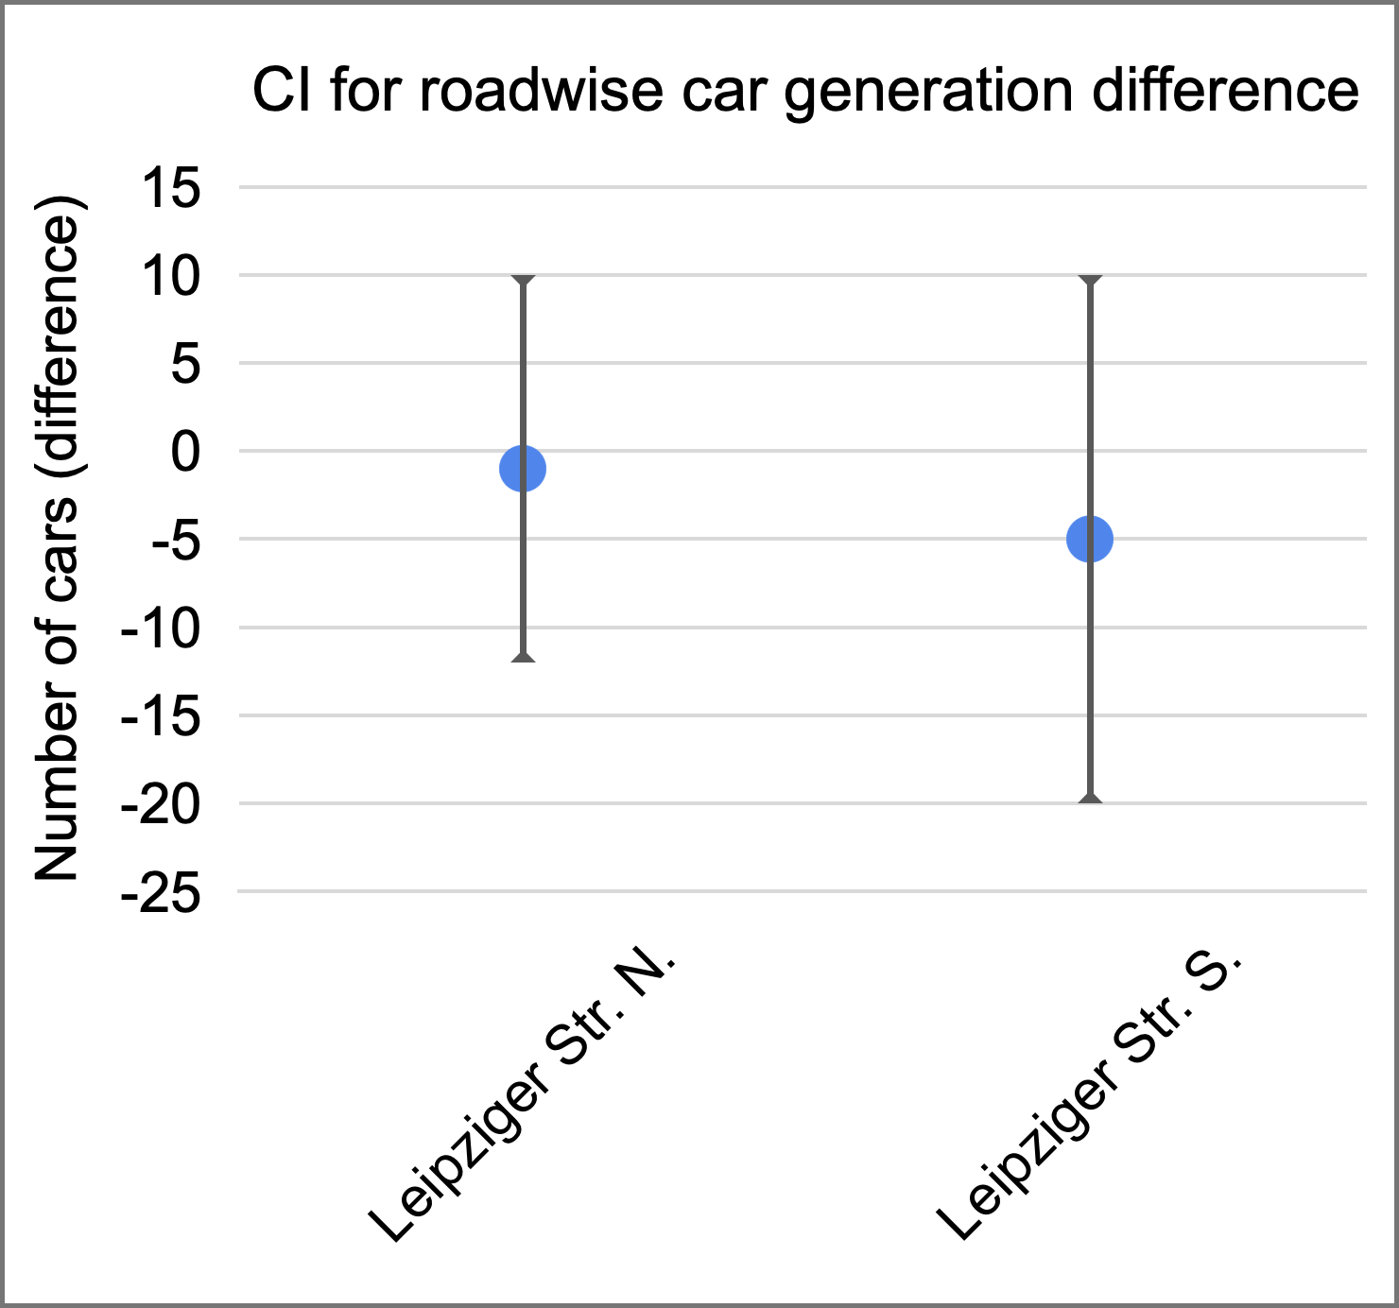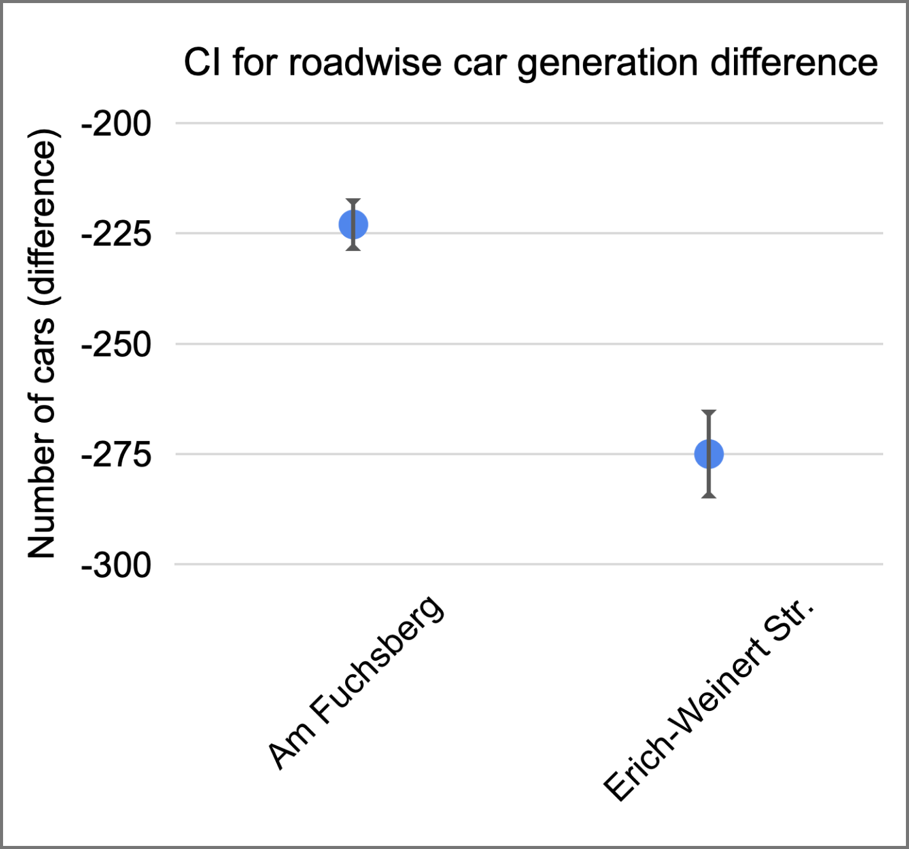

**Figure 12:** Results of car generation experiments

### 1.6.2 Sensitivity analysis

Next, we have performed a sensitivity analysis experiment on the input parameters in order to verify that the model does not behave unexpectedly for varying input values. We have varied both the mean and the standard deviation of all car generation theoretical distributions, and have observed that the findings are very similar to all the roads. Therefore, we focus our discussion on the variation of one input parameter, namely the mean of the theoretical distribution for car generation on Erich-Weinert Str. Figure 13 shows the average throughput of each road for different values of the varying mean. Figure 14 shows the changes in percentage terms.

The images reveal several interesting traits of the model. First and foremost, we highlight the fact that, for very small interarrival means, the throughput barely varies. This is because the incoming roads of the system are full, and AnyLogic stops generating cars once the roads do not have additional space. We can conclude from this experiment that the threshold for Erich-Weinert Str. to not be fully congested is an interarrival mean of around 2 seconds.

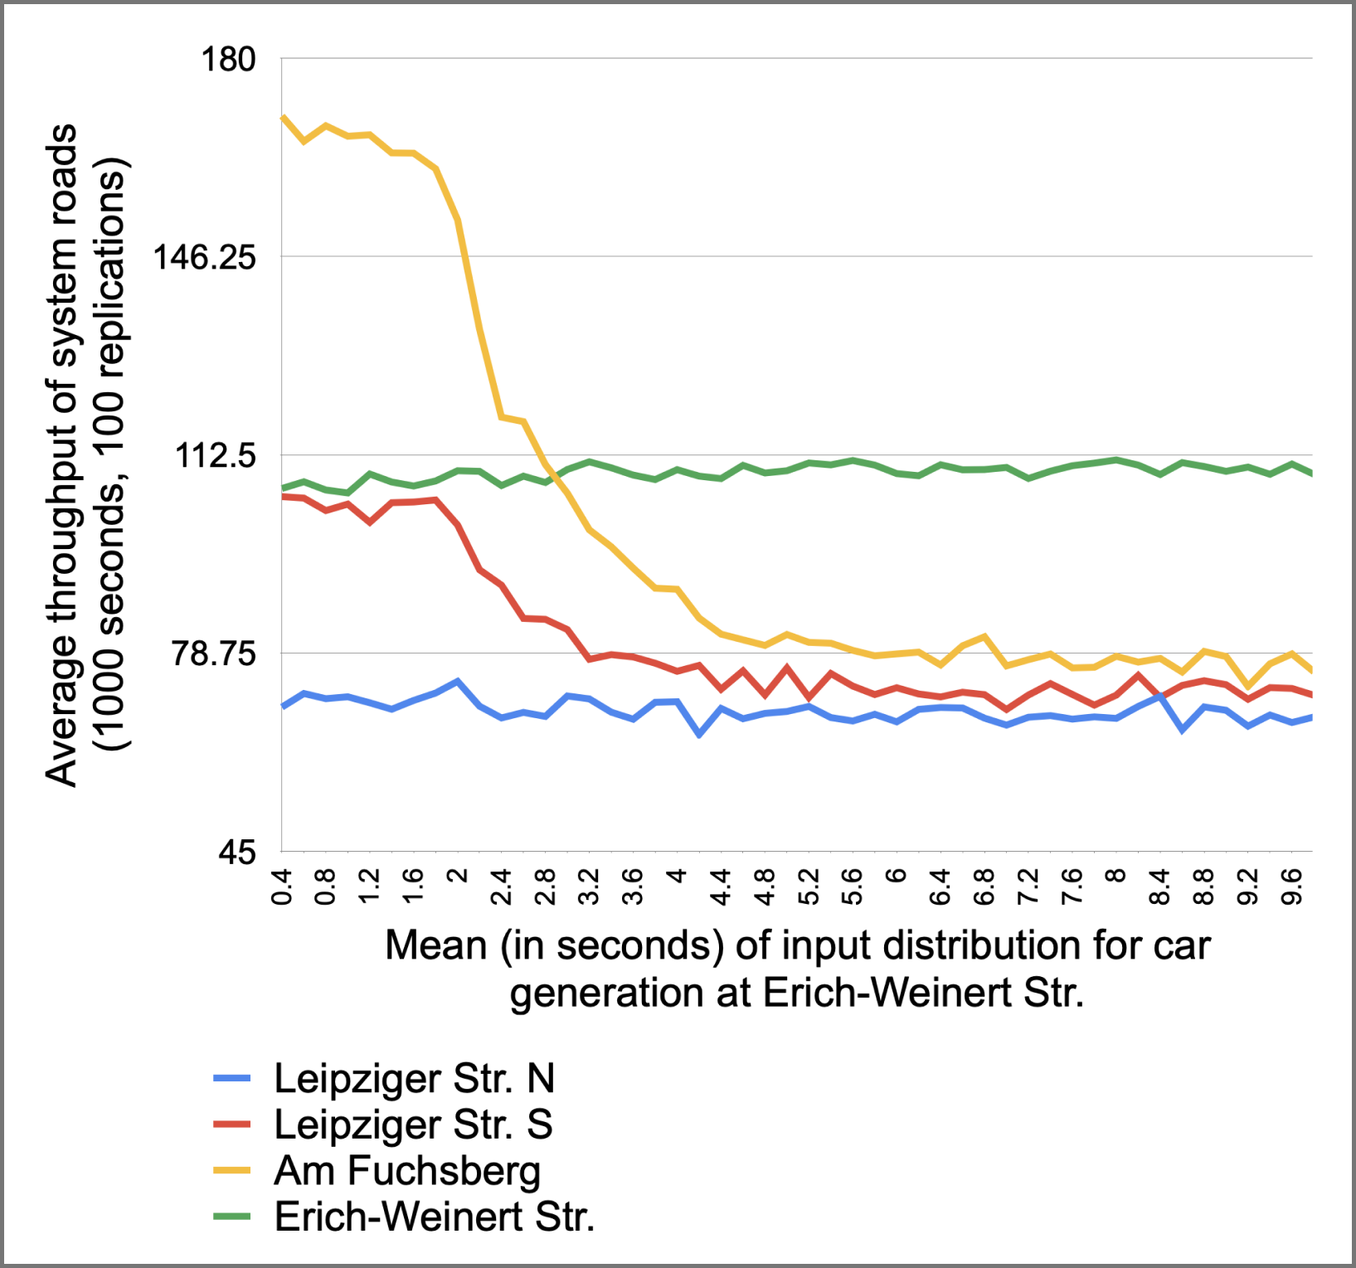

**Figure 13:** Change in throughput with varying input mean for Erich-Weinert Str.

Another interesting conclusion that can be drawn from this experiment is the expected decrease of throughput for roads according to the turning probabilities for incoming cars from Erich-Weinert Str. Since most cars move straight, the throughput decreases the steepest for Am Fuchsberg, with the second highest decrease happening in Leipziger Str. south. The throughput of Leipziger Str. north barely changes due to the fact that the probability of turning right is very low for cars coming from Erich-Weinert Str. Finally, the throughput of Erich-Weinert Str. increases slightly due to the fact that less cars originating from that street are turning left within the main intersection and preventing cars coming straight from Am Fuchsberg from directly moving straight.

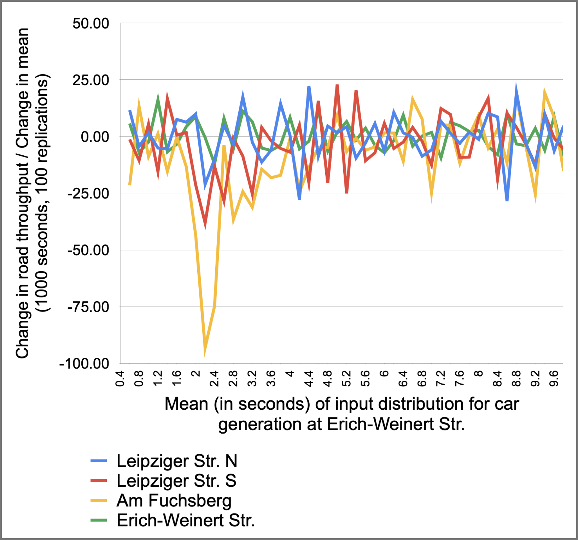

**Figure 14:** Relative change in throughput

A third conclusion can be drawn from Figure 14. Most relative changes are consistently around zero. In fact, more than 80% of the changes lie between -25 and 25. Special attention should be drawn to the range between 1.6 and 3.2 for the mean in seconds, which shows the steepest decline in the throughput. While the decline is relatively steep, it presents no signs of unexpected behavior.

The sensitivity analysis experiment described above was performed for all the parameters of the car generation theoretical distributions, and the results were very similar in shape. Thus, we conclude that, despite not being able to verify the validity of the output data against data from the real system, we were able to build a very robust model that performs as expected for a wide range of input parameters.

## 1.7 Experiments

The second to last milestone of the project has the goal of finding answers to two critical questions. Firstly, how can we improve the safety of the node under consideration? Secondly, how can we improve the traffic conditions of the same node? In order to answer these questions, we devised several quantitative measures that are used to evaluate both safety and traffic condition dimensions. This section starts by providing a detailed account of these variables of interest. We then move to our statement of accuracy, where we define several aspects of our experiments in statistical terms to ensure that our results are statistically robust and not only due to random chance. In addition to the statement of accuracy, we also make claims regarding the current system and what could be improved through the experiments.

The scope of this milestone was also to perform and analyze several experiments, and due to their crucial role for the project, we will dedicate a specific section, section 3, to provide a detailed description, justification, and results of each experiment performed by the team. The results of these experiments will then form the basis for the fourth section of this report, our recommendations to the City of Magdeburg.

### 1.7.1 Variables of interest

The team has measured and compared four main variables of interest, three of which relate to traffic conditions and one of which relates to safety conditions.

The traffic-related variables of interest are the throughput of the model, the average time in model of cars, and the queue length of each road. For the throughput, we have calculated the number of cars going to the sink in an hour for each of the roads, as well as the cumulative throughput of the system. Our goal with the experiments is to bring throughput up as a way of improving traffic conditions. For the time in model, we have calculated the average time in seconds taken by a car to go from its source to its destination sink. A reduction of the time in model variable also indicates an improvement in traffic condition. Finally, for the queue length we have measured the amount of cars waiting at the signal for each lane of each road. The queue length is measured after the roads are separated into the different lanes representing different directions. Since high queue length would mean congestion in the system, our goal is to also minimize this variable.

The safety-related variable of interest is a proxy measure due to the fact that there is no efficient way of directly measuring safety in a system. Additionally, the road traffic library used for this simulation program automatically prevents the simulation of any accident in the model. Hence the team has devised an indirect measure for the variable of interest: the count of cars stopping within the main intersection. The main idea behind this measure is that, if a car is stopping inside the main intersection, it does not have a free way to move forward and it represents an obstacle for later cars sharing the same lane. The two main reasons for a car stopping within the main intersection are pedestrians crossing the target road, and flow of vehicles from the lanes in the opposite direction of the same road. As data provided by the city of Magdeburg suggests that most of the accidents are turning accidents, reducing the number of times the cars stop within the main intersection is a reliable proxy for concluding that the system is safer. Our goal, therefore, is to minimize the total number of stops within the main intersection of the system. Table 16 summarizes our variables of interest and our respective goals.

| **Variable of interest** | **Desired goal** |
| --- | --- |
| Throughput | Maximize |
| Time in model | Minimize |
| Queue length | Minimize |
| Stop count within the main intersection | Minimize |

**Table 16:** Variables of interested and respective experiment goals

### 1.7.2 Statement of accuracy

None of the results from the experiments would lead to valid inferences and recommendations if the statistical foundations are not strong. Therefore, we hereby state the considered statistical elements that ensure that our results can be trusted:

* **Replications:** We have executed 100 replications of simulation runs for all our experiments, as well as for the base model used as ground truth.
* **Randomness:** All the runs use unique seeds for input distributions, and these seeds are consistent throughout the execution of different experiments.
* **Confidence intervals:** We have used 99% confidence intervals for all the variable measurements.

### 1.7.3 Claims regarding the current system

In this subsection, we pose three claims related to the current system, as well as the numerical and statistical justification for such claims. We identify several opportunities for improvement through these claims, and the specifics of the experiments are discussed in the third section of the report.

**1.7.3.1 The current system has a low throughput**

The base system has an average throughput of 1585 cars per hour. We believe that the count is low, and our experiments will demonstrate that the number can be significantly improved. The 99% CI of the throughput measurement is from 1556 cars to 1613 cars.

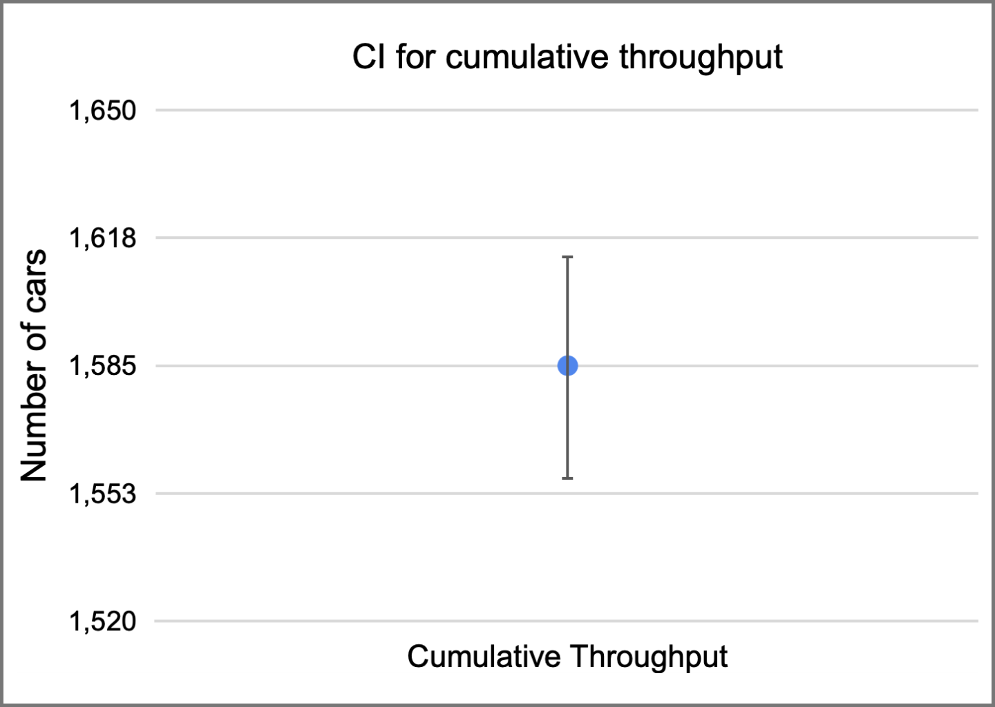

**Figure 15:** CI for the cumulative throughput of the current system

**1.7.3.2 The current system has a high average time in model**

We consider that the average time in model is considerably high, since after running 100 replications the average time in model is as high as 263 seconds, with the CI varying from 259 to 267 seconds. This is an indication that there is congestion in the system. We believe this can be improved through experiments that relieve the intersection lanes which present a high number of cars on the queues. The strength of the results here, however, is limited due to the fact that AnyLogic handles full roads in a questionable way.

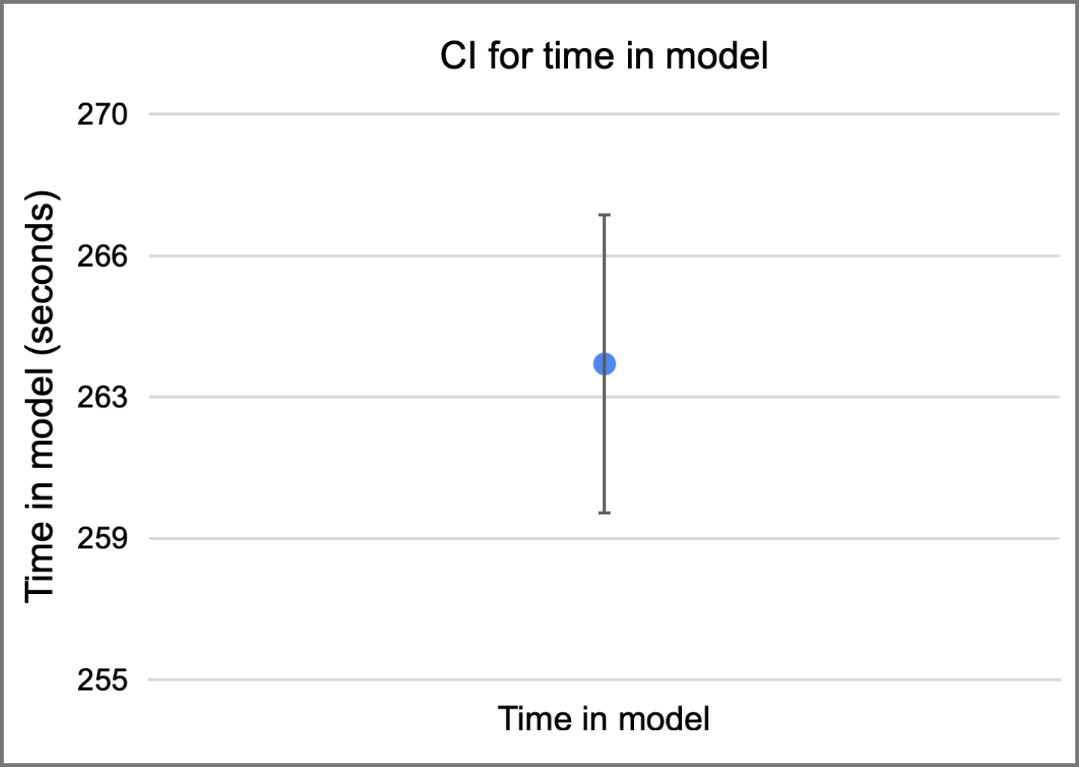

**Figure 16:** CI for the average time in model of the current system

**1.7.3.3 The current system has a low safety**

On safety grounds, we claim that the existing model is performing poorly. On average, cars are stopping a total of 704 times in an hour. As this is an indication for potential accidents, we claim that the base model is not very safe for cars turning from one road to another inside the intersections.

Table 17 summarizes the confidence intervals for the three system-related variables of interest (cumulative throughput, average time in model, and total stop count). The queue lengths will be analyzed on a per-lane basis, and more information will be provided in the third section of this report.

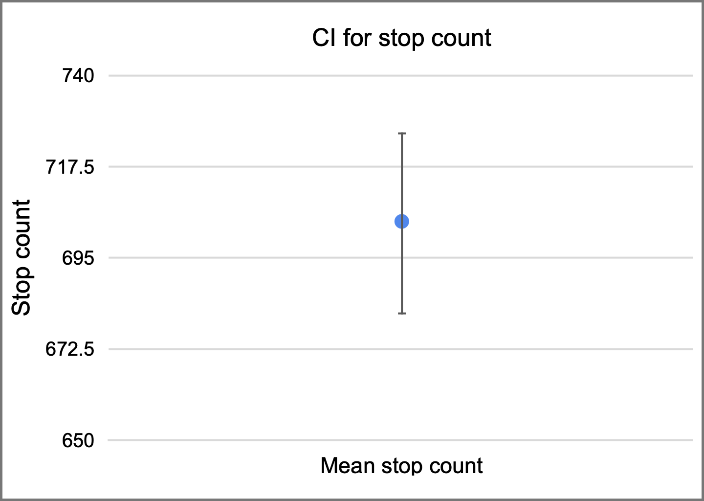

**Figure 17:** CI for the total stop count of the current system

| **Variable of interest** | **Confidence interval information** | | |
| --- | --- | --- | --- |
| **Lower bound** | **Mean** | **Upper bound** |
| Leipziger Str. south throughput | 369 cars | 375 cars | 382 cars |
| Leipziger Str. north throughput | 244 cars | 251 cars | 258 cars |
| Am Fuchsberg throughput | 568 cars | 582 cars | 597 cars |
| Erich-Weinert Str. throughput | 368 cars | 376 cars | 384 cars |
| Cumulative throughput | 1556 cars | 1585 cars | 1613 cars |
| Average time in model | 259 seconds | 263 seconds | 267 seconds |
| Stop count in the main intersection | 681 stops | 704 stops | 726 stops |

**Table 17:** Overview of measurements for variables of interest in original model

# 2. Model assumptions and decisions

Regarding the final model assumptions and decisions, we have kept several of the assumptions highlighted in milestone 3. As a brief review, the first assumption refers to all motor vehicles being of the same type (type “car”), except for trams, which are of type “tram”. The second assumption states that all pedestrians and cyclists behave in the same way. The third assumption refers to all pedestrians moving only in one direction. Finally, we assume that trams are given higher precedence when there is a conflict between a tram and a car in a specific lane.

In addition to these assumptions, we have made several additional assumptions and decisions during the simulation program and the validation milestones (sections 1.5 and 1.6 respectively). The new assumptions are as follows:

1. Traffic light phases behave predictably and have only one sequence.
2. Extend roads considerably so that AnyLogic does not stop generating cars when traffic accumulates on a specific lane.
3. Finetune the acceleration and deceleration of cars so that collisions are avoided within the system.
4. Create areas and stop lines to prevent cars from colliding with pedestrians.
5. Pedestrian interarrival time follows a uniform distribution.

It is important to mention that the assumptions made for the model do not drastically affect the model behavior, since the simplifications work towards facilitating implementation and do not eliminate key behaviors and interactions.

# 3. Experiment description, justification, and results

Sections three to five focus on the final part of this simulation project, respectively the experiments, our recommendations, as well as the limitations and trade-offs involved. This section focuses on presenting the individual motivation, description and results of each relevant experiment performed in the model.

The steps we have implemented for analyzing the effectiveness of the experiments is as follows. We first start with a comparison between the confidence intervals (CI) for the ground truth model and for the modified model for the experiment. We then identify strong variations in the CIs as indicators that the experiment has probably produced significant results. For the experiments that present expressive CI changes, we have performed additional statistical validation by calculating the CI of the difference between the ground truth measurements and the experiment model measurements. This is accomplished by calculating the difference between the final value of the variable of interest for each iteration run, followed by the computation of the CI for the difference numbers. From a statistical point of view, this allows us to conclude whether the experiment has produced actual improvements with a 99%-confidence level. For a variable of interest that we seek to minimize, for example, a statistically significant improvement is identified if the entire CI of the difference between the two models is below the zero line.

Several of the experiments have shown little change when compared to the original CIs, and the team has decided to not take the analysis of such experiments further with statistical validation. Since every experiment and subsequent changes are bound to implementation costs for the City of Magdeburg, we have decided to drop the experiments that did not provide clear improvements in any of the variables of interest. Finally, the queue length and time in model did not show significant improvements in most of the experiments. The only experiment that provided statistically significant results on these two dimensions was experiment 4 (section 3.4). Therefore we discuss queue length and time in model improvements only in this specific subsection. For the other subsections, there were no statistically significant changes.

## 3.1 Experiment 1: Open one road at a time

The scope of **experiment 1** was to vary the traffic phases by opening one road at a time in a particular phase, allowing cars to go in all directions from this road, whereas all the traffic signals from all other roads remain closed. This means that the new traffic phases would be composed of four non-overlapping green-yellow-red-yellow sequences.

The team’s goal with this experiment is to improve the safety measure by minimizing the stop count inside the intersection. We have reasoned that, if there are no cars coming from the opposite direction, there would be virtually no stops within the main intersection (except for those caused by pedestrians crossing the target destination street).

### 3.1.1 Experiment results

This experiment has produced significant improvement in terms of safety. As Figure 18 shows, the new confidence interval for the stop count inside the main intersection is drastically lower than the original confidence interval. While we should still perform additional tests to verify for statistical validity, this already indicates a strong improvement in terms of safety. The new bounds for the stop count confidence interval are 23 and 29, with a mean of 26 stops, while the original confidence interval had bounds of 681 and 726, with a mean of 704 stops.

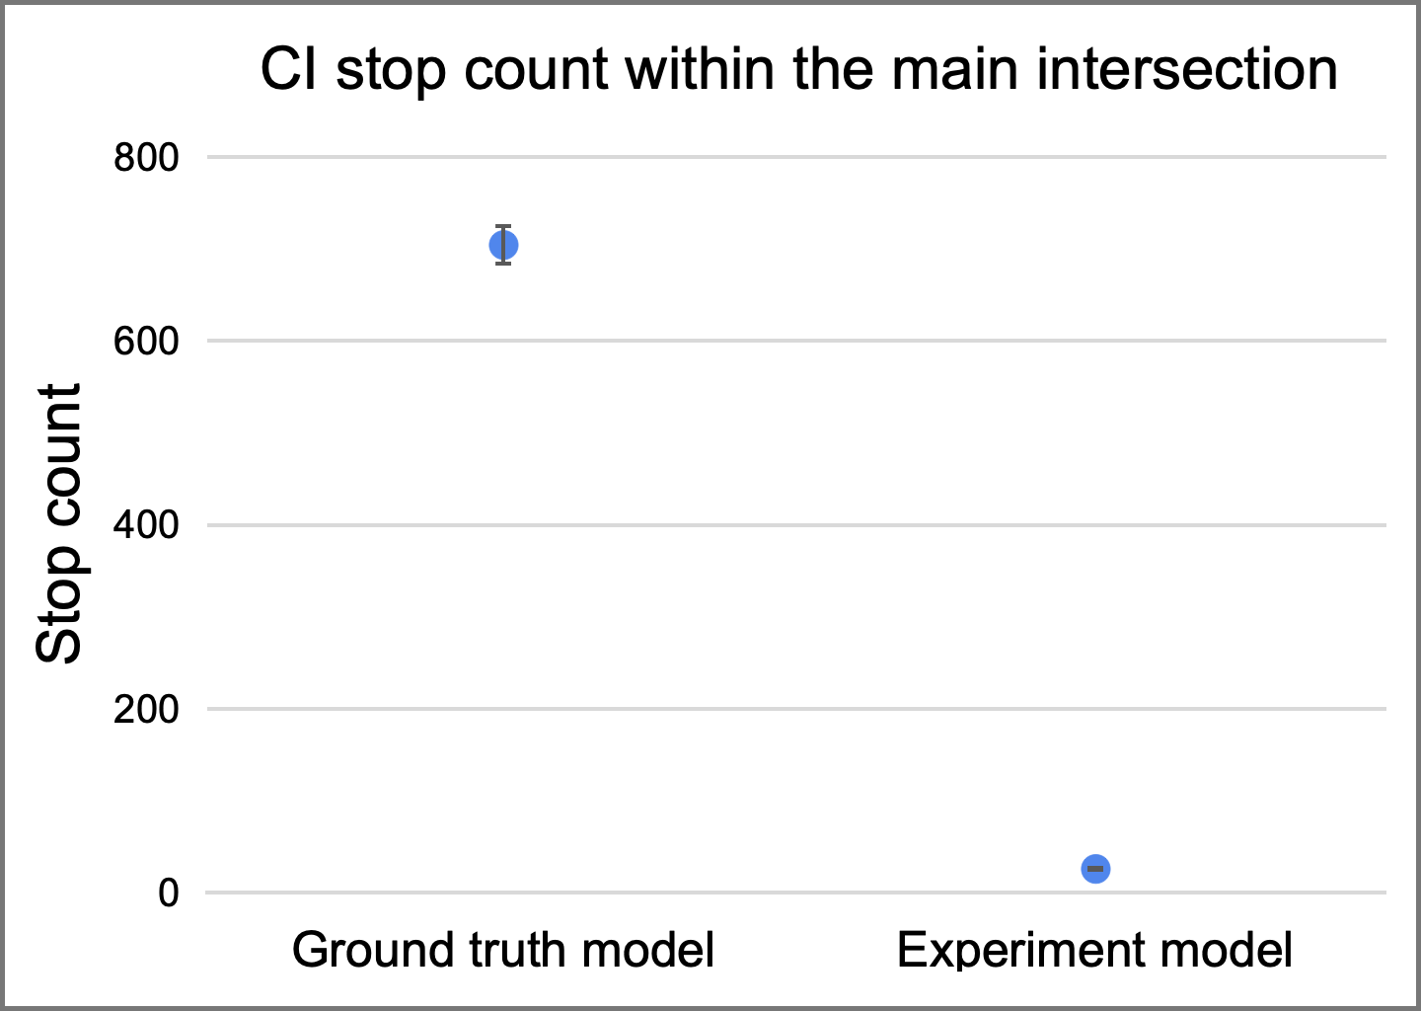

**Figure 18:** CI for the total stop count with the changes from experiment 1

While there were clear improvements in the safety of the node, throughput was reduced and time in model increased, thus having undesired effects on traffic conditions. This can be seen in Figure 19, which shows the CIs for the throughput of the individual roads. Additionally, Figure 20 shows the CI for the time in model. As it can be seen, there are clear reductions in the throughput for all roads, and the time in model has clearly increased. Table 18 summarizes the numerical findings of experiment 1. These facts led us to drop experiment 1 as a potential candidate for our recommendations to the City of Magdeburg.

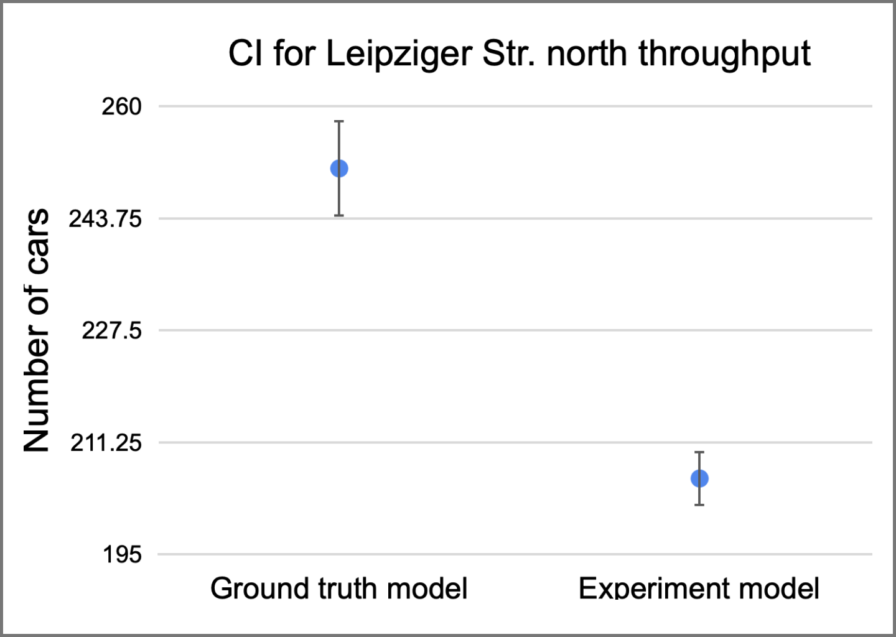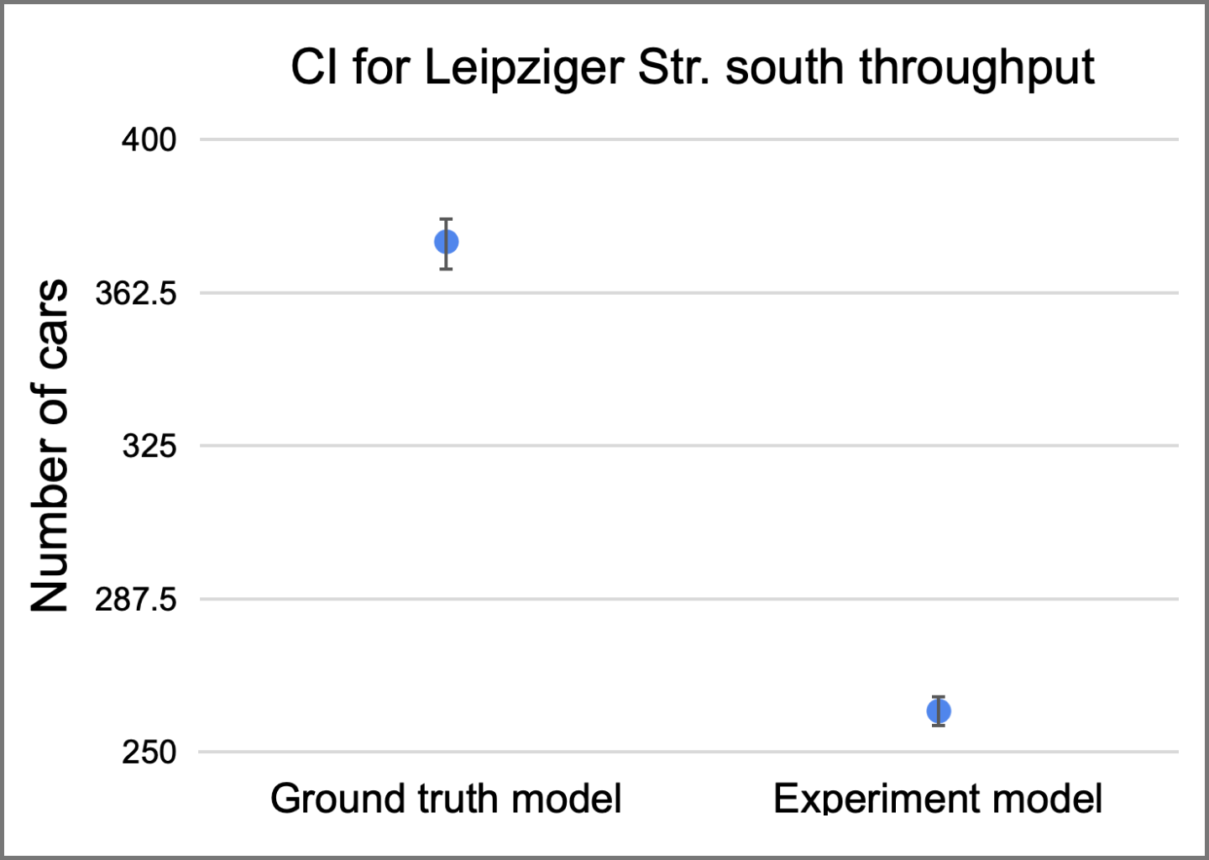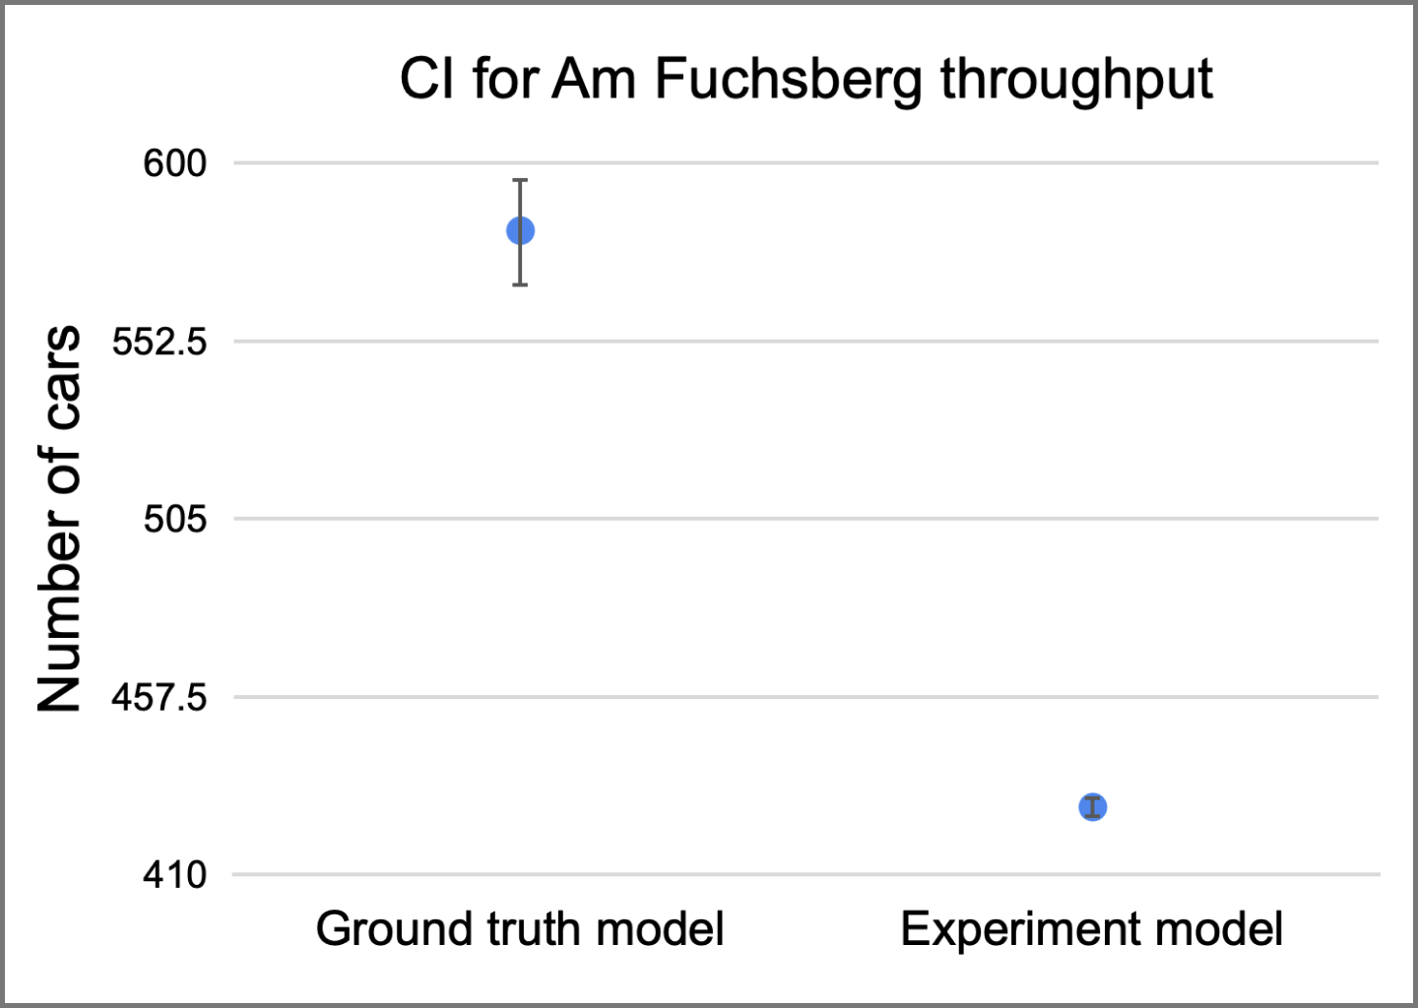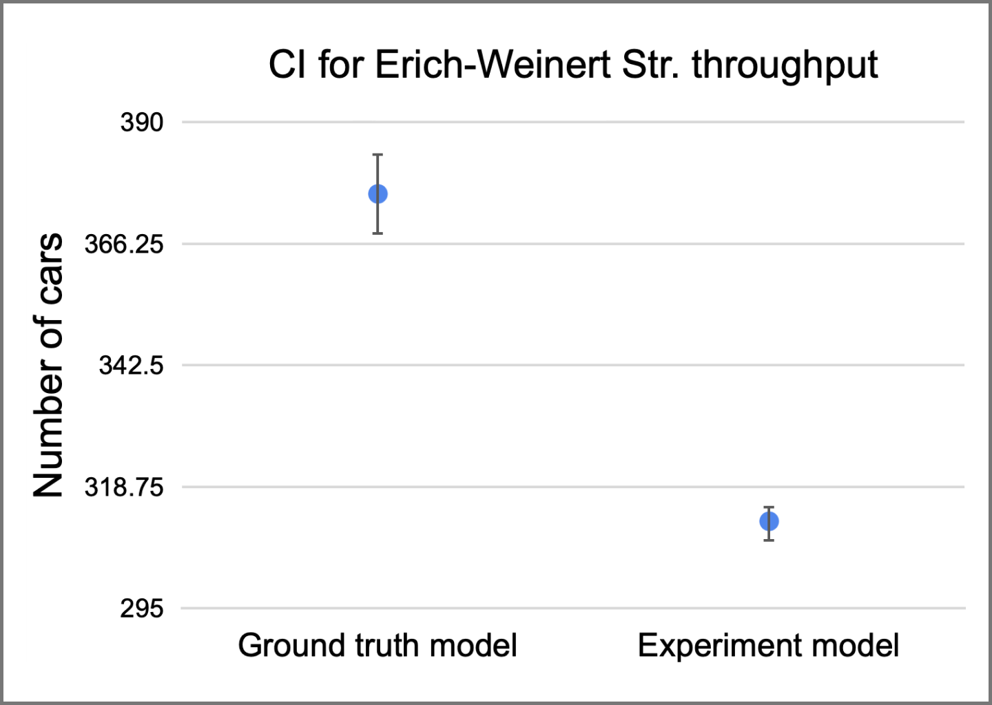

**Figure 19:** CI for roadwise throughput with the changes from experiment 1

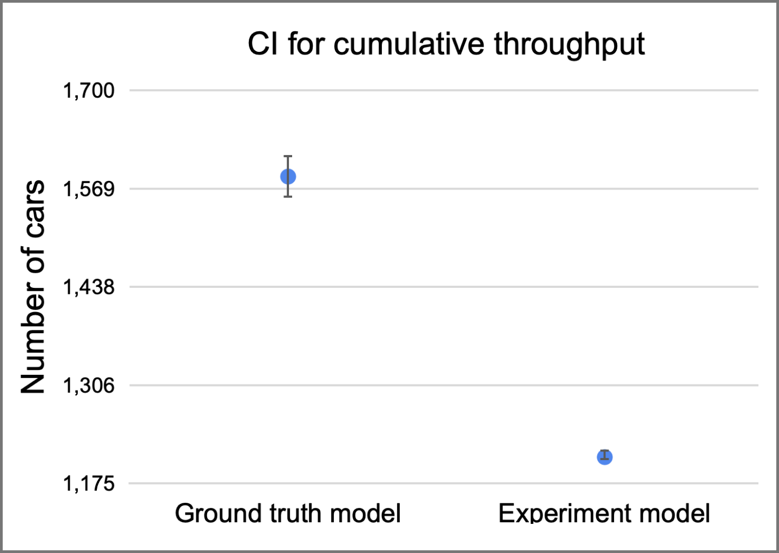

**Figure 20:** CI for cumulative throughput with the changes from experiment 1

| **Variable of interest** | **Confidence interval information - Experiment 1** | | |
| --- | --- | --- | --- |
| **Lower bound** | **Mean** | **Upper bound** |
| Leipziger Str. south throughput | 256 cars | 260 cars | 264 cars |
| Leipziger Str. north throughput | 202 cars | 206 cars | 210 cars |
| Am Fuchsberg throughput | 425 cars | 428 cars | 431 cars |
| Erich-Weinert Str. throughput | 309 cars | 312 cars | 316 cars |
| Cumulative throughput | 1200 cars | 1210 cars | 1214 cars |
| Stop count in the main intersection | 23 stops | 26 stops | 29 stops |

**Table 18:** Numerical results of experiment 1. Green indicates a CI interval improvement in the respective dimension when compared to the ground model CI, and red indicates a worsening of the indicator.

## 3.2 Experiment 2: Open non overlapping traffic signals of opposite roads

While the idea of opening one road at a time has proven itself to be considerably harmful for the throughput of the entire model, as well as the time in model, the team has devised another traffic phase variation that has led to similar drastic improvements in the stop count within the main intersection and yet to much less adverse impacts on the other variables of interest.

The scope of **experiment 2** was to vary the traffic phases by opening non-overlapping traffic directions for opposite roads one at a time. As an example, cars from opposite roads moving forward and turning right are allowed to move simultaneously. The next phase then allows cars from opposite roads to turn left. Table 19 clarifies the specific directions and traffic phases for the experiment.

| **Traffic phase** | **Car direction** |
| --- | --- |
| Phase 1 | Cars going straight and turning right from LSS and LSN |
| Phase 2 | Cars going left from LSS and LSN |
| Phase 3 | Cars going straight and turning right from AF and EWS |
| Phase 4 | Cars going left from AF and EWS |

**Table 19:** Traffic phases and directions for experiment 2

The team’s goal with this experiment is again to improve the safety measure by minimizing the stop count inside the intersection. The reasoning is similar to that of experiment 1: if there are no cars moving simultaneously into conflicting directions, the number of stops within the main intersection should drastically decrease.

### 3.2.1 Experiment results

Similarly to the first experiment, opening non-overlapping opposite directions has produced significant improvements in terms of safety. In fact, the improvements are very similar to opening one traffic phase at a time: the mean stop count for experiment 2 is 28 stops within an hour, with the CI lower bound being 24 and the upper bound being 31. Figure 21 shows the comparison of the stop count CI between the ground truth model and the model resulting from experiment 2.

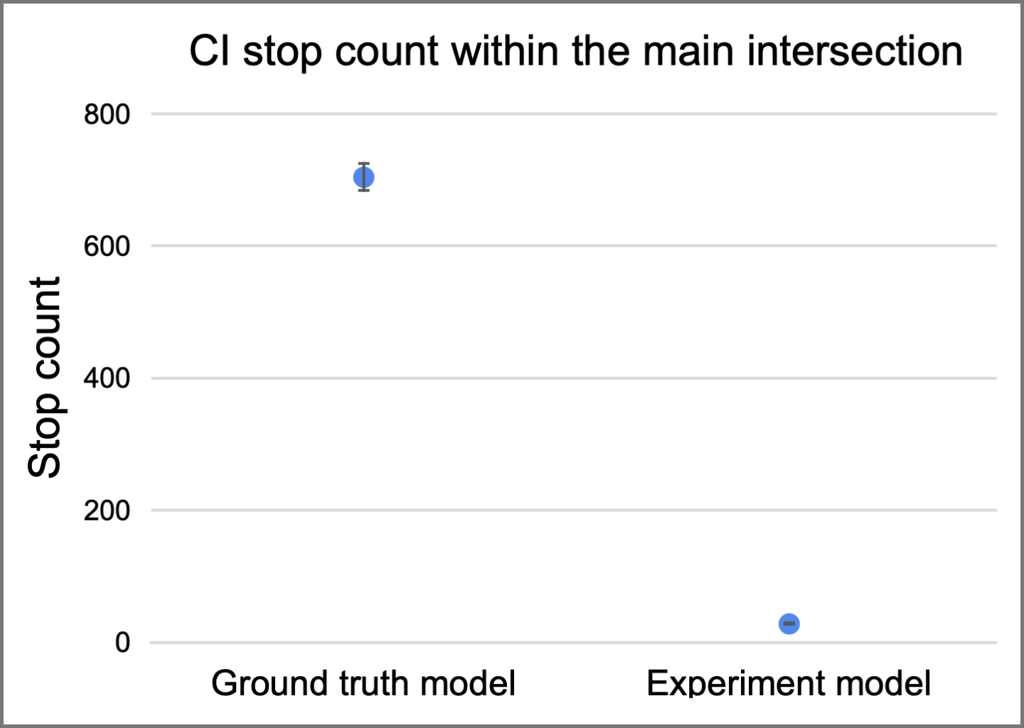

**Figure 21:** CI for the total stop count with the changes from experiment 2

What sets experiment 2 apart from experiment 1 is the impact it has on throughput and time in model. Differently from experiment 1, the throughput is only very slightly decreased, with some roads showing non-significant changes. The time in model has slightly increased by an average of approximately 20 seconds due to the fact that cars wait longer for the respective traffic phases to open. Figures 22 and 23 show the comparison between the ground truth and the experiment 2 models’ CIs. We can clearly see that the throughput for Leipziger Str. north and for Erich-Weinert Str. do not seem to decrease, while the throughput for Leipziger Str. south and Am Fuchsberg decreases only by a small amount. Additionally, Table 20 provides the details of the numerical analysis performed for the experiment.

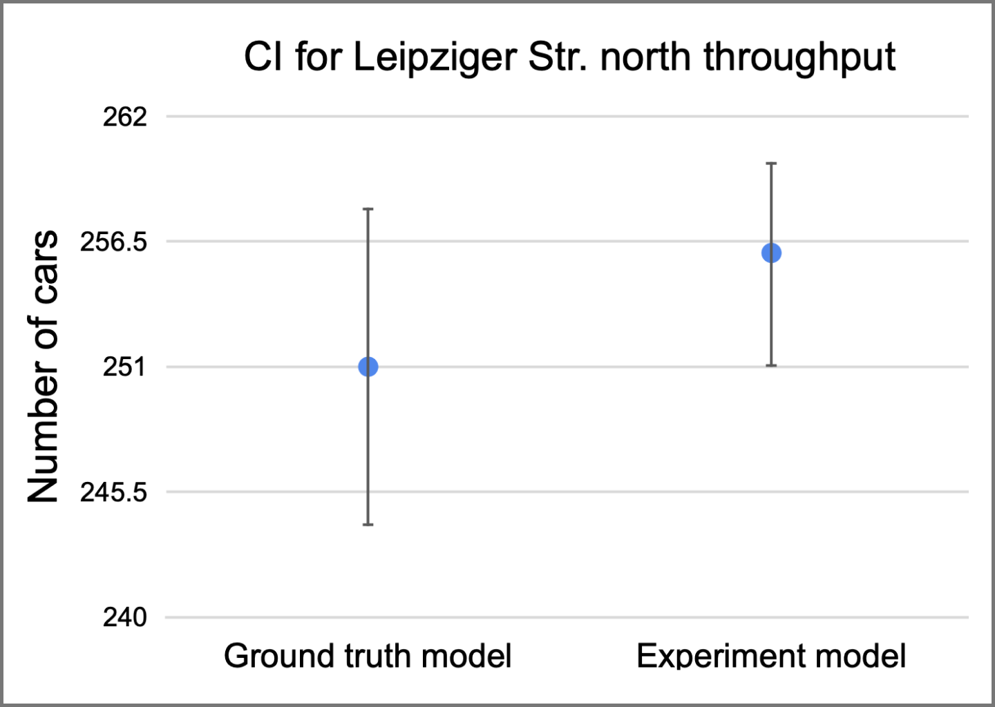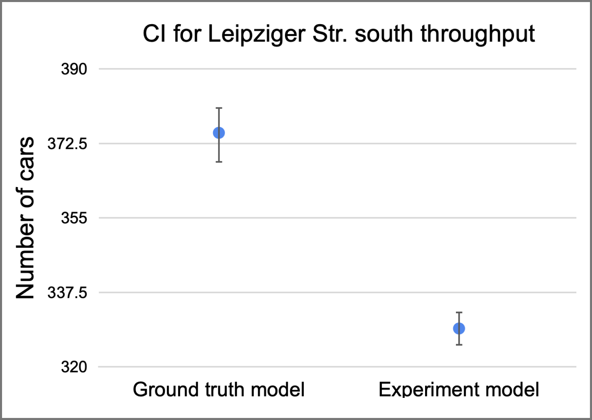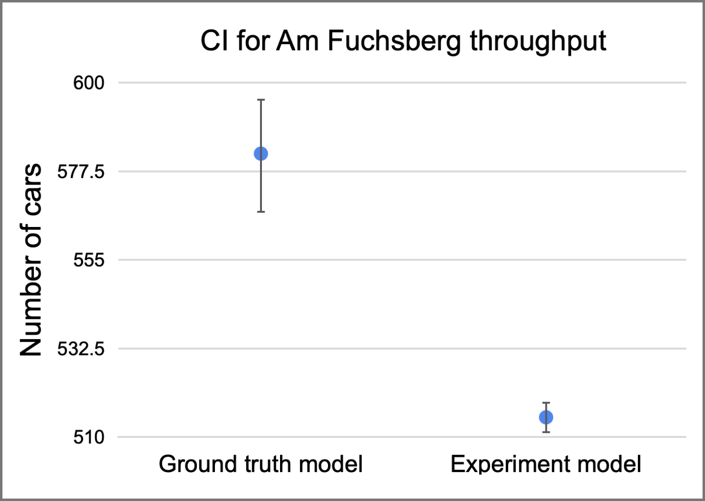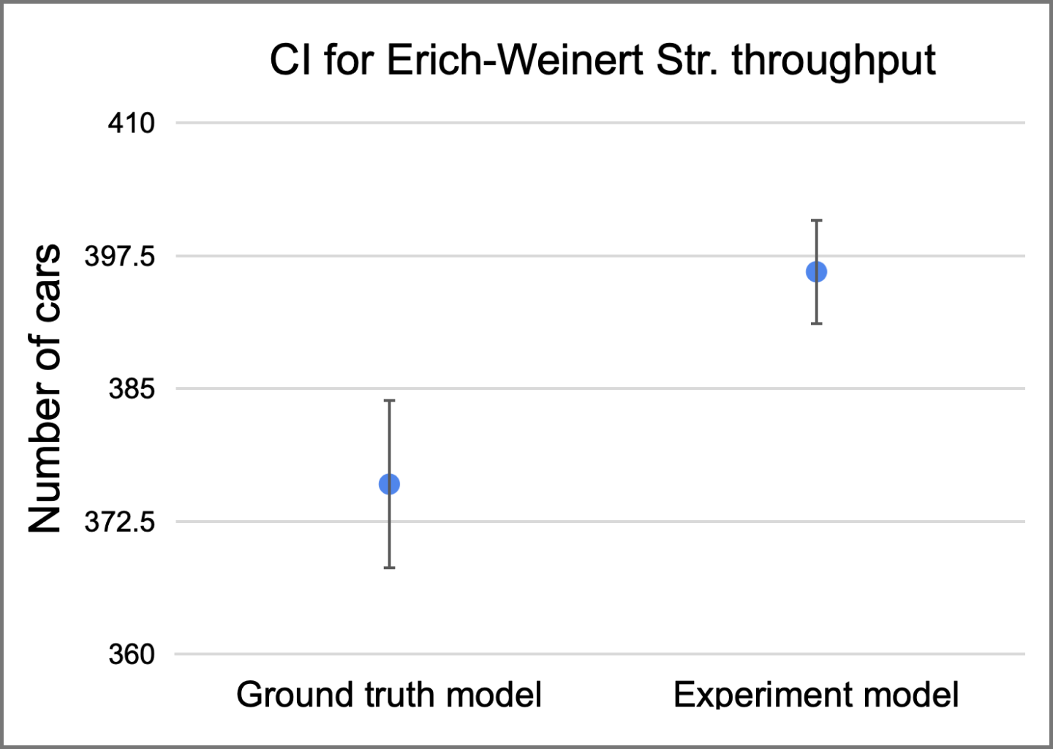

**Figure 22:** CI for roadwise throughput with the changes from experiment 2

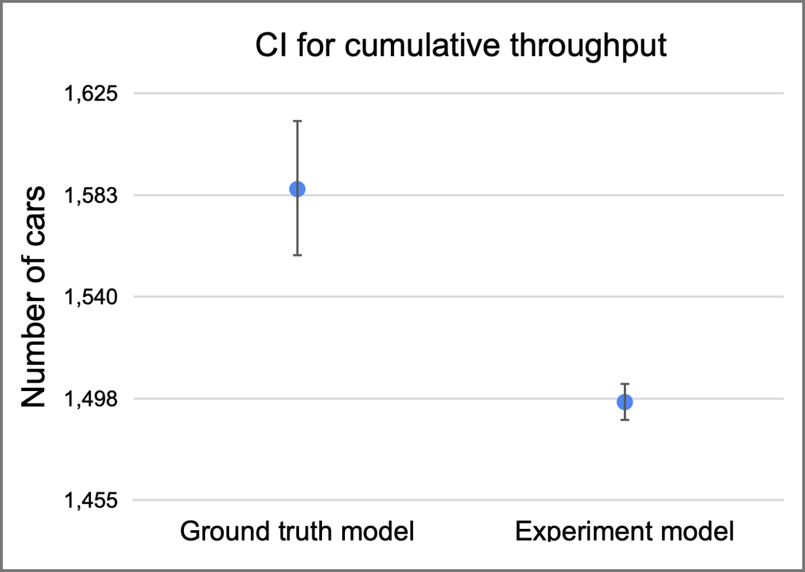

**Figure 23:** CI for cumulative throughput with the changes from experiment 2

| **Variable of interest** | **Confidence interval information - Experiment 2** | | |
| --- | --- | --- | --- |
| **Lower bound** | **Mean** | **Upper bound** |
| Leipziger Str. south throughput | 325 cars | 329 cars | 333 cars |
| Leipziger Str. north throughput | 252 cars | 256 cars | 261 cars |
| Am Fuchsberg throughput | 511 cars | 515 cars | 519 cars |
| Erich-Weinert Str. throughput | 391 cars | 396 cars | 401 cars |
| Cumulative throughput | 1488 cars | 1496 cars | 1504 cars |
| Stop count in the main intersection | 24 stops | 28 stops | 31 stops |

**Table 20:** Numerical results of experiment 2. Green indicates a CI improvement when compared to the ground model CI, with yellow representing a slight worsening of the indicator.

The team has considered the safety improvements to be significant enough to overweigh the slight worsening on the other variables of interest, and we have conducted a more thorough statistical significance of the impact on the throughput of the model in order to verify the strength of experiment 2.

### 3.2.2 Statistical significance

The statistical significance is carried by computing the CI of the difference between the indicator of interest on the ground truth model and on the experiment model. Figure 24 shows the calculated CIs for road-wise throughputs and for the stop count within the main intersection. The results point at no significant changes on the throughput in Leipziger Str. north, slight worsening on the throughput for Leipziger Str. south and Am Fuchsberg, and slight improvement on the throughput for Erich-Weinert Str. Astonishing is the drastic improvement on the stop count of cars within the main intersection.

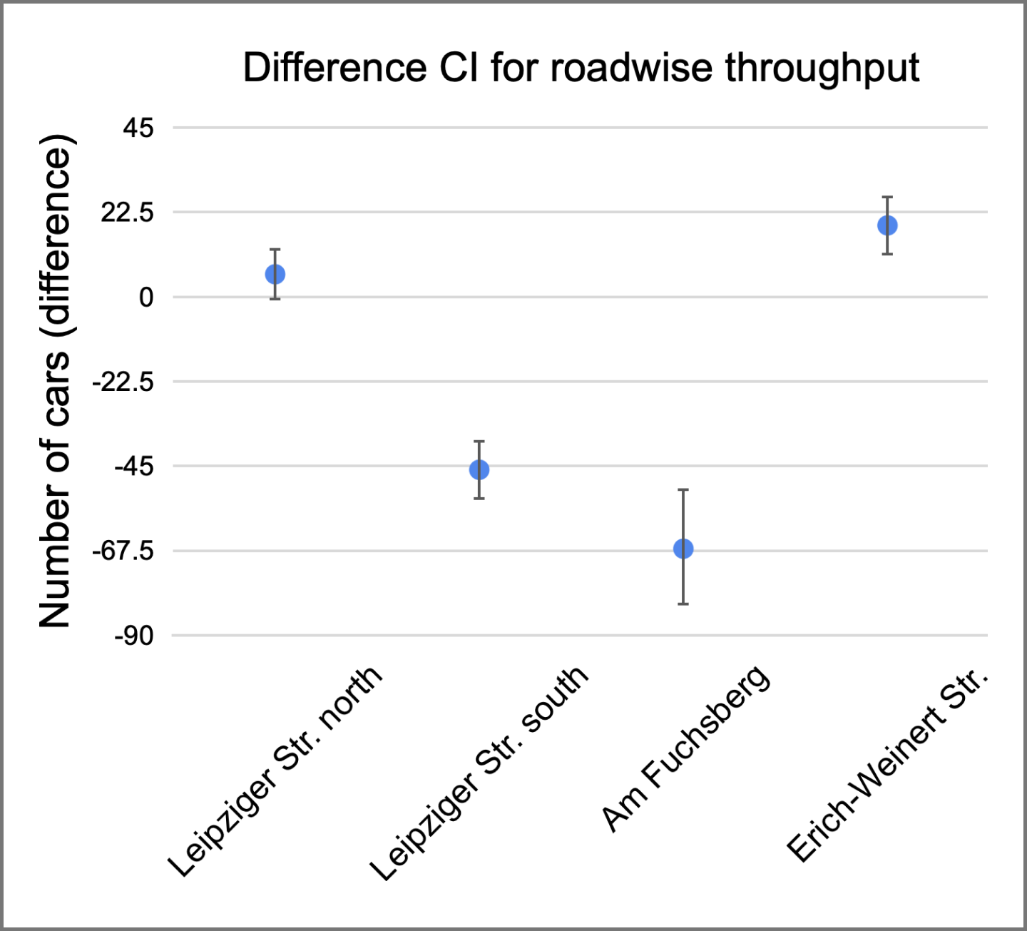

**Figure 24:** Difference CI for roadwise through and stop count for experiment 2

Considering the results from this experiment, the team has considered it to be a strong candidate as a recommendation for the City of Magdeburg.

## 3.3 Experiment 3: Allow cars on the blocked tram line on Leipziger Str. north

While analyzing the node, we have observed that cars are not allowed to navigate on the tram line on Leipziger Str. north (direct Hasselbachplatz). We have conceived an experiment to free traffic on the respective tram line and evaluate whether there are improvements in the traffic conditions. The goal of this experiment is related primarily with traffic conditions, since we believe that there will be no noticeable changes on safety measures due to the unchanged traffic directions and traffic light phases.

### 3.3.1 Experiment results

The experiment leads to an average improvement on cumulative throughput via this experiment whereas the safety conditions are similar to the base model. Figures 25 and 26 show the CI comparison for the throughput in all roads, as well as for the cumulative throughput, and Figure 27 presents the CI comparison for the stop count within the main intersection and the time in model. Table 21 summarizes the numerical results of the experiment.

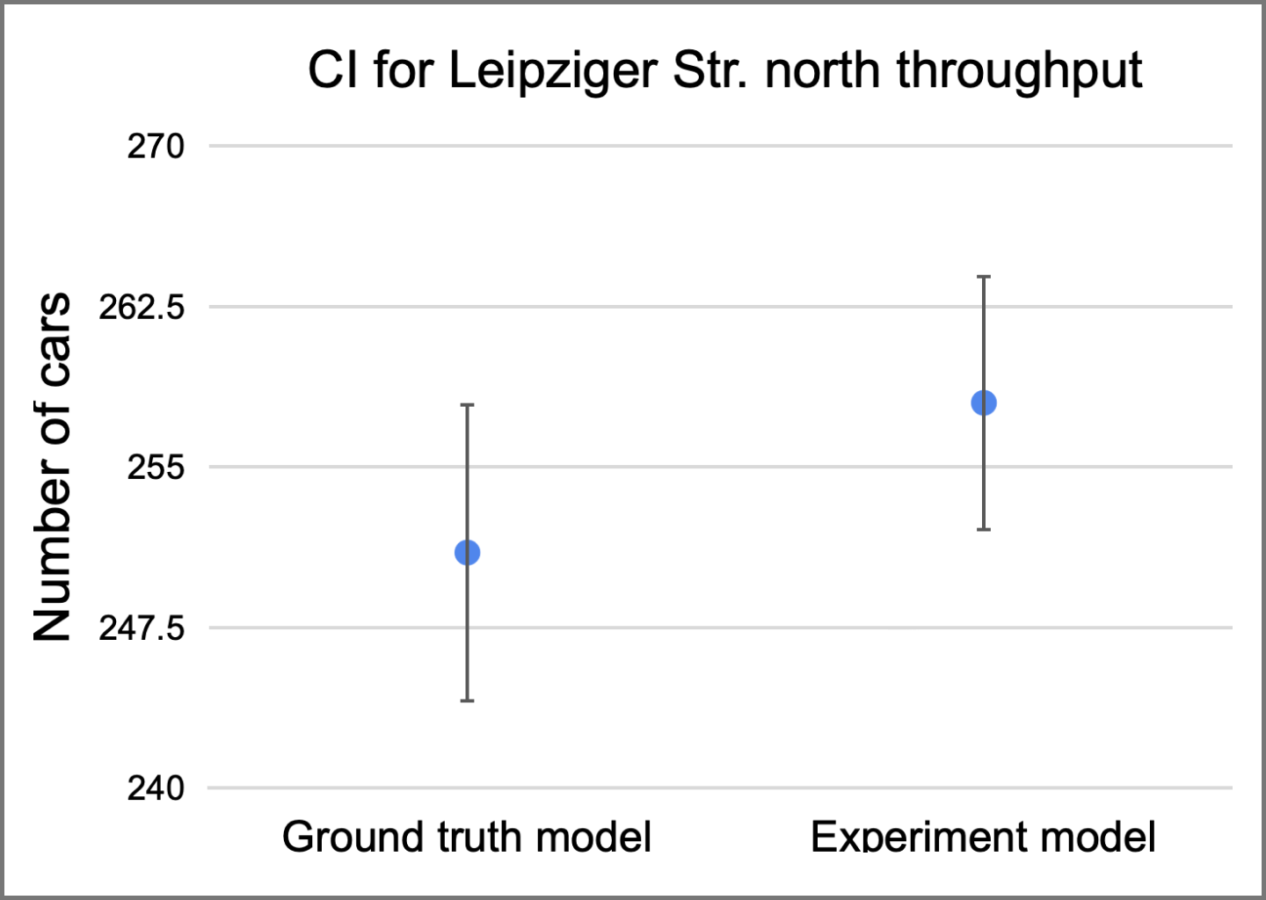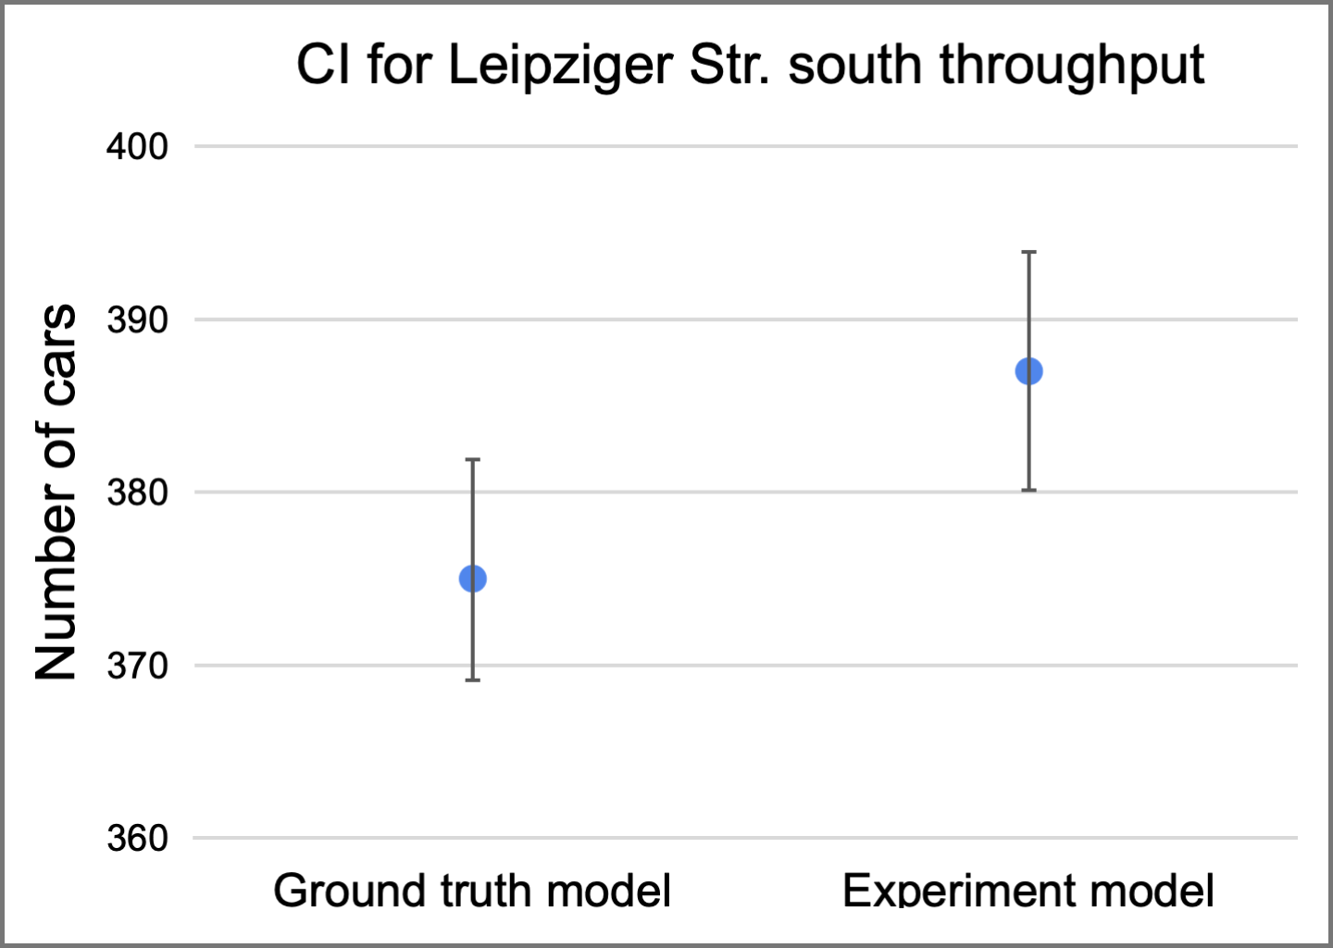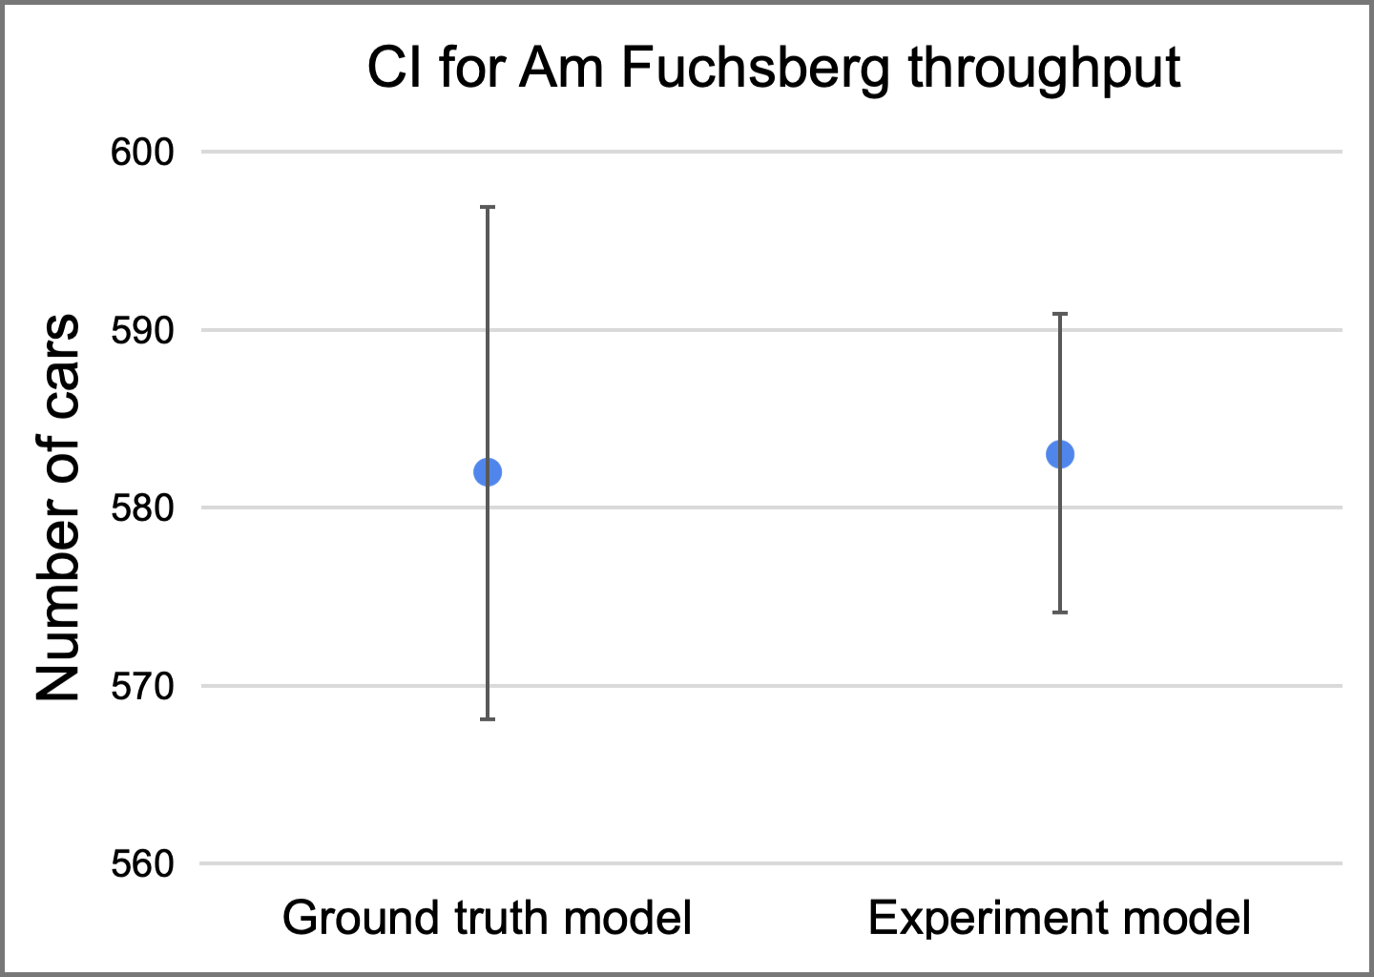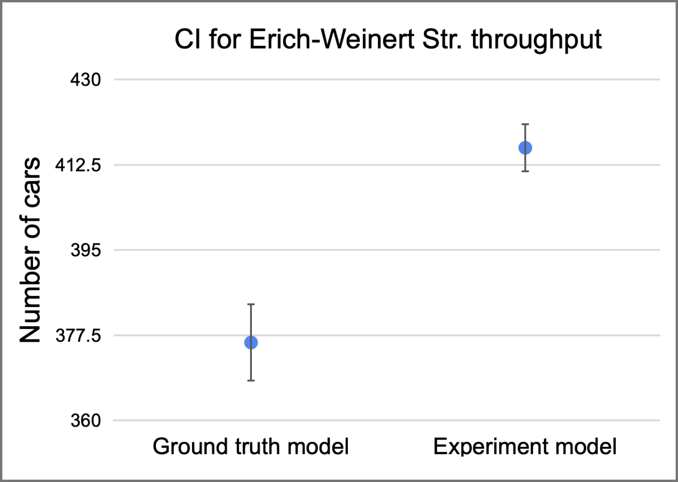

**Figure 25:** CI for roadwise throughput with the changes from experiment 3

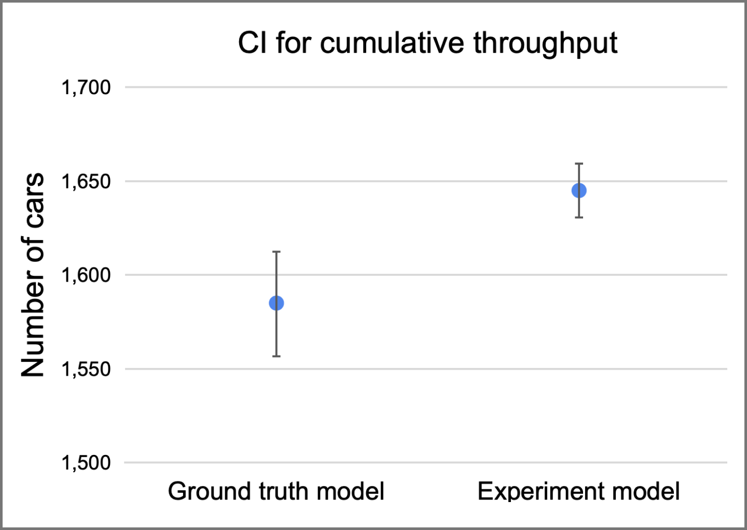

**Figure 26:** CI for cumulative throughput with the changes from experiment 3

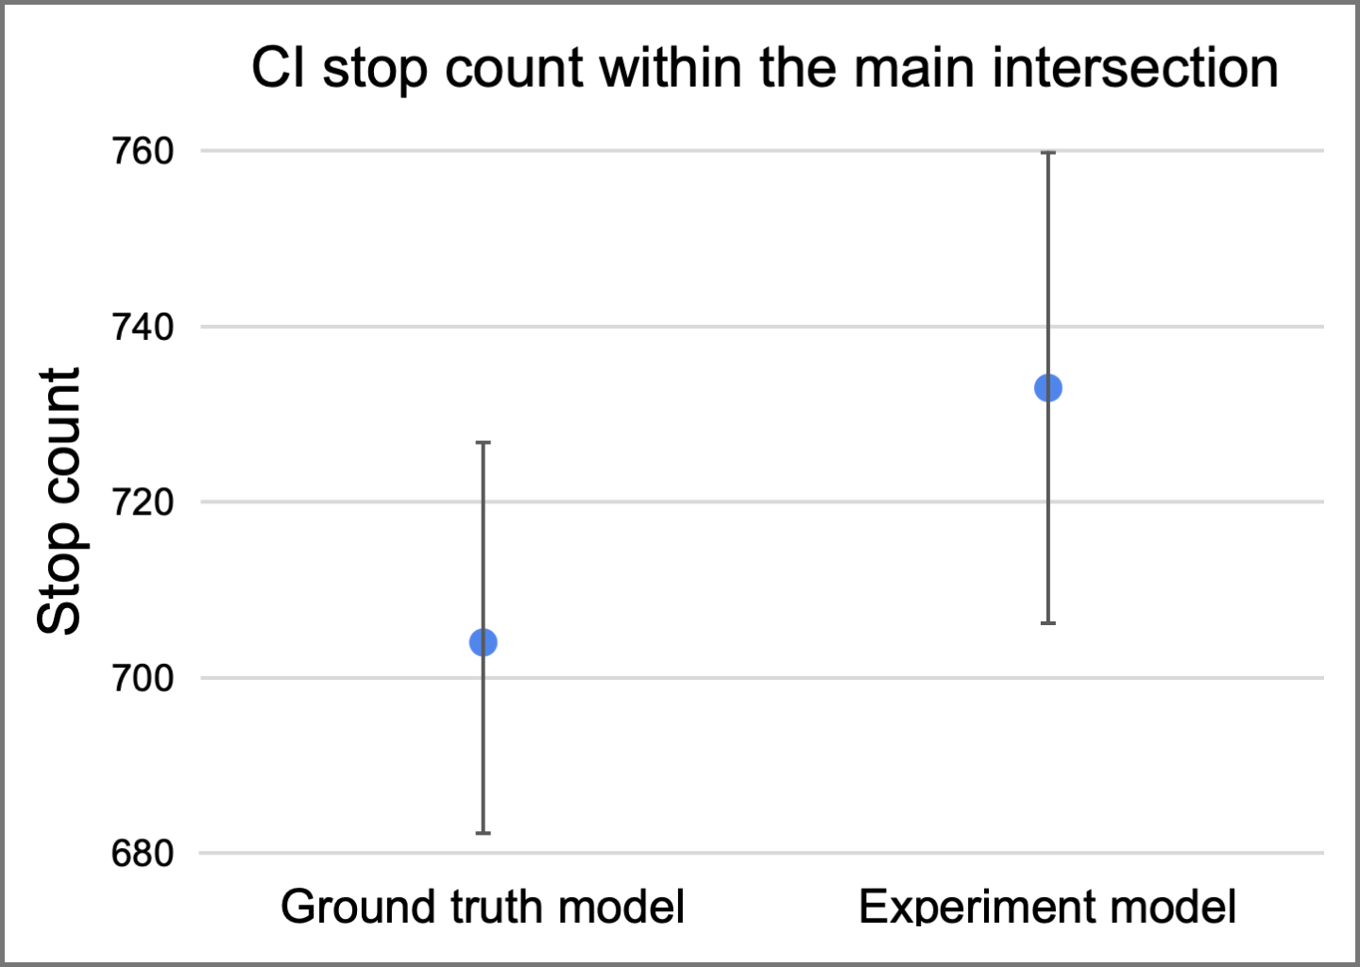

**Figure 27:** CI for stop count and time in model with changes from experiment 3

| **Variable of interest** | **Confidence interval information - Experiment 3** | | |
| --- | --- | --- | --- |
| **Lower bound** | **Mean** | **Upper bound** |
| Leipziger Str. south throughput | 380 cars | 387 cars | 394 cars |
| Leipziger Str. north throughput | 252 cars | 258 cars | 264 cars |
| Am Fuchsberg throughput | 574 cars | 583 cars | 591 cars |
| Erich-Weinert Str. throughput | 411 cars | 416 cars | 421 cars |
| Cumulative throughput | 1630 cars | 1645 cars | 1660 cars |
| Stop count in the main intersection | 706 stops | 733 stops | 760 stops |

**Table 21:** Numerical results of experiment 3. Green indicates a CI interval improvement in the respective dimension when compared to the ground model CI, with yellow representing a slight worsening of the indicator.

### 3.3.2 Statistical significance

Since we have observed average improvements on traffic conditions and no worsening of any particular variable of interest, we have conducted a more detailed statistical significance test by calculating the CI of the difference between the ground truth model and the experiment 3 model. Figure 28 presents the CIs for the differences in each road throughput, as well as for the cumulative throughput. As shown in the figure, Leipziger Str. south, Erich-Weinert Str. and the cumulative throughput all have difference CIs entirely above zero, meaning that the improvements on the throughput of these roads were significant at the 99%-confidence interval level. We have thus considered the modification implemented in this experiment as a candidate for our recommendations to the City of Magdeburg.

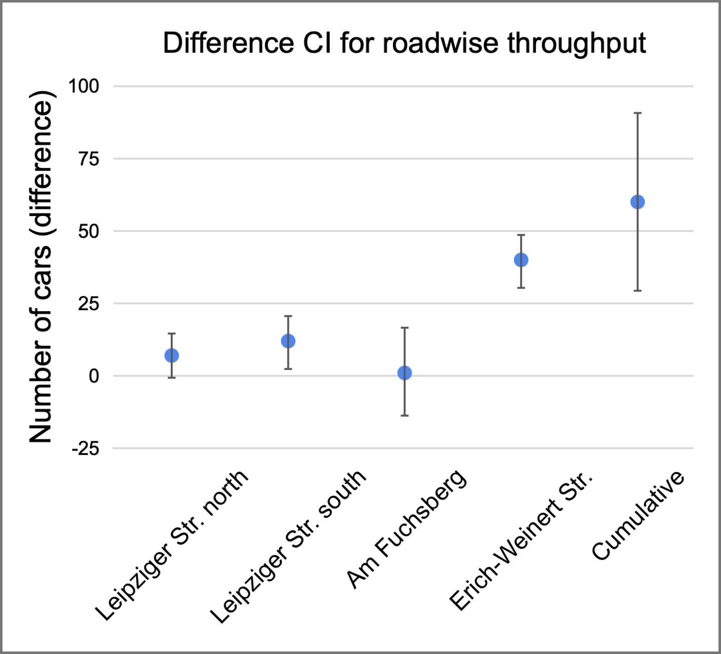

**Figure 28:** Difference CI for roadwise throughput and stop count for experiment 3

## 3.4 Experiment 4: Car bridge between Am Fuchsberg and Erich-Weinert Str.

The scope of the fourth experiment involves building a bridge (or, as an alternative implementation, and underbridge) connecting Am Fuchsberg and Erich-Weinert Str. and allowing the cars moving in the forward direction on both roads to proceed without entering the intersection. The motivation for this experiment is the fact that the analysis of the previous year's data has shown Erich-Weinert Str. and Am Fuchsberg to be the streets with the highest incoming number of cars. While this differs from the 2015 data provided by the City of Magdeburg, the incoming traffic from both roads is not negligible, and we estimated that allowing cars to move forward without impediments would lead to drastic improvements on traffic conditions, as well as positive changes on the safety measures in our system.

The major goal of this experiment is to improve throughput, but we also believe that there will be positive indirect consequences in safety due to less cars directly entering the intersection.

### 3.4.1 Experiment results

The fourth experiment has clearly produced the best results in terms of traffic condition improvements. Both the throughput of all roads and the safety measures have shown statistically significant increase at the 99%-confidence level. Figure 29 and 31 show the roadwise throughput CI comparison, as well as the cumulative measure. As it can be seen, the experiment model has a mean value of cumulative throughput of 2343, with the CI varying from 2322 to 2363 cars. The mean throughput for Leipziger Str. north increases from 251 cars in an hour to 349 cars. The mean throughput for Erich-Weinert Str. increases from 376 cars to 627 cars, whereas for Leipziger Str. south the mean throughput value increases from 375 cars to 502 cars. In Am Fuchsberg, the throughput mean value rises to 864 cars from a mean of 582 cars in the base model, whereas the CI varies from 854 to 872. This experiment also makes the queue length lower for the Am Fuchsberg right lane, as the cars going straight now avail the bridge , the average queue length at the signal goes from 6 cars at each time step to 1 car, and the CI varies between 0 cars and 2 cars.

Figure 30 shows how the safety measure and the average time in model have both improved under the new model. We can clearly see that there are improvements in safety as well, with the new mean for the stop count being 494 stops and the CI varying between 478 stops and 511 stops. When it comes to the average time in model, the average has decreased to 150 seconds, with the CI ranging between 146 and 153 seconds.

Table 22 summarizes the numerical results of this experiment. It makes clear that there were improvements in all variables of interest.

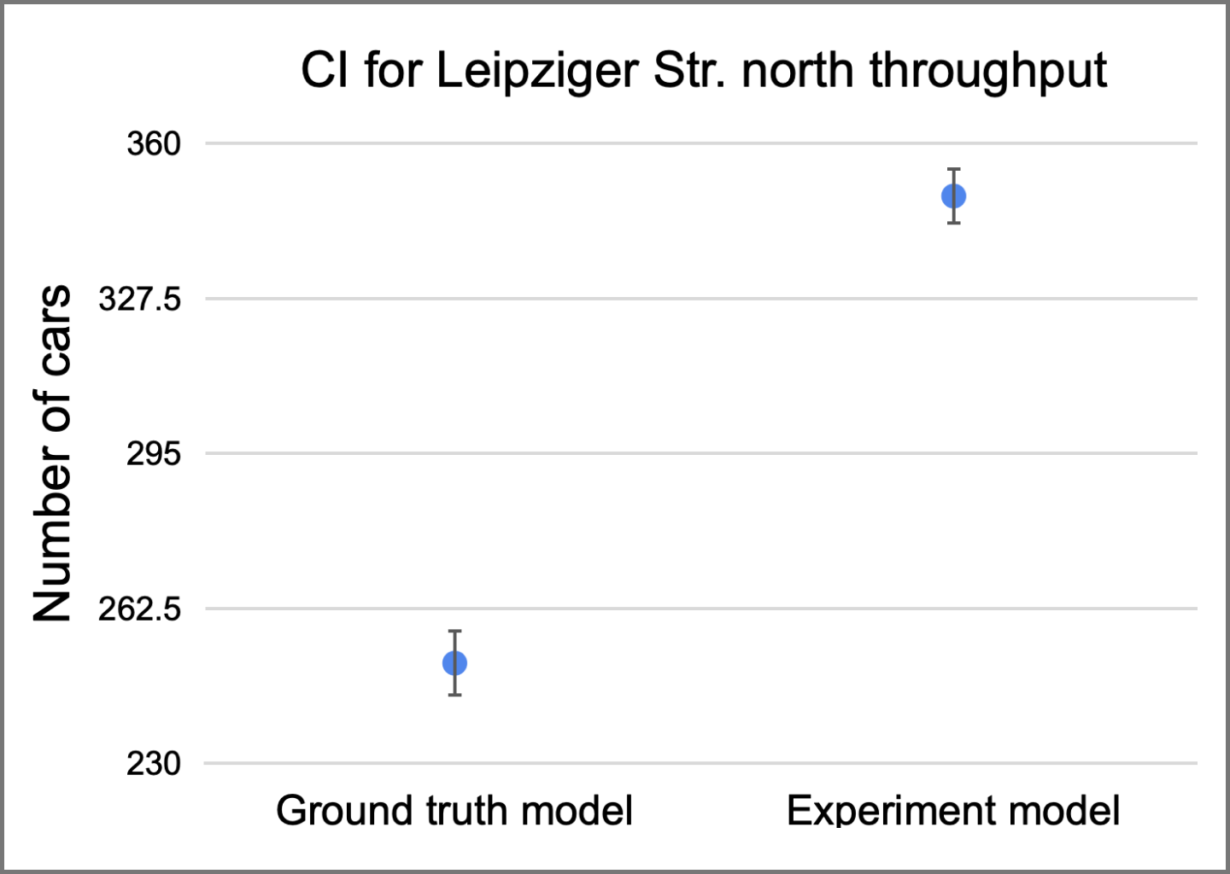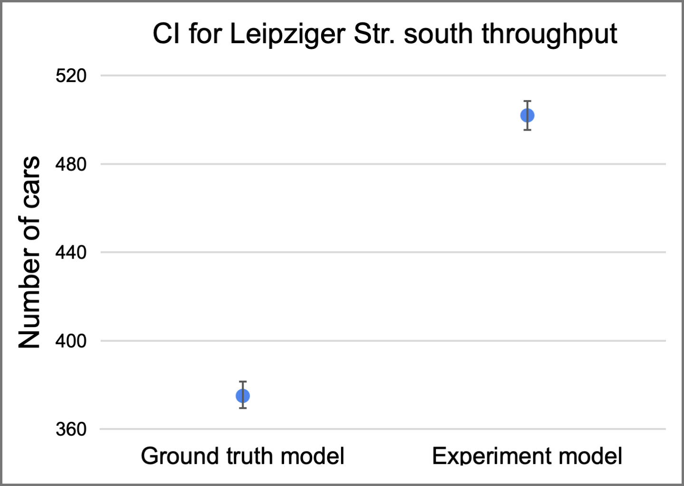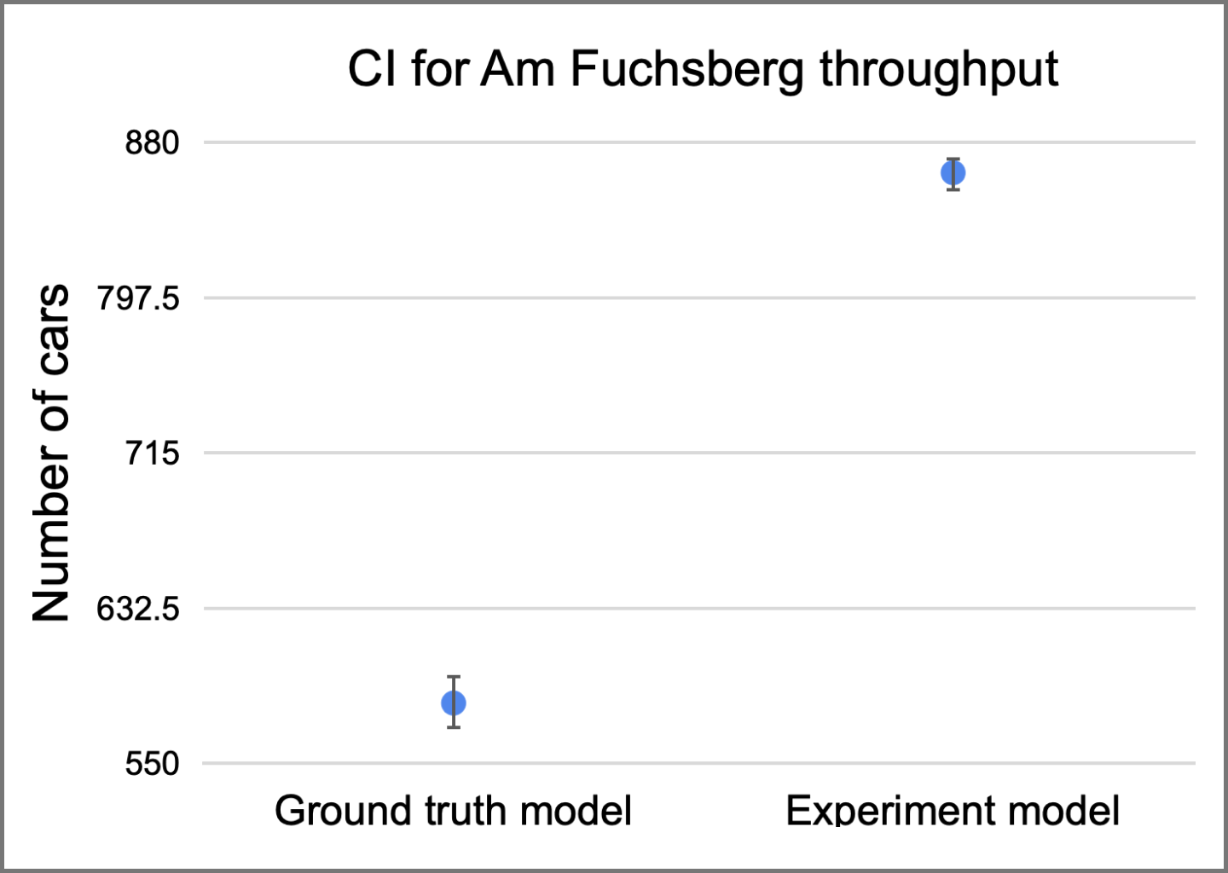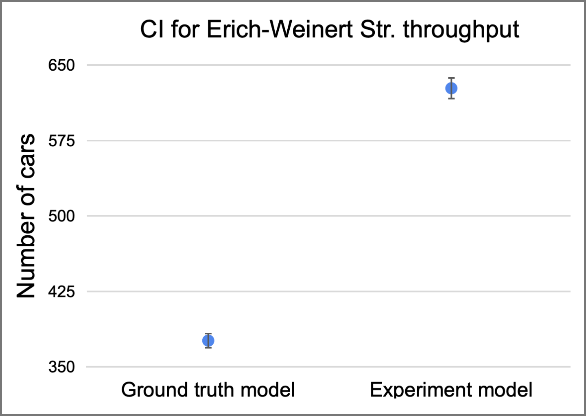

**Figure 29:** CI for roadwise throughput with the changes from experiment 4

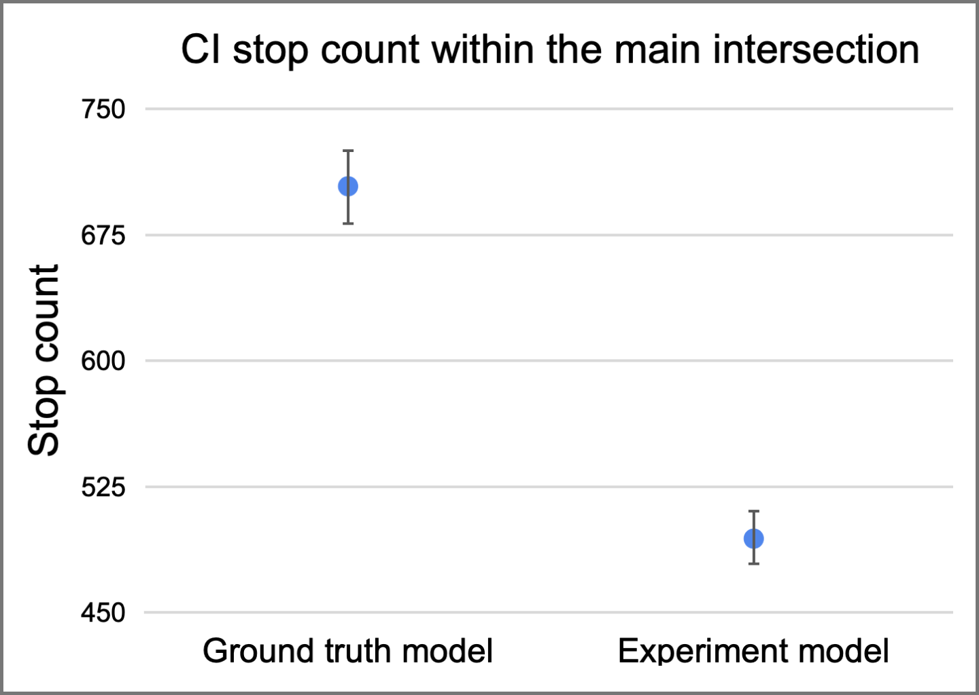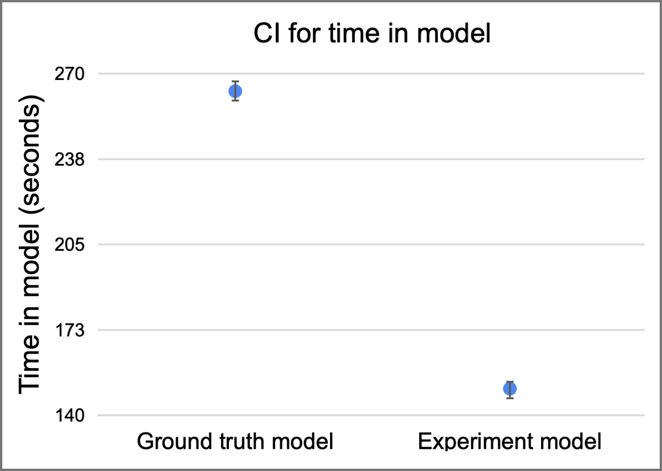

**Figure 30:** CI for stop count and time in model with changes from experiment 4

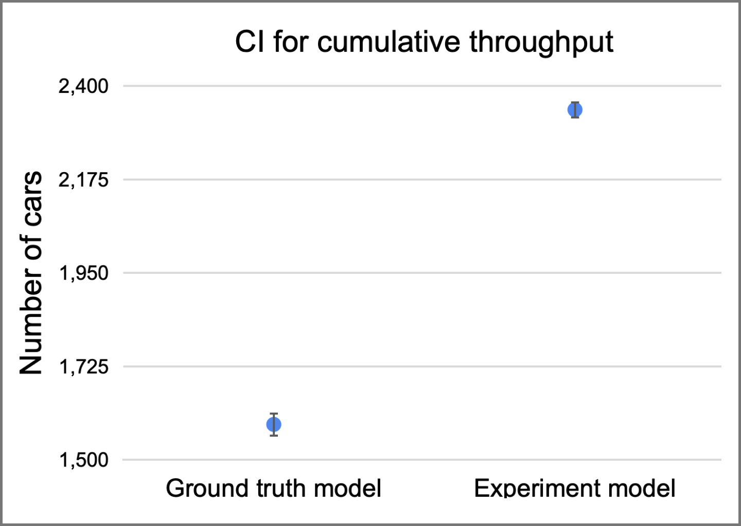

**Figure 31:** CI for cumulative throughput with the changes from experiment 4

| **Variable of interest** | **Confidence interval information - Experiment 1** | | |
| --- | --- | --- | --- |
| **Lower bound** | **Mean** | **Upper bound** |
| Leipziger Str. south throughput | 495 cars | 502 cars | 509 cars |
| Leipziger Str. north throughput | 343 cars | 349 cars | 355 cars |
| Am Fuchsberg throughput | 854 cars | 864 cars | 872 cars |
| Erich-Weinert Str. throughput | 616 cars | 627 cars | 638 cars |
| Cumulative throughput | 2322 cars | 2343 cars | 2363 cars |
| Stop count in the main intersection | 478 stops | 494 stops | 511 stops |

**Table 22:** Numerical results of experiment 4. The fact that all rows are marked green shows improvements in all dimensions.

### 3.4.2 Statistical significance

Since this experiment has provided the best improvements in terms of traffic conditions, we now perform a more detailed statistical analysis of the results.

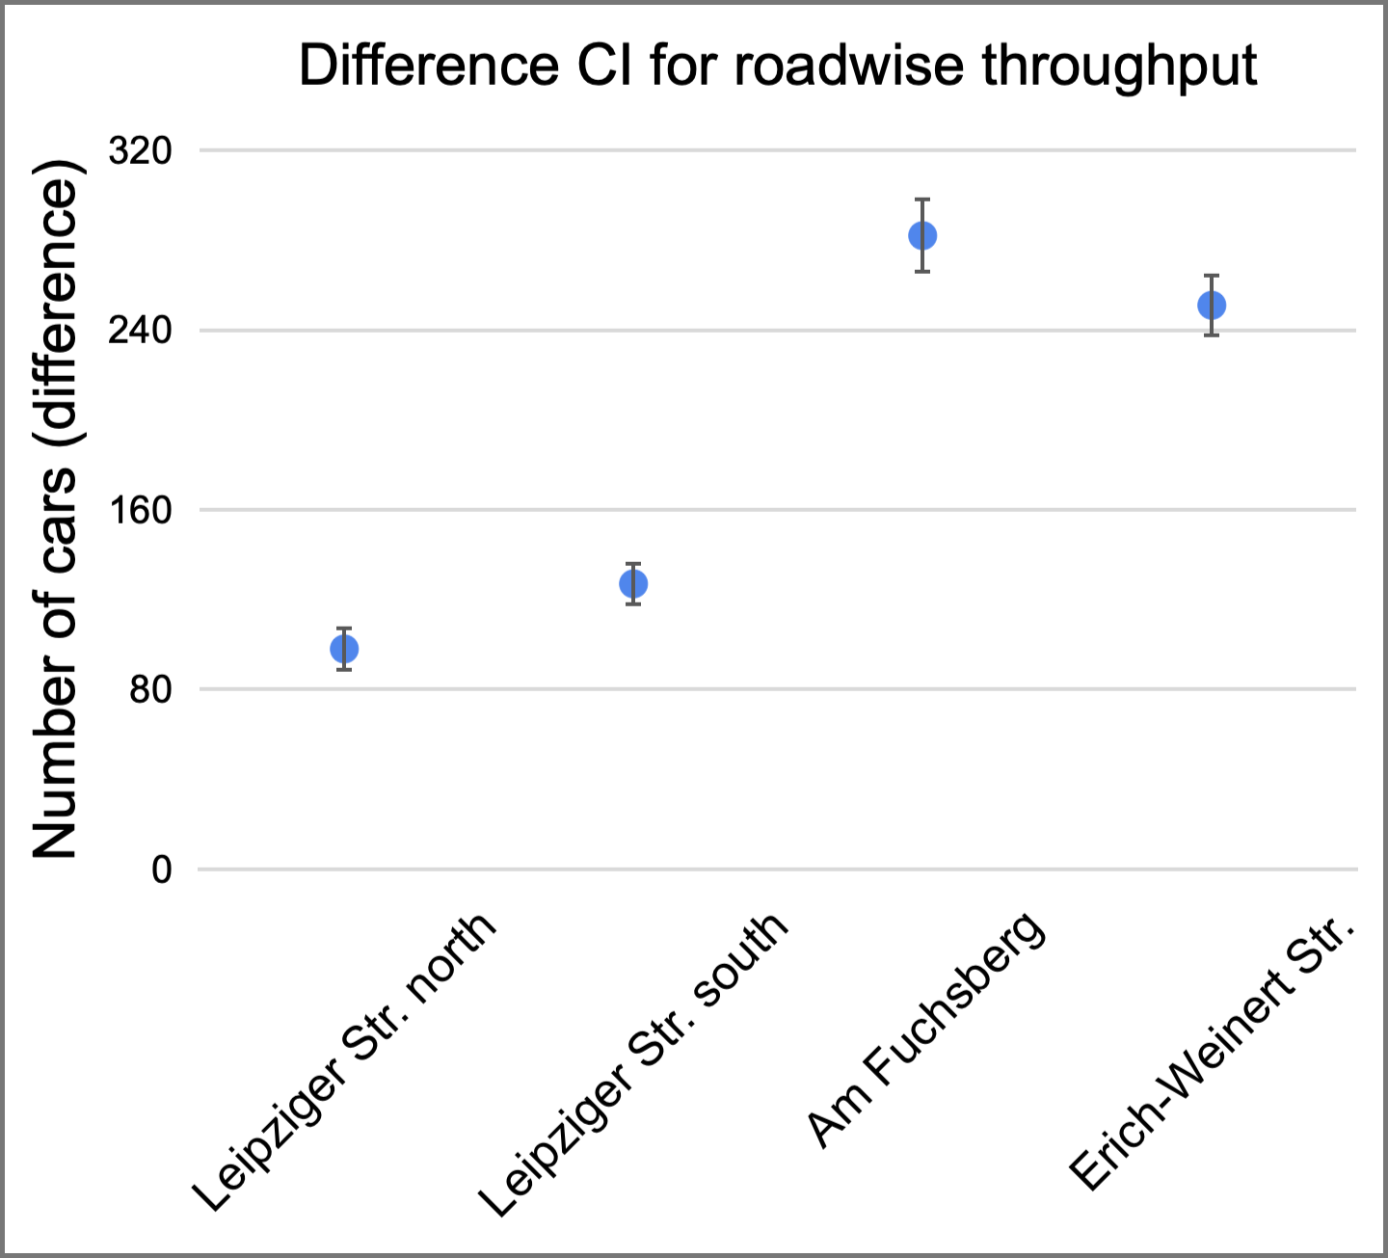

**Figure 32:** CI for stop count and time in model with changes from experiment 4

As it can be seen, all the difference CIs are above the zero level, showing statistically significant improvements at 99%-confidence level. Given the strong results of this experiment, it has also become a strong candidate for our recommendations to the City of Magdeburg.

## 3.5 Experiment 5: Free right lane from Leipziger Str. south into Erich-Weinert Str.

The scope of our last experiment was to simulate a free right lane from Leipziger Str. south towards Erich-Weinert Str. so that cars turning right can directly proceed without having to wait for a green traffic light. The goal of this experiment was primarily concerned with throughput improvement, as we have originally estimated that a free lane would relieve the system and allow for improved flows.

### 3.5.1 Experiment results

Unfortunately our conjectures about traffic flow improvements were not confirmed by the experiment results. There was no significant throughput improvement, and the safety measures were also within the boundaries of the ground truth model.

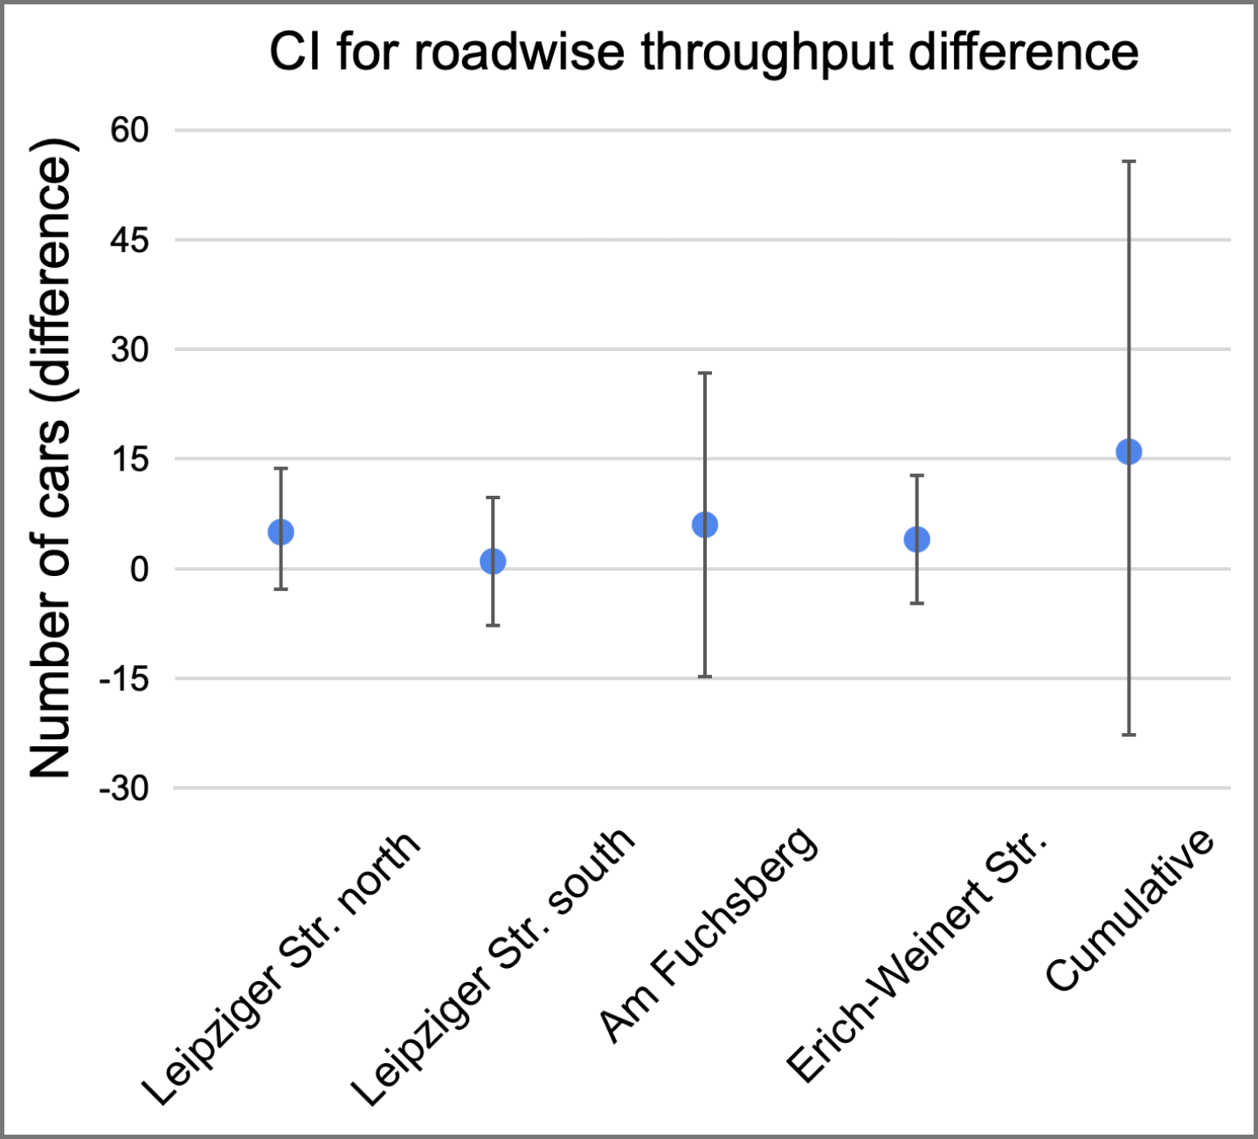

**Figure 33:** CI for roadwise throughput with the changes from experiment 5

Figure 33 provides the calculations for the difference CI for each road’s throughput, as well as for the cumulative indicator. As it can be seen, all the difference CIs contain the value 0, showing that there are no significant improvements in any of the roads. Because of that, we have decided to drop this experiment and do not include it in our recommendations.

# 4. Recommendations

This section of the report builds on the findings from the previous section, the experiments, to provide several recommendations to the City of Magdeburg as to how to improve both traffic conditions and safety in the intersection between Leipziger Str., Am Fuchsberg, and Erich-Weinert Str.

The team has also agreed that having statistically significant results is not enough to form the basis of our recommendations; we must also include the cost of implementing each recommendation in our considerations, as to provide more realistic and implementable advice.

This brings us to three main recommendations to the City of Magdeburg. The first change refers to experiment 2 (section 3.2), and we propose opening the non-overlapping, opposite traffic directions so that cars can flow through the system without stopping in the main intersection. The cost of implementing such improvement is relatively low if compared to the other experiments, and the benefits in terms of node safety are unquestionable.

The second improvement proposed by the group relates to experiment 3 (section 3.3), and we propose allowing for car traffic on the blocked tram line on the north part of Leipziger Str. (direction Hasselbachplatz). The costs of realizing this change are also relatively low, since no major structural changes are needed on the roads. The only necessary change is to adjust the ground markings and implement proper visual signalling so that cars are well oriented regarding the new directions allowed on the roads.

Finally, the third change put forward by the group refers to experiment 4 (section 3.4), and we propose building a bridge (or, alternatively, an underbridge) to connect the streets Am Fuchsberg and Erich-Weinert Str. We must highlight, however, that the high benefits of this change come at high costs: this is the most costly recommendation among the three proposals discussed here. Nonetheless, we believe that the long term improvements in both traffic conditions and safety metrics will eventually overweigh the initial fixed costs to implement the proposal.

Table 23 provides an overview of how each recommendation compares with the other in terms of the variables of interest and the implementation costs.

| **Recommendation** | **Variables of interest** | | |
| --- | --- | --- | --- |
| **Cost** | **Traffic condition** | **Safety metrics** |
| Open opposite not overlapping signals for cars | Very low | Slight decrease | Drastic improvement |
| All cars to go on blocked tram lane on LSN | Low | Improvement | No change |
| Make a bridge or underpass for cars going straight in between AF and EWS | Very high | Drastic improvement | Improvement |

**Table 23:** Summary of recommendations to the City of Magdeburg

## 4.1 Statistical analysis

In addition to providing written recommendations, the group has decided to build an additional model with all the provided recommendations implemented simultaneously. This is relevant to verify that no individual experiment interferes with each other in a drastically negative way. In other words, if a model combining all the three recommendations would perform worse than the base model, then we should reconsider our recommendations and identify the root cause for such an unexpected behavior. It is important to highlight, however, that it would be incorrect to make simplistic inferences such as “the expected result of the combined model is the sum of the expected results of the individual recommendations”. This is hardly ever the case, since combining multiple recommendations lead to unobservable influences between each other.

With that in mind, we now provide the results obtained from running the model with the combined recommendations and comparing it with the ground truth model. Figure 34 shows the difference CI for the throughput in each road, as well as the difference CI for the cumulative throughput. The mean cumulative throughput of the system increases to an average of 1899 cars, with the CI varying between 1878 and 1919 cars. The charts also show an improvement in all roadwise difference CIs, pointing towards an overall improvement in traffic conditions within the system.

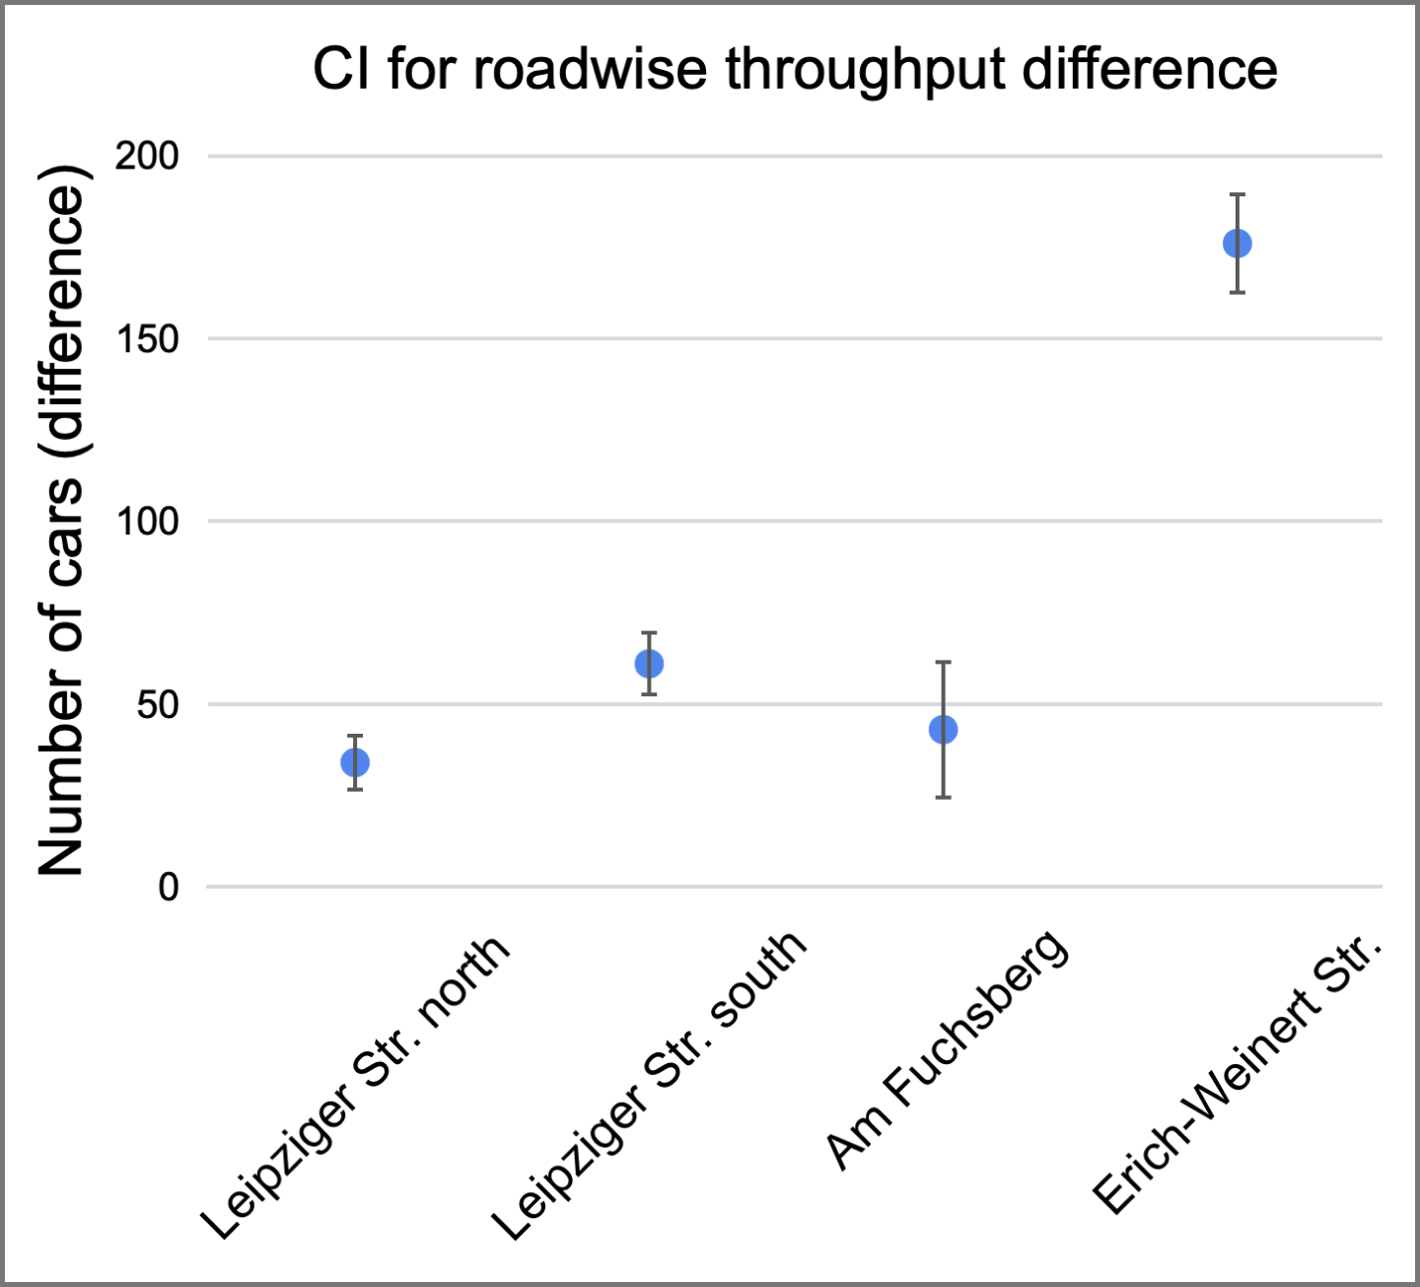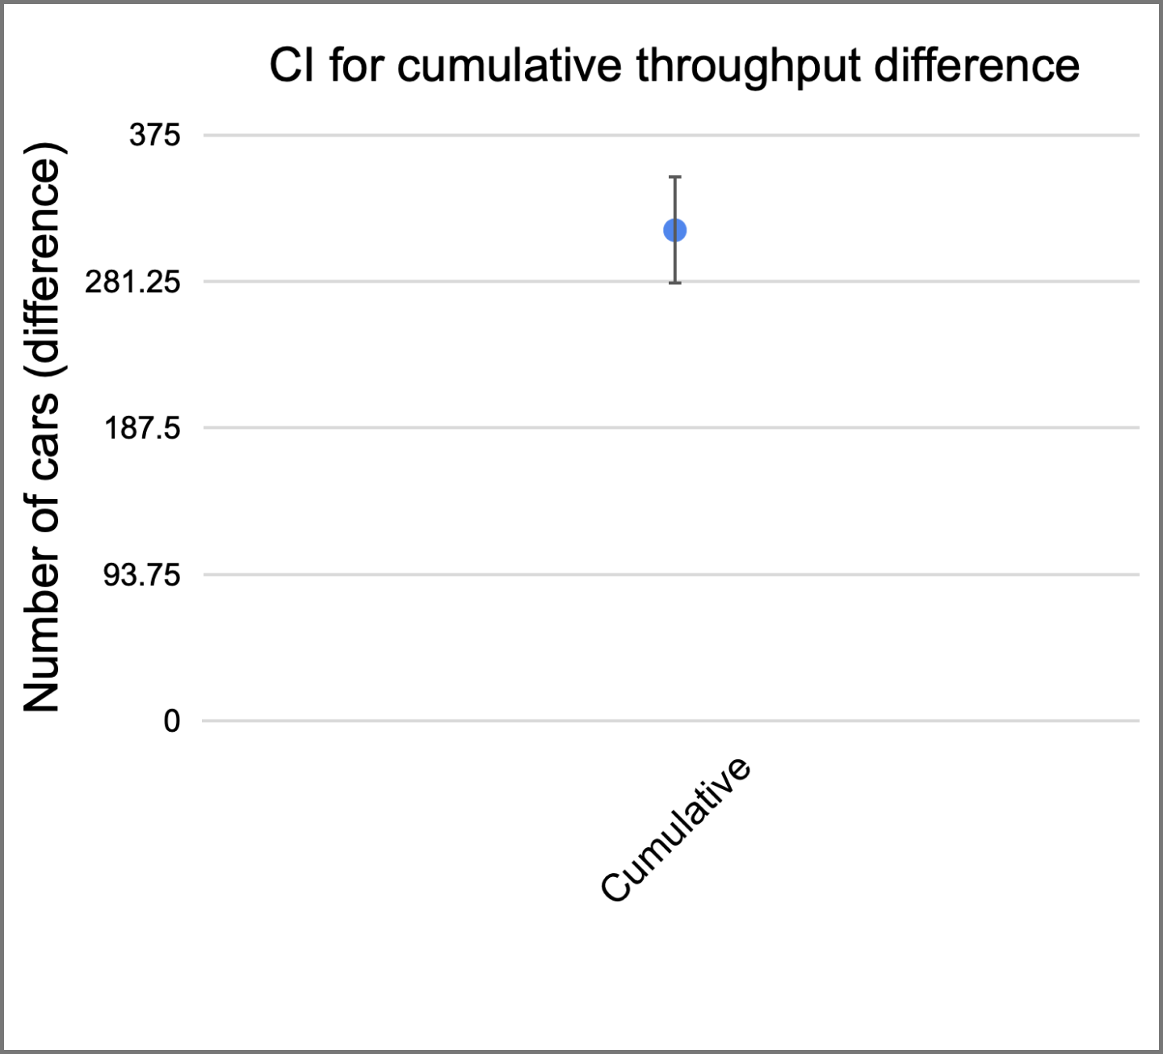

**Figure 34:** Difference CI for roadwise throughput with cumulative changes

Figure 35 shows how the stop count within the main intersection varies with the combined recommendations. The new stop count average is now 78, down from 704 in the base model. The new CI varies between 73 stops and 82 stops.

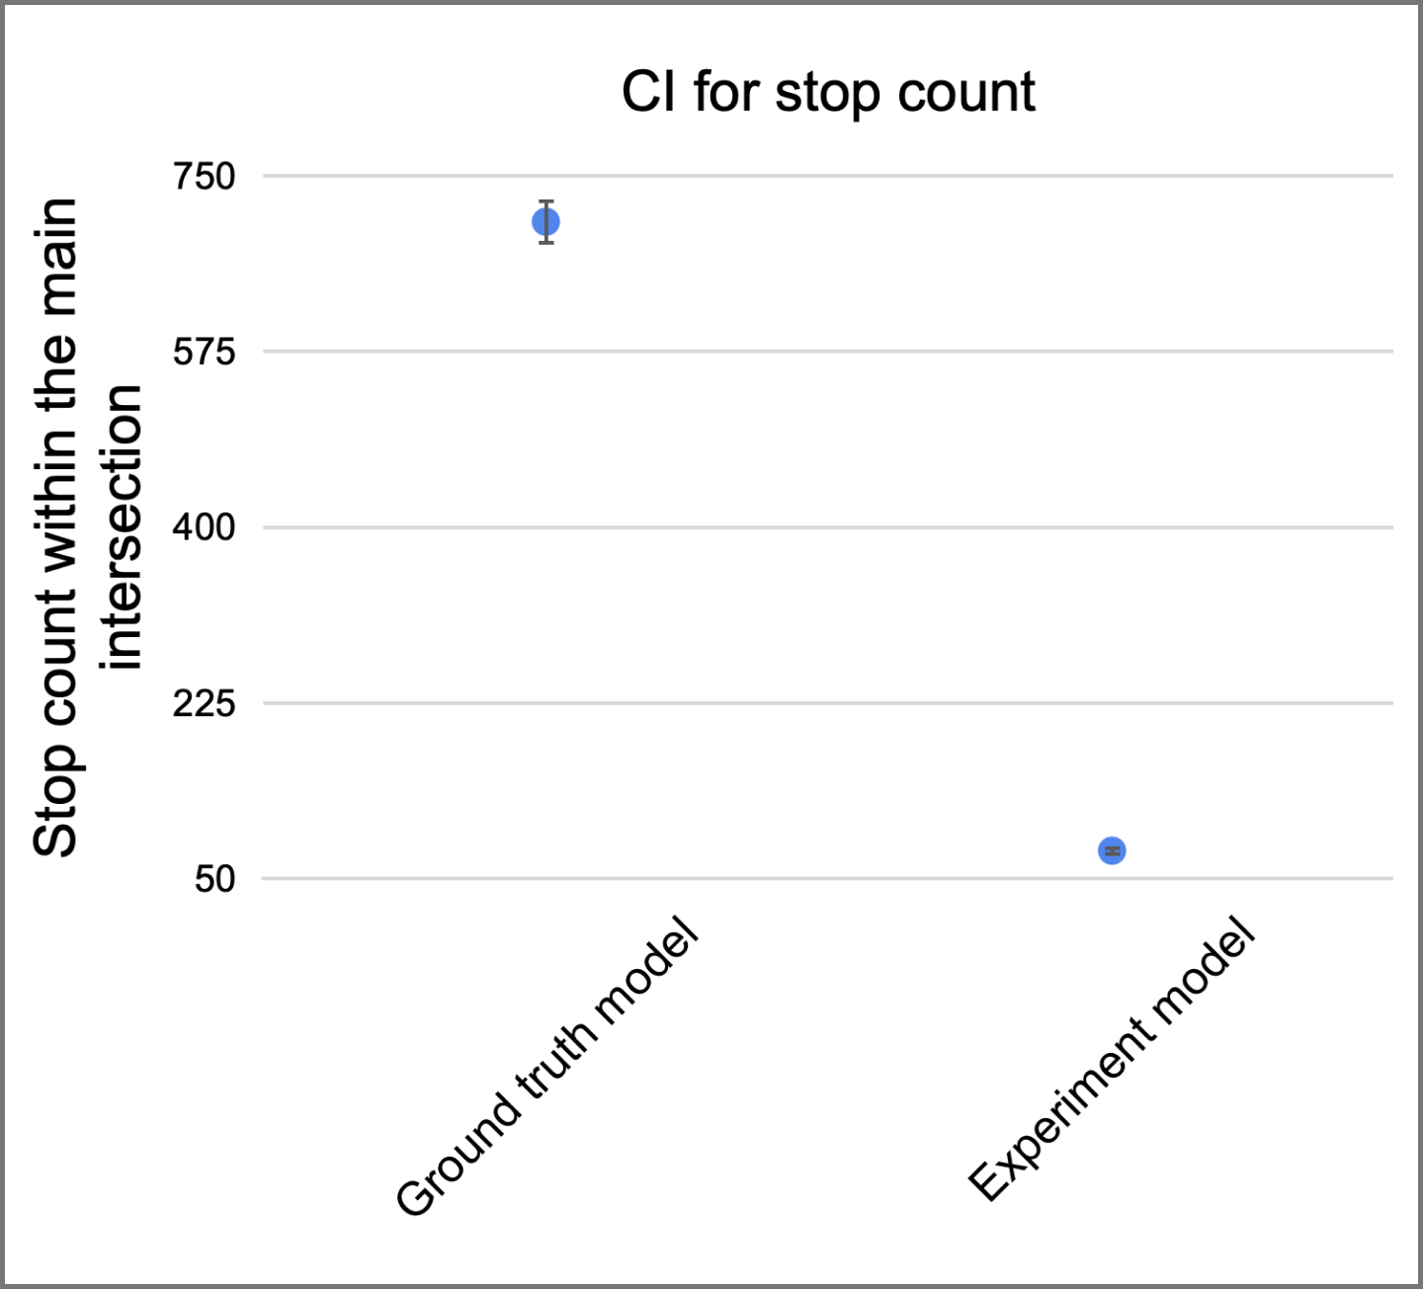

**Figure 35:** CI for stop count with cumulative changes

Considering the thorough statistical analysis we have conducted over the experiments, and the significant results obtained for both the individual recommendations and the combined model, we are confident that our recommendations offer real value and actual implementation possibilities to the City of Magdeburg.

# 5. Limitations and trade-offs

This section discusses the limitations and the trade-offs of the recommendations in more details. While the results obtained from the simulation experiments are clear and point towards effective improvements in the variables of interest, it is important to comprehend the limits imposed on the model due to the unique circumstances under which the project was conducted.

First and foremost, we draw attention to the constraints imposed by the pandemic situation of COVID-19. The social distancing and public circulation restrictions have a sensible impact on the amount of cars navigating the road, as well as on the number of pedestrians interacting on the intersection. As a consequence, the behavior at the intersection in the year of 2020 was not representative of the normal traffic on other years, and any between-year comparison of the data collected would not be reliable. This has forced us to work with the data from the previous team, and limited insight into the detailed data collection process was not provided. Hence, we were not able to make a final judgment of whether the data was reliable or not, and had to proceed with the given data under the assumption that it reflected reality in the year of 2019.

Another aspect that imposes some limitations on the results obtained are the differences between the data provided by the City of Magdeburg and the data from the previous year’s team. The overall estimates for car generation and throughput were slightly different, and having proceeded with the data from the previous year’s team, we suggest performing a more detailed analysis of the validity of the estimated theoretical distributions once the circulation conditions return to their normal levels.

AnyLogic, the underlying software being used for the execution of this project, itself presents several limitations when it comes to the modelling of road traffic. For instance, it is not possible to fine tune the behavior of the model on the collision detection or on the car generation at the source dimensions. This raises the need for unrealistic constructs, such as long roads to allow for more incoming traffic without affecting car generation behavior.

On the measurements side, it is important to highlight that safety and traffic conditions are likely to be two opposite metrics. In fact, most of our experiments have pointed in this direction: improvements in safety are coupled with throughput decrease, and higher throughput levels normally do not lead to improved safety measures. Nonetheless, our experiments have shown that strong improvements in the safety dimension can be achieved even with low worsening of throughput. In fact, a recommendation of further analysis and simulation through optimization experiments stands in place for seeking the optimal phase sequence to maximize throughput within the system.

Also on the measurement side, an already mentioned limitation of our analysis is the fact that there is no direct measurement for the safety of a system. This can only be inferred through indirect measures, which may not capture the essential elements that lead to safety improvements in real life. Perhaps safety could be improved by changes as little as adding a warning sign a few meters before the intersection, thus leading to behavioral changes on the drivers’ behavior and to a safer node. Modelling the overall impact of simple measures such as this one is, however, considerably complex within the realm of computerized simulation programs due to the fact that there are many underlying, unobservable variables influencing the interactions.

Safety measures could also be devised to be more complex than the stop count within the main intersection, but we are not convinced that more complex measures offer higher real value to the analysis. We have, therefore, opted for a direct measure of car stops, which indirectly indicates how often cars accelerate and decelerate within the system, as well as how many opportunities for accidents are generated.

# 6. Cost overview

In this section, we detail the costs of each milestone and of each team member, as well as the cumulative costs of the project throughout its execution. Figure 36 provides an overview of the individual and cumulative costs for each of the milestones, and Table 24 provides an overview of the expenditures per member and per milestone.

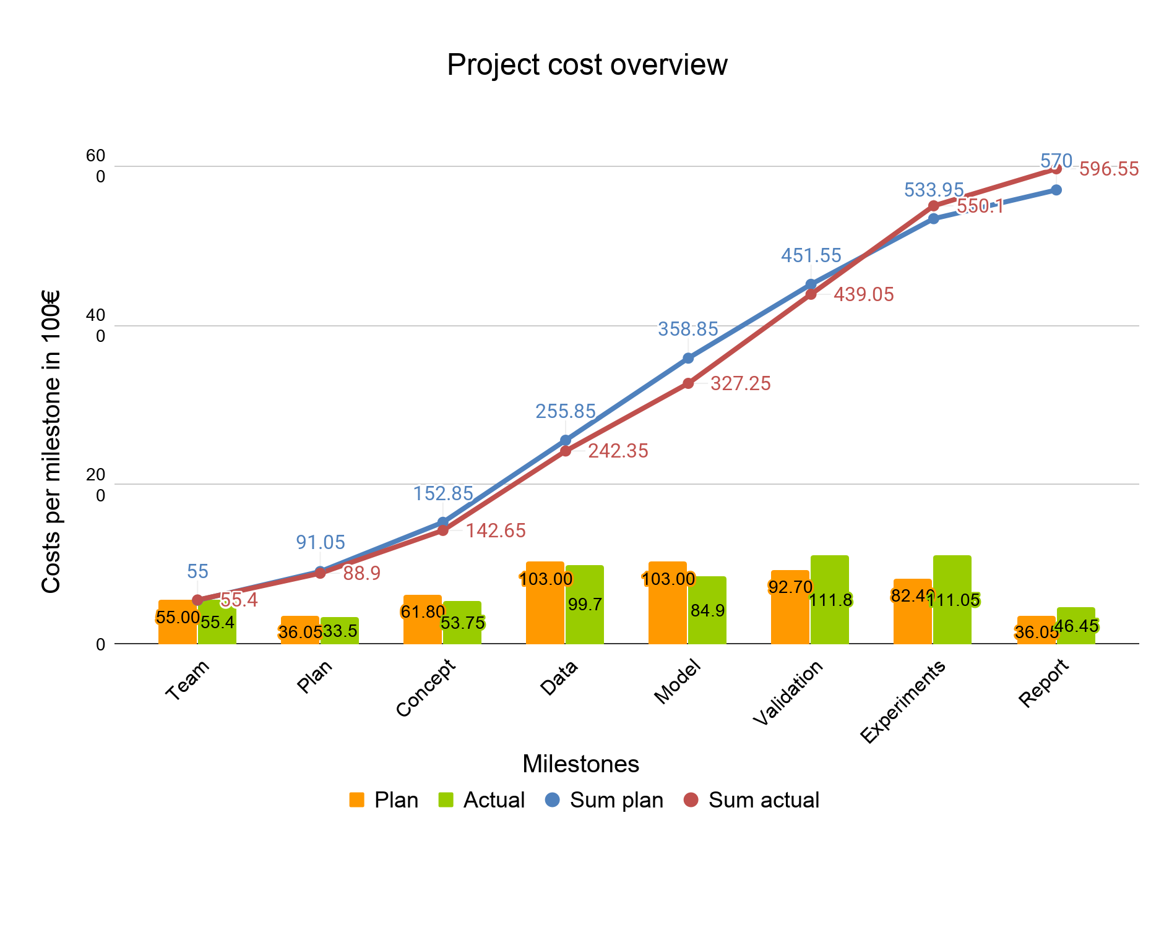

**Figure 36:** Project cost overview

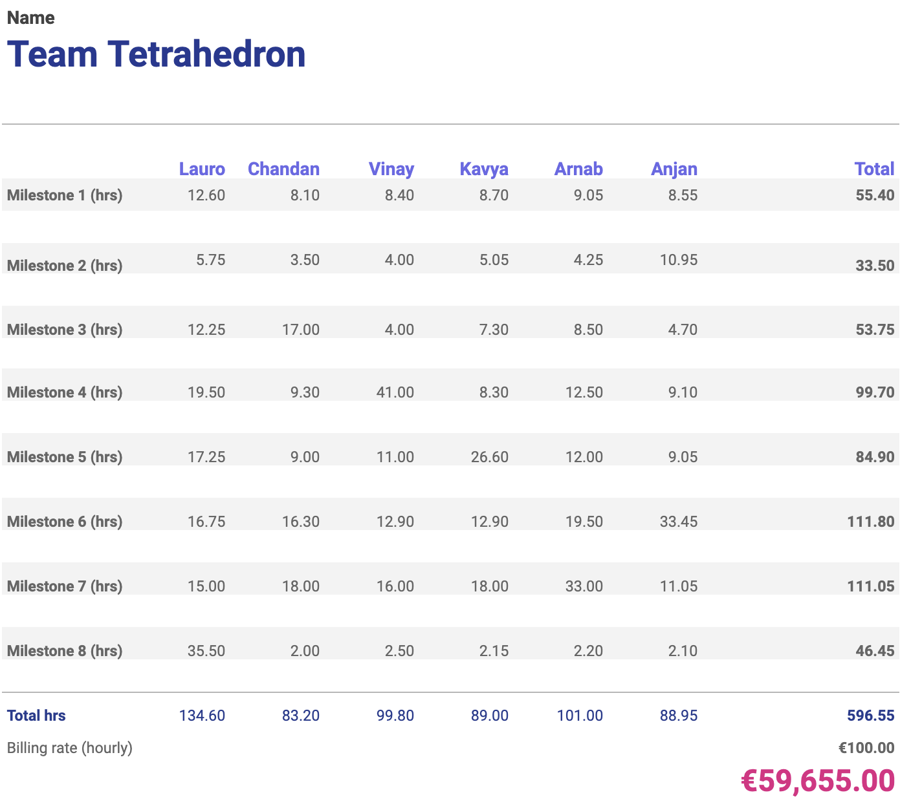

**Table 24:** Cost overview per milestone and team member

## 6.1 Statement of profit / loss

Last but not least, we provide a final statement of profit / loss at the end of this report (last page). We are proud to announce that we were able to execute the project within the stipulated budget and to deliver all milestones within the deadlines. In fact, we have a remaining € 345.00 that we managed to save due to efficiently completing the work of each milestone. We are confident that our simulation program is reliable, our experiments are relevant, and our recommendations provide significant improvements to the City of Magdeburg.

# 7. The team

So far we have presented the results related to the project execution, experiments, and recommendations to the City of Magdeburg. This section focuses on providing a more detailed assessment of the team members’ perspectives on the project. During these two and a half months, we all have had multiple opportunities for personal growth, as well as for developing technical skills that prepare us better for the professional world. The remainder of this section addresses multiple topics that can provide relevant input for the Simulation Project organizers when planning the upcoming versions of the project.

## 7.1 Specific difficulties faced during the project execution

The project execution was mostly without considerable challenges, however we have encountered several limitations imposed by the unique circumstances under which the project was executed.

The quarantine situation during the beginning of the semester forced the project to be executed virtually. Several of the challenges raised due to this drawback were already mentioned in the report, with special attention to the fact that we had to work with different, often contradicting, datasets (one from the previous year’s team, another from the City of Magdeburg). It was particularly challenging to devise ways to integrate both datasets.

On the same lines, the lack of knowledge regarding the data collection and verification mechanisms for the datasets received prevented us from making any inference regarding the reliability of the information. Since we had no influence whatsoever on how the data was collected and validated, we have assumed it to be correct and proceeded with our analysis. It could be the case, however, that the data provided contained systematic inconsistencies.

A third difficulty faced was due to the underlying limitations of the software used for simulation. AnyLogic and its Road Traffic Library do not provide as much customization as necessary to fine tune the model, so we had to conceive workarounds to adjust the model to the specifics of the intersection we have worked with. This has been particularly challenging when integrating interarrival distributions for several roads, due to the considerably high expected number of cars generated by the distributions.

## 7.2 Experiences and events of interest

We all agree that executing the entire project in a virtual platform was a new, very challenging experience. Some of us thought that such an endeavor would not be successful, and we are proud as a team of having successfully completed the project. The online experience, together with the real-world underlying nature of the project, has given all of us much benefit in both personal and professional dimensions.

The fact that we were all able to work smoothly together, despite small differences of opinion on several topics, was also a very positive experience for all our team members.

## 7.3 Team evaluation

Leadership was done exceptionally well. Our leader managed the team, worked very well, and put in a lot of effort to make sure everything remained in proper shape. This does not mean that the other team members did not work properly. In fact, all of us have shown due efficiency, co-operation, and proactive gesture.

In terms of team atmosphere, we have managed to build a very democratic environment, and with no sense of dominance or competition, we all managed to complete all the tasks that we were supposed to do. No team member has fallen short of delivering good work within the deadlines for his / her milestone. This makes the project a very good learning opportunity for all of us.

On the workload distribution side, all work packets were equally distributed throughout the project, and no particular team member felt overburdened. Naturally, each team member has worked slightly more in the milestone under his / her responsibility, but this was expected by everyone, and we have supported each other very well during the project execution.

Overall we can say that our team was a very motivated and highly coóperative team, and we believe we would be very successful in other endeavors.

## 7.4 What could be done differently

One common issue that we have identified is the fact that all of us would like to have worked on the data collection instead of working with third-party datasets. Whether this is a one-time event in the history of the Simulation Project or just the first of other virtual projects, we would suggest instructing new teams to think of active data collection from the very beginning.

## 7.5 Most important lessons learned from the project

As the team environment was very well integrated and working on many different areas of the project execution, the Simulation Project automatically became a great learning experience for all of us.

First and foremost, we all have learned how to work on a project entirely virtually. This has required us to take the time to know each other’s strengths and weaknesses, and assign the work accordingly, so that our responsibilities would be clear and we would meet everyone’s expectations in terms of work output.

Secondly, our experience with proper granular planning and time management has made us realize that such elements are very important for any project to succeed. We have also learned how productive the team environment can be in terms of generating new ideas and accomplishing tasks efficiently.

Thirdly, we have learned in practice the importance of proper justification and testing for every technical change and improvement we propose. While gut feeling may give us an initial direction, it is not always correct, and we should always scrutinize the suggestions through proper verification.

Finally, the project allowed us to become more familiar with AnyLogic and learn several complex routines to use the program. This is of high importance for those interested in professional simulation.

## 7.6 Comments on the project as a university course

The course is very well structured and definitely a recommendation for those considering pursuing their career as professional simulation experts. The instructions of the course are very detailed, and the milestones are properly paced. We find that the organizers have also managed to work around the virtual limitations and implement a complete learning experience for all of us. Perhaps one suggestion for the instructors is to include a more detailed introduction to the Road Traffic Library in the introductory courses of the discipline, but we have found no major hindrance caused by our initially low knowledge of the tool.

# 8. Conclusion

This report has provided a detailed overview of the entire work carried by Team Tetrahedron during the execution of the Simulation Project 2020. We have provided not only an overview of each milestone’s tasks, but also detailed accounts on how we have analyzed the data, built the model, validated it, and performed the experiments. We have dedicated extra attention to highlighting the limitations we have observed in our product, as to ensure that our customer is aware of the challenges we have faced and the solutions we have proposed to each difficulty encountered. Nonetheless, we are certain that our recommendations provide real value to the City of Magdeburg, and believe that we have successfully accomplished our goal of providing a high-quality, high-value simulation program to our customer.

We are very proud as a team to deliver our final report of the Simulation Project 2020. It has been a challenging period, not only due to the hard work required to ensure we deliver a high quality product, but also due to the unique social configuration due to the COVID-19 pandemics. Nonetheless, each and every one of us is very satisfied with the outcome of participating in this project. We thank the City of Magdeburg and the Otto-von-Guericke University for the opportunity to take part in this project.

1. Banks, J., Carson, J. S., Nelson, B. L., & Nicol, D. (2010). Discrete-Event System Simulation. (5 ed.) Prentice Hall. http://www.bcnn.net
2. https://www.anylogic.com/
3. Banks, J., Carson, J. S., Nelson, B. L., & Nicol, D. (2010). Discrete-Event System Simulation. (5 ed.) Prentice Hall. http://www.bcnn.net